Chapter 9 – On saying yes to women
This should be one of the most fun chapters to write, but also one of the most difficult; integration with the largest minority "we" are prejudiced against - half of humanity. How can I honestly dissect my prejudices, or rather the prejudices of my time, without expressing some "view of women" that I don't believe I have and which, by the way, changed throughout my life depending on which environment or American state or era I was in? Perhaps as absurd as women postulating that they have a general "view of men" that is not proportional to which random representatives of the gender have harmed them.
So let me start by stating that I have no intention of attempting to describe "women" (whatever the similarities between the Namibian, Eskimo, Polynesian, Arab or American woman), but only to describe "my women". Hey, what kind of view of women just slipped through the cracks here? Because I learned early on, as described in the first volume of "On Saying Yes" (page 166), that by considering women as your property, you inevitably also lock yourself up, and soon end up in a closed ward, as in the case of Lisbeth.
No, women, like all other human beings, are only to be borrowed and shared. OK, again, this will probably be misunderstood as "pleasure girls". Because if you are prejudiced against someone, you should just move in with them - "sleep with them" - just like I "slept with the enemy" in all other groups I was prejudiced against - even when it came to the Ku Klux Klan, black gangsters, etc.
But even in this respect, my warped view of women failed and betrayed me early on in my free expression. Because how well brought up are you for equality when you, like me, throughout your childhood, were waited on and serviced and tucked in around the clock by 19 different maids with their parallel upbringing that their destiny was to serve in the house without getting any other education. I wasn't even allowed to repair a sock on the darning egg by myself. And the pattern of not playing with the girls at school and bringing them to children's birthday parties was so well indoctrinated in me that they didn't attend my 30th birthday and book release party either. The pattern wasn't helped by being in an all-boys class in high school.
My childhood ideal of a woman was undoubtedly shaped by the movies we could watch in West Jutland with "larger than life" beauties like Lone Hertz in Miss Nitouce, which I saw at the age of 13. | 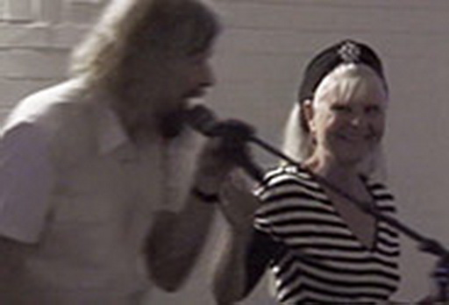  However, when I later came to work closely with Lone Hertz on integration, it was more her inner beauty that I noticed, and that she wasn't "larger than life" after all when she gave me a speech for my 60th birthday.
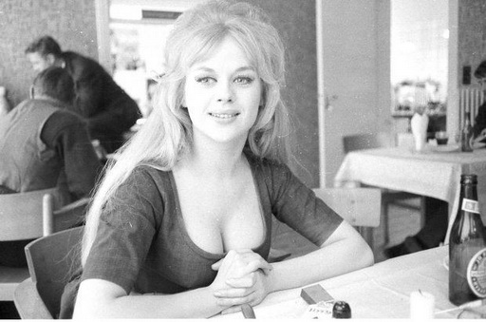  If I was instilled with any ideal of women's breasts, it probably came from Dirch Passer and Judy Granger's "boob and hooker" performances. That's the kind of thing an 11-year-old boy notices. | 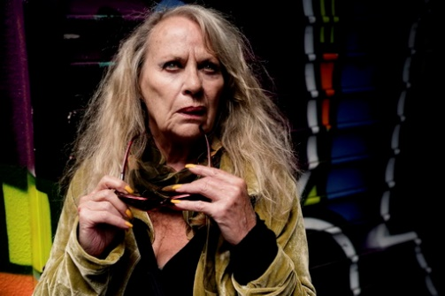  In that respect, I had probably become more mature and less curious when Judy Gringer frequently rang my doorbell in Købmagergade in the 80s when she was drunk as hell at 4-5 in the morning and needed a place to sleep.
MY FIRST (AND, I SWEAR, LAST) JILTED GIRLFRIEND
Here, however, I was clumsily helped to break out of my gendered prison of womanizing. Yes, yes, as always, let's blame the victims - completely free of charge now that we're not allowed to see them as "victims" anymore. Because my schoolmate in the village, Birgit, in 8th grade in our new metropolitan school in Esbjerg, made a friend, Sus, who had taken a liking to me from their parallel class. I think it all started with Sus giving Birgit secret notes for me to meet behind the water tower, but soon I was so embarrassed to use Birgit as a messenger that we started putting the notes in a discreet hole in the wall in the pantry. I began to meet regularly with Sus in a hidden spot between the trees at the Art Museum where we sat and braided Brylcreem greasy fingers overlooking the harbor. Or while her father was touring the country as a train driver, she would take me home to their cramped apartment in Jyllandsgade. Eventually, she dared to show me off to her loud, coughing mother, who spewed out clouds of black smoke from her cigars almost as big as her father when he fired coal in the locomotive. Even though I once joined them in the summer house on Fanø, everything remained as innocent under the joint supervision of my mother and my priestly upbringing as it could in the pre-Beatles era. Their chicken-like social control was not at all necessary as my internalized "view of women" was so warped at the age of 15 that I had no idea what to do with this daring city girl. Today, in our "arranged relationship", I see no difference between me and the men I have since experienced in Middle Eastern relationships. That is, a completely suppressed ability to express love and infatuation.
Therefore, I was also unaware of how in love the controlling Sus was when I broke off the relationship the following year because I had "fallen in love" with Ingrid from the neighboring village during high school. Since then, when I learned how easy it was on the road to have several "boyfriends" at the same time in different cities, states and continents, I have found it hard to understand how I could be so cruel to Sus. After all, I could have easily intertwined fingers with a city girl and a village girl at the same time when they were separated by 25 kilometers of ignorance about each other. Again, in my twisted mind, it must have had something to do with "having a girlfriend" being the same as having exclusive ownership of the object. Again, a Middle Eastern view. I didn't even dignify Sus with a glance anymore in the schoolyard. Or rather, out of embarrassment, I avoided seeing her sad look when she walked arm in arm around the schoolyard with the comforting Birgit. Because it felt just as painful for me to see her pain-filled eyes. Sus never got over her heartbreak, Birgit told me many years later, "and you should know that it's your fault that both of her two later marriages, including one to a university rector, failed."
Birgit was the girl who accused me of my inherent self-absorption in the first volume of "On Saying Yes", so her accusatory words hit home again. My cruelty towards Sus was one of the reasons why I always later made an effort to NEVER again give women such high hopes, which is what this chapter is about, and never again to "break up" with someone, i.e. not to use someone and then coldly and cynically throw them away after one use. No, once you have developed mutual feelings towards another person, you are marked and shaped by each other and in that sense "married" to each other for life.

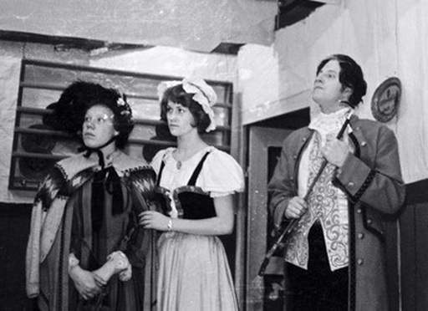  Ingrid from the neighboring village here in the middle in the amateur play "Erasmus Montanus" for which I painted the scenery. While working for a month, we fell in love with each other and began an innocent relationship. I wrote hundreds of diary pages about her. | 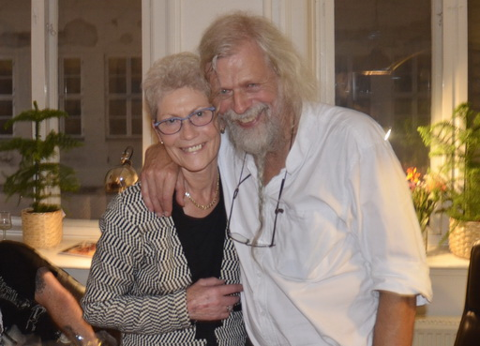  Here I am with Ingrid 55 years later at the book release of "On Saying Yes" where I described the relationship. In the intervening years, I frequently used her and her husband's home for overnight stays during my lectures, which they also organized at their school.

When I traveled around Denmark as a lecturer after trying this for 5 years in the US, I met Sus for the first time in 15 years at Aalborg train station and talked to her about it all now that I had gained "a little more control over women" during my exile. But she was again very controlling and insisted that I should come home and spend the night with her, as the man in her second marriage was going to be a night watchman at their youth school. And now that we were both a lot more mature, she finally seduced me sexually. I just remember her saying something about how she had never been able to ejaculate with other men and that she now realized that she couldn't with this, the great love of her youth. And it was obviously a liberation for her to come to that realization, because it meant that she could now move on with her life. Soon after, she threw out her second husband and finally found the happiness of her life in a right-wing professional hunter, "believe it if you will," as she said. And when I later visited them in their various homes, she told me how she had finally achieved complete and unbridled sexual happiness with him.
Only she now regretted that in the intervening wasted years she had burned all our old letters to each other in her desperate attempt to free herself from her unhappy youthful infatuation, "because I wanted so much to show you today how closed off, twisted and clumsy you were when I was naïve enough to think I could free you," as she said, while entertaining her laughing husband with ridiculous examples from my youth. Pictures often say it better than words. In a romantic, colorful drawing I did in her sophomore year of two lovers sitting in a rowboat at sunset, the girl says, "Look at the moon, darling!" The boy responds as I would have, "Yeah, what's wrong with it?"

Maybe I had just been too immature in relation to her, as boys often are at the age of 15, because when I kicked her out of high school in favor of Ingrid from the boondocks, I had at least begun to be able to express love covertly on a literary level. I don't know whether Ingrid also perceived the love at that time, but she certainly did when, at the age of 72, she received a 100-page diary that I had written about her without her knowledge, sent to her in book form with the title "My Evenings in Paradise". It's important to learn to say "I love you" to all your lifetime lovers - before death do us part - especially when, like me, you once only managed to whisper, almost inaudibly, a suppressed "you're the worst person I've ever met."
ON THE USE OF THE TERM "LIFETIME GIRLFRIENDS"
...... FOR THOSE WHO CAN'T CHOOSE

My crime against Sus meant that all my girlfriends after her - even before I left for the US in 1970 - became "lifetime girlfriends", whom I never "broke up with" and cling to as friends to this day. So it was natural for me to try the same thing in the "throw-away society" of the USA, where this relatively Danish pattern was not so common. When the popular American radio storyteller, Garrison Keillor, among his serial marriages, was married to a Danish woman for a time (before losing both status and position after sexually assaulting a woman in the more recent #MeToo era), he often entertained American listeners with how confused he was when he first visited her family in Denmark, and to his astonishment was immediately introduced to all her former lovers at the first family gathering. That was in the 80s, but I'm not sure if this Danish cultural pattern is still as natural today as it was for those of us shaped by the sharing economy of the 68s (as opposed to serial relationships), or if it has been replaced by a more American throw-away pattern. Because if so, my younger readers might have a hard time following me in this chapter.

In any case, I reacted negatively to the Americans' overconsumption - both of things and people with "built-in obsolescence" that were simply thrown away and "ghettoized", which I expressed by using and illustrating this black song by Esther Phillips in American Images:

Disposable Society
has thrown away the best in me.
It has thrown away sincerity,
the keystone of integrity.
Disposable to throw away,
buy something new another day.
There is nothing made there is made to stay.
Planned obsolescence will make you pay:
paper plates, cardboard skates, plastic silverware,
automobiles with disposable wheels,
whigs instead of hair, that's fine.
Disposable the way you love,
not exactly what you are thinking of.
Dispose of me when you are through
for fear that I dispose of you.
Disposable friend,
you are supposed to love right to the end.
Your rigid mind won't let you bend.
You're further gone than you pretend.
Paper plates, cardboard skates....

The problem is that when you feel that something can or should be thrown away after use, it's easy to end up in immoderate overconsumption without a sense of responsibility. I still have audiotapes that drivers would play for me of their ex-girlfriends crying and begging them to get back into the relationship. Then I would sit and cry along to their amazement. "What? You really like to hear that pain in the ass crying so sorry for herself? Well, you can have the tape!" they said, laughing every so often, giving me their only memory of the one they had previously loved. I couldn't believe this cruelty, let alone that they frequently sued each other for money in the use-and-discard society.

This was the image that greeted me as soon as I crossed the border into the US after - in terms of female relationships - a very lonely year in puritanical Canada. There's no doubt that this is why I enjoyed what Americans called "our new sexual freedom" in the post-pill era. But many men, feeling like losers in this game of overspending for the chosen few, fantasized about utopian societies in which there was even greater freedom and kept asking me, "Is it true that you have sexual freedom in Denmark?" Probably because of the Swedish cult movie "I am curious yellow" and their usual confusion of Danish/Swedish.
I quickly learned to answer, "Yes, but Americans make far more irresponsible use of their far less freedom." Or as other European travelers I met astonishedly expressed their experience of the country, "Americans fuck like rabbits!" (Hm, did that expression originate from the idea of tail-wagging Playboy bunnies?)

ABOUT BEING DUMPED BY YOUR FIRST "ONE AND ONLY"
I probably didn't give much thought in the beginning about showing responsibility in this loose sexual circus that I was about to perform in. It was probably mostly my inherent narrow-mindedness, perhaps again due to my priestly upbringing, that held me back and triggered the constant accusations from the women, "Why are you so prudish?" The first year, 1971, I had only a few relationships in the US, partly because I took them too seriously and stayed too long with each of them, as I was still too scared to break away from the security to hitchhike further down the road.
But then I had my 9/11, when on this very date that year I was attacked in the queue in front of The Broiler room nightclub in Montreal by the beautiful and extremely charming and talented Jewish girl, Marly Sockol. I will only briefly tell you about her here, as the main story belongs in "Saying Yes to Jews."

She had gone to Montreal to visit a Jewish girlfriend but ended up taking me to his house that night to have sex with me instead. And for the next week we barely got out of bed as we hitchhiked across Quebec to her parents' big millionaire home in Boston, which they said we'd inherit when we got married, and then down to NYC where she was studying at New York University. Everything swung between us and I was sure I had finally found the love of my life. She was supportive of my still radicalized politics and went with me to political meetings and sat through Vietnam movies and knitted my Vietcong sweater, which has followed me ever since and in 2014 went to the Cold War Museum on Langeland. But she was also good at getting me to examine my deeper political motives from a higher philosophical perspective. When I began to fear that I wouldn't be moving on as planned - and yet continued to passionately talk about going to fight in Latin America - she found me a job in the folk music club The Gaslight to keep me going. It was run by her friend, Betty Smyth, who Marly had helped get an A in an exam paper. It was here that I met all sorts of famous musicians, including throwing Bob Dylan out by mistake. However, Marly was annoyed by my emerging interest in the unattainable black women and bought an afro wig and put it on, "Will you now pay me more attention?" she laughed. I was beginning to feel a betrayal of my political ideals of fighting for the poor by essentially marrying into wealth and security. But at Christmas time, I discovered that there were exceptionally cheap tickets to London and suggested Marly come home for Christmas so I could proudly show my parents that there was now hope for their prodigal son. She complained a lot on the hitchhiking trip from London about having to lug the heavy suitcases of Vietnam literature I had collected (stolen) to give to the Vietnam committees back home. My parents loved Marly, who I hitchhiked across Europe with during the New Year's holidays before she went back to her studies.

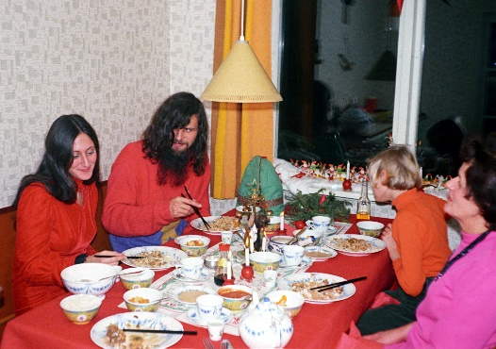  Marly cooked Japanese food during our visit to my parents' home in West Jutland at Christmas 1971. I'm sitting in her knitted Vietcong sweater while all was well. | Marly returned to Denmark frequently. In the 2016 movie about my life, she surprised me by suddenly revealing that it was my past interest in black women that had led her to break up with me.
I chose to stay a bit longer, as people in Denmark were heavily influenced by my first pictures from the US and started organizing lectures for me. But Marly kept calling me almost every day to beg me to "come home" so we could get married soon, etc. I didn't take it seriously, as I had for the first time found some confidence in my political work, and dragged out my American return. Then one day she called and said she had met Fidel Castro's former comrade-in-arms Enrique and was falling in love with him, "so you have to hurry home." I thought she was just saying this to pressure me, but when I finally returned to New York on April 22, 1972, Marly had moved in with Enrique. This was an extra blow to me because, as a former Cuban revolutionary, he had now become a counter-revolutionary and fled Castro's Cuba, which both Marly and I had idealized. I therefore had to hastily move in with another Jewish woman, Alice Turak, whom I thank in the colophon of my later book for her contribution to it alongside Marly's major contribution.
To emphasize her kicking of me, Marly showed up in expensive "bourgois" mink fur when I requested a conversation if we couldn't salvage our relationship. So the message was clear, she was now part of the use-and-throw-away society and it was in this deep pain that I then sought solace or meaning by identifying with the pain of others. For Marly's relentless rejection led me into a deep depression that made me resolve never again to get so heavily involved with people only to be brutally thrown away. I would rather die for a higher cause.

Initially by going down to fight alongside the guerrillas in Guatemala. But as fate would have it, throughout my hitchhiking trip down through Mexico and Guatemala in the summer of 1972, the good Lord sent me one "saving angel" after another in the form of seductive and idealistic Jewish women of Marly's type who kept getting me derailed, Rebecca Bilsky, Stephanie Silverman, Marcia Yutman and Jane Schreibman. They had each gone there out of an interest in culture and politics, but quickly realized they needed male protection in this machismo hunting ground. So every time I managed to get rid of one of them, the next one was there to ask me to become their travel companion, which they probably didn't realize at the time was the same as becoming my "life partner". I, on the other hand, had - in the sense that I expected a high risk of a very short "lifetime" - by going to my death with the guerrillas. But for the same reason - call it feminism - I never found my idealized freedom fighters in the mountains.

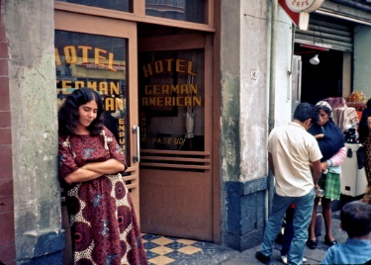  The 21-year-old Rebecca Bilsky, whom I met on July 12, 1972, when I was looking for a couple of other New York girls I had traveled with. Rebecca is here outside our first hotel in Mexico City. We had a long hitchhiking trip on trucks to Guernavaca, Acapulco and Oaxaca, after which I had to hitchhike her back to Mexico City on July 22. | 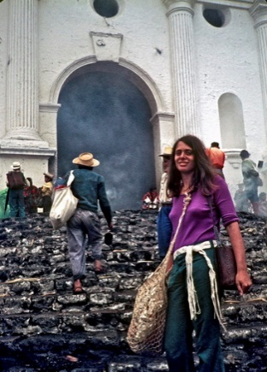  I found 28-year-old professor Marcia Yutman on July 30 by asking around Oaxaca if anyone wanted to share a room (to save money), after which we hitchhiked around Guatemala until August 6, when we parted ways because she wanted to study Indian art and I wanted to fight for the Indians as a guerrilla.
So after a few months, I returned to the US and dedicated my life to the poor black ghettos instead. However, Marly quickly gave up her Cuban counter-revolution against me and the following year tried to persuade me to resume the relationship and travel to Latin America with me. But in the meantime, I had been through a long ordeal and depression and had found my identity, happiness and freedom on the road. I didn't want to give that up now for any woman, so Marly had to settle for becoming my "girlfriend for life" like the others. Funnily enough, I later attended Marly's wedding to her replacement, the Jewish Gary, who was even more fanatically left-wing than me and went underground shortly afterwards to bomb the government.
HOW TO MAKE “AMERICAN PICTURES ON THE EDGE OF THE BED”

It was after her refusal to marry me in 1972 that my real adventure with women started in the US. I interpret this to mean that from then on, I apparently radiated a deeper commitment to a higher idealistic cause that was no longer subconsciously motivated by selfishly wanting the "woman in my life". Only then did I gain the authenticity that made me exciting to many women and gave them a sense of security in inviting me into their violent society. (So, listen, dear men, don't get interested in women, because only when you get them out of your head will they be interested in you. And no, this is not a calculated scoring technique, because if it doesn't come naturally from within, you're in trouble.)
The only people my new black commitment didn't really work on were the black women, because as I fell in love with the cause, I couldn't help but fall in love with them too - not as people, but as political templates, which is why they subliminally became so desirable to me that I lost my genuine authenticity. I'll talk about the few exceptions in the chapter "Saying Yes to Black Women."
So, ironically, my fascination with black women was the reason why I was now getting incredible attention from white women. And more importantly, it was also the reason why they were never disappointed by expecting something more from our relationship. Therefore, I never needed to "break up with them" in order to move on. On the contrary, I could confidently keep coming back and staying with them and their later husbands for the rest of my life.
In the early years, I only had to stick out my thumb for them to pick me up as a hitchhiker, especially when I waved my "Touring USA from Denmark" sign. About every tenth ride was with women, many of whom said they would never have picked up an American man. It was a good educational way to tell me that as a trustworthy foreigner, I had to behave properly if I was to hope that they would invite me home with them. And the easiest way to do that with white women was to start "talking black", e.g. asking them how I got to their local black ghetto, etc. They would very often come up with a story about how they wanted to take me there, but it was getting too dark or they had something else to do right now, "but why don't you come home with me and I'll drive you there tomorrow (read: when I get the courage to do it in daylight)? Then I can make you some dinner too."
Depending on the time of day or the person, I was often a little annoyed by these delaying "white digressions", but I had to live up to my policy of saying yes even when my heart said no - in other words, thinking white when my heart was thinking black.
When we got home, it usually turned out that these - mostly student - young women only had one bed - usually a double bed - so after a little chat, they invited me to share it with them. Now I knew that the big test was coming as to which of us could pretend for the longest time that we weren't sexually interested in the other. And I knew from experience that I would always win, for several reasons in my tangled web of black thoughts.
1. Firstly, my firm rule of never violating people's hospitality, which is why I always left it up to my hosts to take the initiative on what to do. That way I didn't risk "reading them wrong". Of course, I often did that anyway, as they were brought up to read based on a macho culture where the man always took the initiative and therefore were confused by my passivity, which mystified them, but apparently made me even more exciting in their eyes.
2. Secondly, I was usually exhausted from traveling and especially from frequently having had other sexual relationships immediately before, which made me feel guilty. Especially from the almost daily sexual assaults from homosexuals, which I reluctantly had to agree to "deal with" during the day as a hitchhiker. So at least the first night with a new woman, I was uninterested for that reason alone - especially in women I was really interested in and therefore didn't want to disappoint by acting impotent. (Let me go back to the majority that I was not deeply interested in having sexual relationships with, but rather intimate ones).
3. for the first couple of years, I had frequent outbreaks of herpes, which I had brought with me from Denmark. It didn't bother me much, but I knew that it was very painful, especially in the first time after women were infected. I was therefore so terrified of passing it on that I often used it as an excuse to aggressive women, who then immediately pulled out their feelers/catching arms. "Wait a few days and I'll be ready," I would say if I wanted to prolong my stay with them out of convenience. At the time, herpes was so unknown in America that I often claimed that I had brought herpes to the US after the STD had become a national epidemic during my time as a lecturer in the 80s and I myself had long since been so cured that I now (again) used it as an excuse not to be re-infected myself.
However, it was far easier to imply (or outright show) that I, as a European, was not circumcised like all American men were at the time, as many women did not dare to sleep with an "unclean" uncircumcised man.
4. I have never been an automatic sex animal by nature. It takes a lot to turn me on compared to many other men - especially American men. I experienced their horniness almost daily by watching (and measuring) the flagpoles of unruly gay men in their cars by simply looking at me while driving. Or sharing a bed with heterosexuals as I gratefully watched them take on the task from me of fucking women who in no way tempted me.

This particular aggressive American sex culture was something I tried to write about sympathetically in American Pictures:
"Admittedly, I found both straight and gay American men incredibly sexually aggressive, but one must try to understand the oppression that had created this John Wayne culture. Black men in particular suffer from this culture because their mothers raised them in it (I always automatically do the dishes in people's homes; but I've gotten to the point where I've stopped doing it in black homes because it always embarrasses the women: they simply don't know what to do with a man who does the dishes. So, isn't it disingenuous of me to try to change their culture when they still have to live with the oppression?") And when it comes down to it, white women have the same attitude. Time and time again, I am invited home by single white women who, unlike single women in Europe, almost always have a double bed and therefore place me next to them. But it's shocking to see how they are usually completely incapable of dealing with a non-aggressive man. After two or three days, they usually say something like "Have you always been gay?" to bring out some male aggression in me, or more often, "Let's go out and get drunk." No doubt they'd be a little uncomfortable if a new guest walked straight to the fridge and ate all the meat. Yet American women seem to feel uncomfortable if a man doesn't walk in their own flesh and blood. With black women, I sometimes find it necessary to modify my passive rule of not violating people's hospitality with a little affirmative action. They often do everything in their power to humiliate a "soft" or non-aggressive man, which stifles any chance in the womb of building a more meaningful relationship with them."
EXAMPLES: THE MIDWESTERN TOWN, JACKSON, MI

Let me give an example, from the same street in just one American city of both the black and white consequences of my stubborn principle of saying yes, but not crossing the line and violating women's hospitality. And also to show how it was such sexually aggressive white women that helped create my best photos of black people.
On Friday, June 2, 1972, I came hitchhiking from the ghetto in Indianapolis, where I had been staying with a couple of black girls who, as usual, were under too much social control, including the neighborhood drug addicts who came in all night long, to dare develop an intimate relationship with me. Admittedly, the militant but proud girl Moose had clearly had it in mind by inviting me into their bed several times. I was on my way up to my equally militant black friends in Detroit to arrange our departure to Guatemala the following month with my Black Panther friend, Chris Booker. Among their female student friends, my problem here was the same. They were too proud in their new proud "Black is beautiful" consciousness to even dream of having a relationship with a white man. I had now traveled for a year and a half in the US and shared a bed with several black women, but no one had yet initiated a sexual relationship.

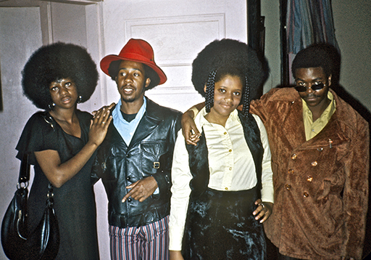  Rosalinda and Joyce were two of the girls I shared a bed with for a few days at 1854 N. Talbott in Indianapolis. The third, the militant Moose, whom I liked the most, was in town when the photo was taken. | 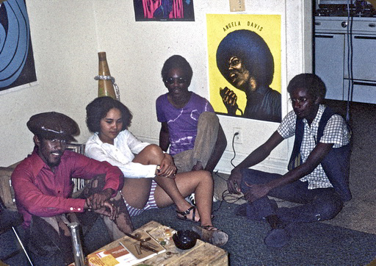  My militant friends in Detroit - featured in "Easter in Detroit" in my book - have been lifelong friends. From left, Jerry, Deborah, Chris and Aaron. Jerry is a frequent visitor to Denmark.
Only 200 km from my destination in Detroit, I was derailed again that day when the white woman Vicky Fuller picked me up in her VW Beetle. As she - even in her hip attire - exuded left-wing thinking, I began to entertain her that I was on my way to see some black panthers. She then quickly suggested that I should first see her local ghetto, because she actually lived right in the middle of it in the town of Jackson. I only knew the city by name as the world's largest prison, which was located there and housed several of my Detroit friends. "Well, I have good contacts there, so I can show you the prison too. But it can't be until tomorrow. My husband Tom might be a little upset if I take you home, so let's stop by my friend Krinchel's house and see if you can spend the night there." Krinchel looked super cute and immediately flirted with me, but this obviously annoyed Vicky as I was now "her hunting trophy." So she said we should both go and pick up Tom from the retirement home where he worked and go out to dinner together. On the way, Krinchel excitedly told me in the back seat that she thought the two of us should go back and "get jumped" as they had two rooms in Tom and Vicky's house. I didn't mind this beautiful white initiative after having suffered the lack of black women for a long time. But Vicky had second thoughts and said I should go with her as a delegate to the Democratic State Convention that night, as the presidential election was coming up. She got me in with 300 delegates by plastering my chest with the crosses and ribbons and stars of the peace candidate McGovern's badges on my chest like a full over-and-under General Warrant Officer's cross and ribbons and stars. However, I got bored during the meeting with all their peace talk and sat ostentatiously reading a book about the guerrilla war in Guatemala. This probably made me exciting again in Vicky's eyes. Because afterwards she wouldn't hear of driving me to the girl I was now dreaming of, Krinchel, but insisted that I could stay with her and "my old man" (as the husband was now reduced to), "because we live right in the ghetto, which is more convenient for you."
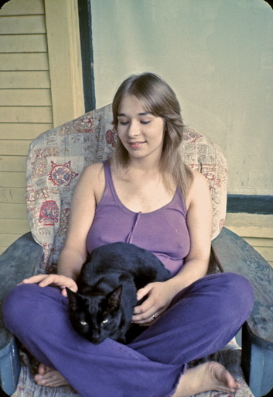 | Together with Vicky, we pick up her husband Tom from the nursing home. To the left is Vicky.
I was put to bed at home in a messy room, but when she drove Tom Fuller to work at 6am, she came in and woke me up and said, "I think you should come in and try my much more comfortable waterbed." And as I wrote in my journal, "We made love and splashed in it until noon." I remember how annoyed I was that we were a good match sexually, because I hadn't "turned on" Vicky in any way, and now my dreams of the far more beautiful and exciting Krinchel were over. It was my principle never to violate hospitality by going out with girlfriends' girlfriends, even though I felt I swung much better with them.
Now I was hooked and practically already in her promised ghetto and prison at the same time - even before we went out at noon to see the State Prison with 5000 mostly black prisoners. But after we had a nice time by a lake afterwards, I finally managed to escape further down the highway to my friends in Detroit, whose panthers Melvin and Jean hijacked a plane to Cuba only two months later and got a million dollars ransom from the FBI for the passengers. They were later granted political asylum in France, where in 1982 they organized my show in Paris. (More about them in "Saying Yes to Terrorists").
But Chris Booker was slower out of the starting blocks and after a few days we agreed to meet in Mexico City en route to Guatemala, as it was hopeless for a white and a black man to hitchhike together. Before that, I managed to visit for the second time the black panther girl, Melvateen Lampkins, who had received a life sentence in a prison north of Milwaukee. She was convicted of a murder she was innocent of because she refused to reveal the guilty panthers. I was allowed to hold her hands intimately in the prison interview room so I could discuss out of earshot my idea of helping her escape to Canada or Denmark and then tried to set up an escape network with my friends in Chicago and Detroit. But she only managed to escape on her own in 1979 - and she is still wanted to this day in 2020. I only mention this to show once again that I was so fanatically obsessed with black women during my radicalized period that I even tried to pick them up in jail while I had no interest in being "jailed" by whites.
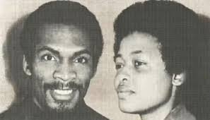  Melvin and Jean before the hijacking. I last spoke to Melvin in France during the writing of this book in 2018 when Jean had died. | 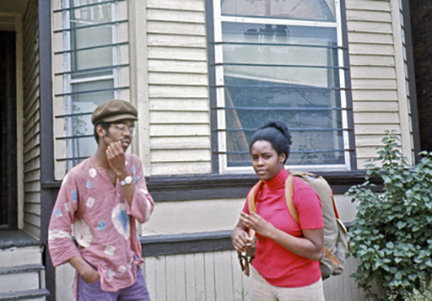  Janice (without afro so as not to scare drivers) getting ready with her backpack before our hitchhiking trip. Above. Chris Booker who I planned to hitchhike to Guatemala with.
Since I had promised to hitchhike with the beautiful panther girl Janice with her proud big afro from Detroit to the University of Ypsilanti, it got dark before I got on I95 on June 6 towards Chicago and my imprisoned panther friend in Wisconsin. At Jackson, I called Vicky to see if she could pick me up for the night. She didn't mind, but her husband Tom wasn't exactly thrilled about my presence again. So, while they argued for over an hour, she sent me on a ghetto visit to the two black girls next door at 116 W. Morrel St.
Unlike my aforementioned political black friends, they were from the ghetto's downtrodden underclass. Pauline and Marie Williams could be seen from afar as they sat on the porch all day drinking and joking for their welfare checks. Pauline said, "Marie would like to kiss me. And when Pauline walked in, after a couple of glasses of cheap apple wine, I dared to give Marie a cheeky kiss. She was surprised and embarrassed. Every time I passed by them after that, Pauline always cheekily asked me if I wanted some "Pussy". I pretended I didn't know what the word meant (or maybe my English wasn't that advanced yet), because it immediately got a dirty laugh out of them. Then Pauline told me to go with her up to the attic where her "Pussy" was. "I'd like to see that pussy," I replied. The enormously overweight Pauline then showed me up the steep stairs to the attic - moaning and panting behind me. But I was surprised when we reached the completely empty attic floor, where there was nothing but pigeon shit and dead mice. "Where's the pussy?" I asked disappointed. Now Pauline was completely embarrassed and didn't know what to do. I wondered if I should help her save face by taking an initiative towards women for once, but if nothing else, I let my prejudices hold me back. Because what could it turn into on the floor?
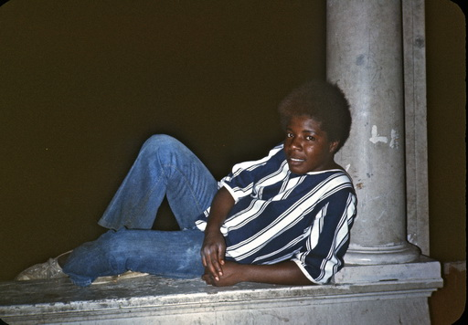  The flirtatious Marie Williams | 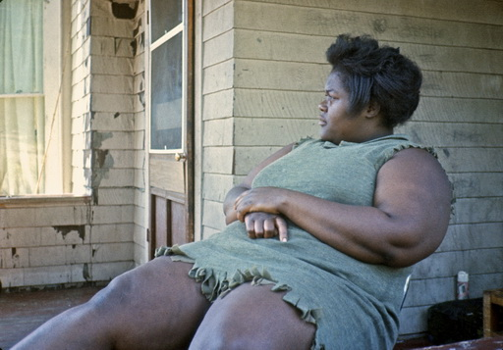  Pauline as she sat on the porch all day long
The thing was, at the time, I was still suffering from a long childhood indoctrination with beauty ideals that couldn't quite accommodate her inclusiveness. I gradually worked my way out of them during my vagabond years, and the funny thing is that when I look at my pictures of Pauline today, which I used to react to as a giant mountain of fat, I no longer find her as overwhelming as she seemed to me at the time.
This is not only because I have changed in a more "embracing" direction, but also because America has since changed towards a society where her BMI gradually became the norm. Especially in the black underclass, which in the 70s was still mostly as slim as her friend Marie. So at one point, when they both asked in embarrassed voices if I had ever "had a black girl," I showed them my pictures of the black women I had stayed with - still too embarrassed to answer the question directly. Because even though we - unlike my political and more educated black girlfriends - were not culturally compatible, I didn't mind "saying yes" to trying to lose myself a little deeper in the ghetto environment, which was still new and exciting to me. And Marie was "a naughty offer" you couldn't just say no to.
Pauline and the legs of Marie on the right | 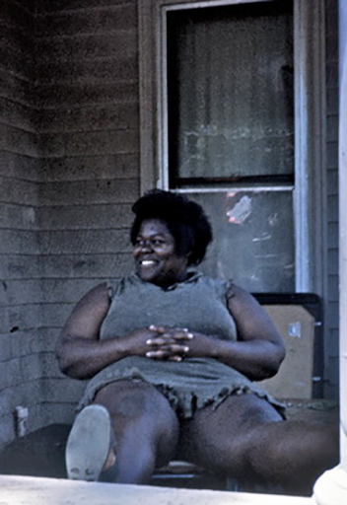  Pauline loved to show off her "pussy cat".  .
But right now I had to be faithful to Vicky, who pulled me onto the water mattress again the next morning as soon as her husband left for work. I hadn't told her that I had a crush on Marie, so when Vicky suddenly - after telling me about her arguments with Tom about me - out of the blue came up with the cocky idea that I could start flirting with "Black Marie" so that Tom could see that I had a relationship with her instead, - well, I felt knocked over again in her waterbed. "And you can sleep with her in here with us." It was like pure Southern racism during slavery, when the white plantation owner had sex with his female slaves early every morning and the refined plantation wife turned a blind eye to it, even though she would have killed him if he was "cheating" with a white woman. Because Vicky would have seen it as a betrayal of our relationship if I had slept with her white friend Krinchel. But she meant it and drove me out that night so I could cheer for Marie at the softball game with "The Black Merchants" she played for.

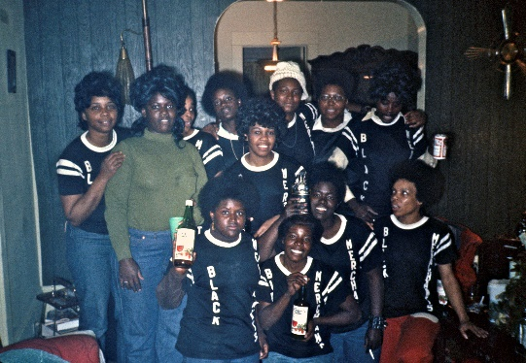  Getting drunk with Marie and the Black Merchants | 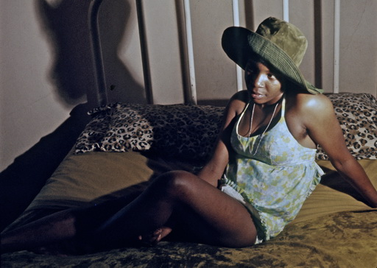  Marie getting hot in bed after the game

Then I went out with all the "black merchant girls" from Marie's team for wine drinking and then I sat with Marie at home and drank wine until 4am. Then we went into her bed, where to my disappointment she immediately fell asleep, which is why I went "home" so as not to be woken up early by her child - my eternal problem with black ghetto women, who already from the age of 15 always had distracting children. But shortly after 6am, I was dragged back onto Vicky's water mattress, where I was reprimanded for not bringing "Black Marie" home so Tom could see that things were serious between me and Marie. As Vicky's loyal guest, the next night I invited Marie in so early in the evening that I thought she wouldn't fall asleep right away, because now we had to seem convincing to poor Tom. So that he would see us together the next morning, I made a bed for us in the middle of Tom and Vicky's living room floor. We only drank a little wine and snuggled for a long time under the blankets and kissed a little. So great was my disappointment when Marie suddenly fell asleep again and before Tom came down the next morning, Marie had gone back to her room with her baby. And so it continued until nothing more came out of our artificially arranged relationship.
I kept returning to Tom and Vicky over the years until the abusive musician Tom married the more harmonious wife Cindy Hayden, from whom he passed away at the time of writing on December 5, 2019. But although the year after my trip to Guatemala I began to more seriously immerse myself in the ghettos, my ghetto immersion on a sexual level remained just as superficial.
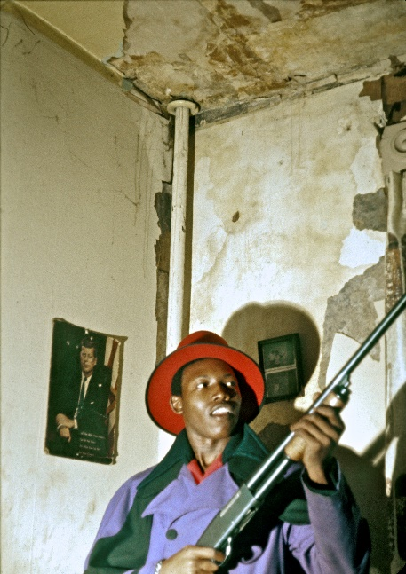  Both Elgin Bennet and Marie around the corner loved to pose for me | "Black Marie" was just as seductive when I returned the following winter
I had started hanging out with a couple of black heroin addicts at Elgin Bennet's around the corner from Vicky's house and photographed them in all their activities. When they fell asleep during their high, I'd sit inside their neighbor's house at 902 Orchard Pl and help sweet drug-free mom Orline on welfare stay afloat in this swampy ghetto area, taking care of her two small children while she went shopping. Slowly we developed a deeper connection, and I started spending the night in bed with her, again encouraged by Vicky - as long as I came home to her every morning. I actually wrote about this depressing experience in American Pictures, "It is appalling how early the blacks become addicted to this noise drug. When I lived with a young black mother in Jackson, 50 miles outside Detroit, I discovered that it was almost impossible for us to live together. When we went to bed, she would always turn on the radio. I would lie there waiting for her to fall asleep and then slowly try to turn the volume down, as it was otherwise impossible for me to fall asleep. But every time I reached a certain volume, her 2- and 3-year-old children would wake up and start crying, so I had to immediately turn the volume back up. I did this for two nights and then I had to move. We were simply, as the woman said, culturally incompatible."

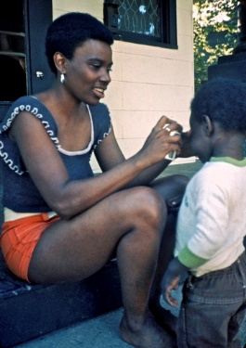 | 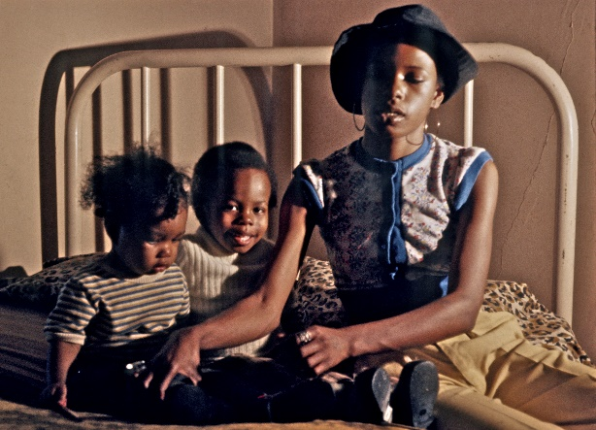  Orline and her two children
So I ended up being more "faithful" to Vicky than she had even imagined, let alone wanted. With her own infidelity, I wasn't sure where to draw my own decent boundaries. When she convinced her professor at her community college to let me teach one of her classes, it went so well that the female professor invited me home for dinner that evening and, after a lot of wine, convinced me to stay the night. Did this violate my principle of not getting involved in relationships with girlfriend's girlfriends? Or would it help Vicky get a higher grade in the course?

I had the same dilemma a few years later when Vicky and Tom had moved and the new white occupant, Martha Crumlish, of their house at 110 W. Morrel didn't know their new address. For Martha immediately invited me in for sex in her own bed after I assured her that she wasn't Vicky's friend - wonderful sex at night which didn't feel like the same waste of time as my earlier periods in the house. Now the only problem was that Martha was a Buddhist, so I had to sit and chant with her and her friends many times a day on the living room floor right where I had slept with "Black Marie". And since one of her friends was an astrologer and was born on the exact same day as me, she was convinced that we were made for each other after comparing our horoscopes. So she now had Martha's express permission to borrow me to try me out for a night. They were all so excited that it felt like we had excited spectators the whole night. I think the girl must have misinterpreted something in her star sign though, because the only thing I remember from the night of this "perfect match" was that we ended up practically running screaming from each other the next morning and that she was too embarrassed to report back to her friends afterwards.
But one thing I remember from this New Age group had a lasting impact on me. Because when they were doing a palm reading on me, they all concluded as one, "On your journey through life, you will always be given an extraordinary amount by the people around you. But if you ever misuse these gifts on yourself, it will be your downfall."
When they said this with enormous empathetic love and conviction, I took the words to heart, because I had already felt how I was carried around by the hands of people everywhere and therefore already began to feel obliged to pass on their surplus of love to the people in society who were not so favored. Both by developing the concept of "borrowed love" in my vagabond years as an ethical demand to pass it on to the love-starved in the ghettos - if only to avoid "falling" myself - and then the profits from American Pictures to poor countries.
My outreach to - or from - these Buddhists took place on February 20, 1973, and concluded much the same as the Bible quote I traveled around with from the Church of Glide, "He who loves his life shall lose it; and he who hates his life in this world shall keep it for eternal life. ("hate" is a poor translation from the Greek of "to lay aside one's life"). John 12:23-33.
It was about not being afraid of losing your life, because by walking around with fear and clinging to it, it is only then that you "lose it". By giving yourself to others, on the other hand, you find a higher meaning, even happiness in life, what Jesus wisely called "eternal life". It was this conviction that had led me to choose to go to my death, so to speak, in Guatemala, but since, as mentioned, I was not good at playing the role of imaginary revolutionary hero and instead had been constantly seduced by saving women on my path, my new "Buddhist warning" reinforced my basic feeling of having to give myself to the ghettos (no matter how dismissive and hostile they were towards me in their own sense of betrayal and rejection with the same defiant reaction we typically encounter in the abused child). If, on the other hand, I started running away from and "distancing" myself from life itself (with all the pain it entails for most people) by short-sightedly and selfishly giving in to all these alluring white women and throwing myself into hedonism, - well, that would be my downfall (for the sole reason that I would immediately lose the interest of these women).
Mao. it is important to understand - for myself and the reader today - that it was not to play the hero that I on the whole (feel that I) behaved decently towards these women. No, they gave me the help and "Buddhist life advice" to behave in such a calculated way by seeing them as trials I had to go through to find "eternal life" beyond the bedside. Only by not falling for their temptations (read trials) could I avoid "falling."

Considering it as "trials" sent from above shouldn't be that difficult if you objectively assess my situation. Many Danish women will probably be surprised to read this paragraph, as I hadn't had much luck with women before I came to the US. I was almost always the last one to leave Copenhagen bars in my youth - alone - after all the other guys had scored women to go home with. And in Canada, as I said, I was unable to find a girlfriend, just like in most other countries I've been to before and since. So what I've described here says more about American youth at the time of my wandering than it does about me. Therefore, hold your tongue - or use it generously in the right place - when I describe the madness I was now forced to survive in, but at the same time could not do without in the process of creating American Images - as a direct product of white American hospitality and love. (For the sake of sociological objectivity, I can also mention that with my hitchhiking sign "Touring USA from Denmark" I frequently ended up with Danish women who had moved to the USA, but they will all confirm that it never ended in a sexual relationship between us back then. So I'm not God's gift to women in general).
How much excess love I was the object of from white women in such small towns in the Midwest can be illustrated by the fact that in addition to those mentioned here, I had two more white "girlfriends" in the city of Jackson with its only 30,000 inhabitants in the 14 days I spent in Jackson's ghetto over the years. Namely Cindy Keagle and Mary Jo Prestler, while another picked me up to rescue me from the ghetto and took me home one night in the neighboring city of Brooklyn - but to my great astonishment did not do so to obtain sex with me. In my diary, I tried to explain this miracle by saying she was a Jesus freak.

Many of these women in this sexually liberated time told me in no uncertain terms that they used me precisely because I was a traveler they knew was moving on. Often, in such small towns, they didn't dare to get involved with local men for fear of not being able to get rid of them again and that they were too violent, especially when relationship crises came up. Conversely, I began to use the term "duty sex" to describe my relationships with them as an unavoidable part of my travel costs. Because it goes without saying that it was hard to live up to their expectations. Especially when they were sexually immature like the 18-year-old Jackson girl Mary Jo Prestler, it was hard for me to get excited about anything. I remember using the excuse with her that "I am always impotent when I lie with my feet outside little single man blankets like yours in such freezing cold rooms in winter." (Scandinavian goose down duvets were unknown).
The problem was even worse when, in the summer, I had to sleep with them in the melting humidity of the South's poorhouses with no blankets at all and only a couple of blowing fans into their heads. Not to mention a noisy, chilling, dripping air conditioning that they turned on even in the winter because they couldn't sleep without the noise. Over the years, I compiled a whole list of such hopelessly unsexy situations in which it was impossible to live up to women's expectations, such as "beds that sloped more than 15-20 degrees", rooms "with more than three smelly dog turds in them", "springs sticking up my back through the mattress", "rats at my side or cockroaches scurrying across my stomach all night long", "double rocking sailing on top of 300-400 pound women in waterbeds", "heavily intoxicated or drugged women or, conversely, myself", "more than one woman in the bed", "people distractingly fucking with overly loud enviable orgasms in the bed next to me and my own partner", "large drooling dogs in the bed that were jealous of me," "back seats of small European cars as opposed to big Cadillacs," "when I tried to lovingly hug the girl but bumped into cold guns under the pillow," "inexperienced young girls acting like virgins" etc. As for the latter, I preferred experienced divorced women 5-10 years older than me, who could teach me everything they wanted with initiative and self-confidence. You have to be really poor in spirit if you dream of going to a frigid paradise with 72 virgins when there are so many life-experienced single women walking around here on earth.
On the other hand, my many excuses about "cultural incompability" had the advantage of making it easier to get off the road without hurt feelings. Walk the walk or sleep the flight.
For a particular but important reason, however, it was about finding the natural balance point, which for me in each new city was preferably a week's stay. For me, a natural marriage contract was not about superficial one-night stands, but about one-week stands. Back then, it took three days to send a letter home to my parents and three days to get a reply back at the address (Poste restante doesn't work for someone who agrees to be seduced to new places and cities all the time). As a result, I did not agree to enter into a new relationship without the woman having or being able to get a typewriter. After that I sat from morning to night hammering away at long letters and articles and ignoring the woman, which probably made me even more interesting in their eyes in many places. In any case, I always had to be shown off to their girlfriends as their "Scandinavian lover", which I guess I became after a week or so when they finally frustratedly said "Let's go out and get drunk" to loosen me up a bit and get me to show some initiative - even in bed - where I then just as skillfully typed on with one finger.
This was especially true of the better educated, while the less educated, such as most of the girls mentioned here in the working-class town of Jackson, had a mentality with a much lower threshold. The difference struck me especially once when I hitchhiked wearily straight to the university town of Kalamazoo just an hour from Jackson and ended up with upper-class girl Virginia Ford from Michigan's wealthy Ford family. She was incredibly beautiful and attractive to me, but I mostly remember how she eventually started getting me drunk and sat naked by her swimming pool or the edge of her bed, making no secret of the fact that the juices were practically pouring out of her. But as much as I wanted to, and as much as she got me a typewriter and meals in expensive upper-class restaurants, for some reason I couldn't function. I remember how it knocked me out because in these luxurious surroundings I couldn't find any good excuses from my aforementioned "sex killer" list and therefore felt that there was something really wrong with myself. Maybe it was just a guilty conscience after all my "duty sex" in the working class just an hour away that gave me a sense of class betrayal. Maybe I feared "falling" by giving myself over to one of those sexism ads. In any case, I left the frustrated Virginia within a week, which is why she's one of those I haven't maintained a "relationship" with over the years as I never quite got it together, so to speak.
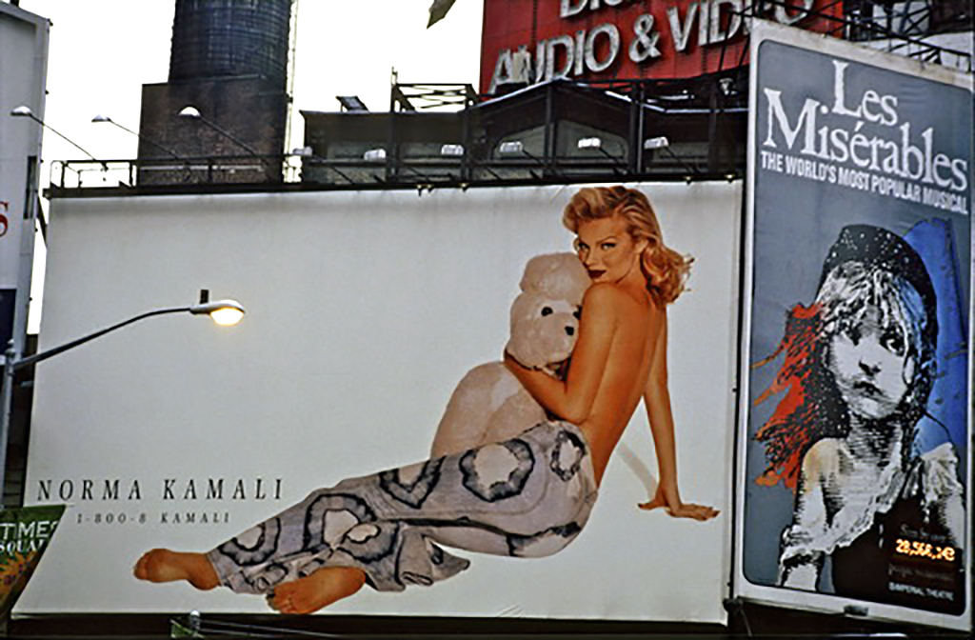
My constant attraction to and attempt to integrate the beauty and the beast.

THE BEAUTY OF SAYING YES .....
.... TO WOMEN I SAW NOTHING BEAUTIFUL IN

I also enjoyed living with women for more than a week for other reasons, as we mutually started to develop feelings for each other and a little more loving intimacy. Especially when I had ended up with women I had neither "seen" nor been interested in in any way, I felt that it always ended up being a great happiness to try living together for a longer period of time as a married couple - as opposed to the feelings of emptiness and superficiality I had usually experienced after drunken one-night-stands in Copenhagen's nightlife. I felt privileged to slowly learn to see the beauty and love in the people who, in the oppressive beauty indoctrination of sexism, had hitherto remained in the dark to me; the angular, crooked, flat-chested, hysterical, limping, introverted, phlegmatic, anxious, smelly, unpredictable, suicidal, psychopathic, violent/violent and downright insane. Oh, how I loved falling in love in a short time with, for example, their awkward limp or when I managed to get the most neurotic to calm down and appear completely normal even outwardly among their friends - if they had any at all. Fortunately, in the crazy world I already inhabited - especially in the darkened psychopathology of the ghettos - there were only a few I currently perceived as outright mentally ill. It was only by following them over the years that I realized that some of them had also been mentally ill during "our marriage" and that maybe that was why we had been "forced" to marry each other.

In most of these marital relationships, we had equal duties in the relationship around cleaning and cooking as opposed to the service they insisted on when I was a short-term guest. In fact, I remember much of my vagabond days as the pleasure of being the man of the house, sleeping late after my "wife" left for work, then writing diaries and letters and washing dishes and cleaning, and only in the afternoon, when the men of the street woke up, going on ghetto visits and hanging out with them - often so long on their raids that I was late for dinner - and therefore breaking our unwritten marriage contracts. In cities like Baltimore and Washington, where I concentrated on gangs and drug addicts, who were difficult to live with also because they were in and out of jail all the time, I typically stayed with white women nearby, while in large ghettos like Detroit, Philadelphia and Chicago, I stayed with black families and students. My lifelong relationship with gangster and drug addict Alphonso Makell after his gang tried to rob me in Baltimore, I covered for four years from the safe homes of four different white girlfriends in the neighborhood such as Cindy Choksky, Carol Simonsen, Leona Smith and Janet DeKenis. Some of these white women were so terrified of the criminals I hung out with that they would leave their guns at the door when I came home late.

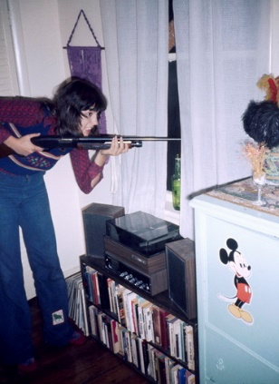  Frequently, I stayed with the ever-armed Leona Smith in Baltimore | 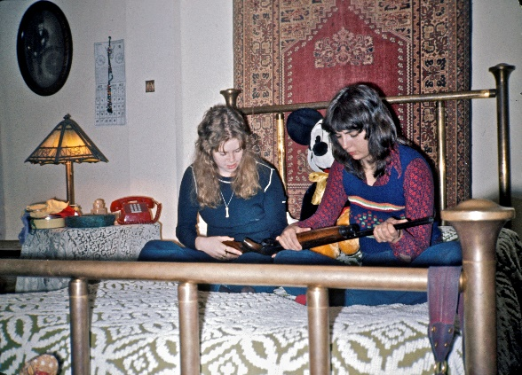  Somehow, I trusted the guns of Alphonso's gang more than the shotguns my terrified white girlfriends left at the door when I was late
Achieving long-term relationships with many of them feels like a miracle in itself in a country without a population register. Too often I had to change my home base when I returned and those like the aforementioned Vicky Fuller had suddenly moved without being able to give me a new address on the road. Even back then, Americans did this on average every four years, but young people much more frequently. Over the years, I spent a lot of time tracking them down when they had moved. That's why I made it a habit to always write down their parents' address, and that's also how I found Vicky Fuller, who in turn helped me to get good pictures from racist America. Because once I found her parents in the suburbs, they were armed to the teeth with rifles and pistols for fear of the "niggers", as they said. It became one of my best and since then most exhibited pictures in museums, but I remember how I inwardly laughed at them because I came straight from Orline and the criminal black drug addicts and gangsters with almost as many guns and therefore did not understand their fear of the ghetto - a fear I had long since unlearned myself with the help of their own daughter Vicky. She had, as I have often experienced, reacted against her racist upbringing by going in the opposite direction and moving into the ghetto and supporting the black struggle - or at least supporting people like me who did. So without such brave, self-sacrificing white women, I couldn't have made American Pictures.
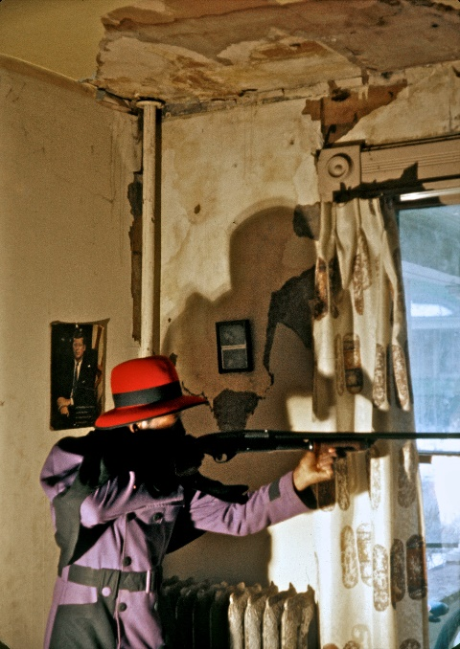 | 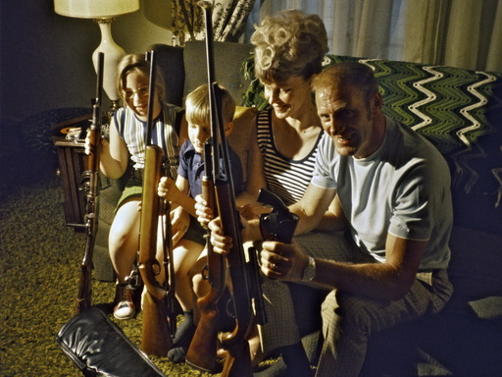  I ranged from the heavily armed Elgin Bennett in the ghetto to Vicky's terrified parents in the suburbs of Jackson. Both photos were taken with the 500-watt bulb with the yellowish lights that I lugged around in the days when I couldn't afford to repair my flash
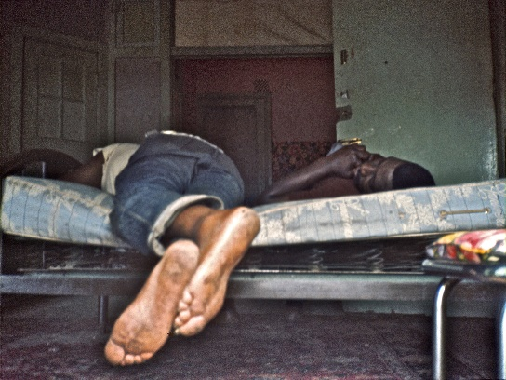  Thanks to Vicky Fuller, who wanted me to hang out with neighbors Orline and Elgin's drug addicts, I got these shots of them sleeping off their heroin high during the day. |  | 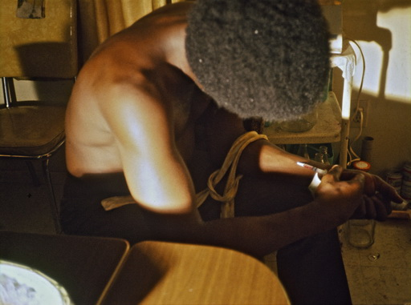  I know it gave Jackson's addicts the confidence that I wasn't a police officer when I would drag myself into their house at night with my giant 500-watt bulb with a long cord trailing behind me to photograph them.
My "fear of falling" probably helped to gradually change my previous concept of beauty, but I had always intuitively lived up to my pocket philosophy of "moving in with those we are prejudiced against."
From one of the first days in the country, I had felt and been annoyed by my prejudices towards overweight women when one of them, Rosemary Deaver, invited me to bed. I felt a little cheated when I hitchhiked into the crowded streets of Chicago on that freezing winter day on Saturday, January 16, 1971 and a couple of hot young hippie girls invited me to spend the night in a since demolished back stairwell behind 1816 N. Mohawk St. in Chicago. Mohawk St in Chicago. But it turned out they were just "crashing" at Rosemary's, so after we had consumed some mescaline and listened to loud gunfire in the street outside, they took off in terror. Suddenly I found myself in Rosemary's strong and insistent embrace on top of her, where she comforted me in my fear of the shootings outside that I was safe with her, "because my husband is a police officer and is out there all night fighting those thugs." Indeed, as I sailed around on her safe ship all night long, I said a silent prayer that the shootings would just continue, so that her husband wouldn't unexpectedly come home and find me in the - as I saw it at the time - unenviable missionary position. Her 15-year-old equally fat sister, Pat, stayed up all night wanting to kill herself because that night she had broken up with an abusive father of their two-year-old boy Alexis, who was wailing in a crib next to me. This last part was probably the one I used most in my own head to explain my impotence, although in my diary I also tried to find mitigating factors in the situation, "I slept with her even though she stank of perfume, but she had beautiful black hair." I'm glad for this last part of the sentence, because it was by always attaching myself to something beautiful and closing my eyes to everything else that I eventually learned to see the beauty in this lazy white underclass and simply to love it and overcome my prejudices. Also by realizing over and over again that it was usually to reveal painful statements about childhood sexual abuse that they had opened up to me as the stranger I was in their lives. Rosemary cried and was genuinely sad to see me go the next day - the day when, in no small part due to her hospitality, I was rewarded by meeting my first lifelong black girlfriend, Denia Lewis, a short distance from her house (described in detail in "Saying Yes to Black Women", but true to form with black women, it was nonetheless a non-sexual relationship for life). So when the night with Rosemary Diaver had shaken me to my core to see a deeper white pain here in abundant America on one of the first days after my arrival from Canada, I promised her I would return. I kept that promise many times over the years, including once by housing a carload of hippies I had hitchhiked with from San Francisco in her embracing safety behind the long arm of the law.
My incipient rejection of the lost and unrealistic ideal of beauty I had arrived with... | 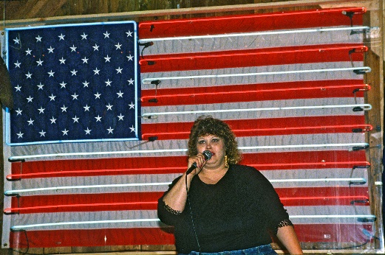  .... slowly gave rise to my increasing integration with and infatuation with the real America of obesity

The more I learned that many of these - as it sometimes felt - "sexual assaults" on me were in fact cries for help from a love-hungry, abused underclass, the more I felt obligated to try my best to pass on some of the love I myself was the object of everywhere to them. And therefore I also noticed how I now began to discriminate against - to be prejudiced against - those I had previously seen as beautiful and desirable - e.g. rich upper-class girls like Virginia Ford and Marly Sockol - for fear of selfishly "falling for" and clinging to them, which would "be my fall". Therefore, whenever I sensed that it was about to happen, I ended up burning the bridges behind me. In American Pictures, for example, I described in the chapter "Between Eloids and Morlocks" how I literally stood up my millionaire girlfriend, Mici, an heiress to the Schlitz breweries, by emigrating across the bridge from her protected, police-guarded private island for the rich only. She wanted to marry me and have a child immediately. Madly in love, for a while we both believed in this elusive relationship. It wasn't until I left her pregnant that the hostile blacks in the local ghetto, who had nearly killed me and caused me to flee into her safe arms, opened up to me and became a part of me. Before that, she gave me her credit card so she could drive around and photograph the poor blacks in the remote tobacco fields while lying on the beach. As mentioned in American Pictures, our relationship broke up and ended with an expensive abortion in Ecuador. "Never mind, I have enough money, I can have an abortion anytime," she had said to my relief. I tried to keep in touch with her throughout the years of lecturing, but her mother sadly told me that she committed suicide on October 9, 1990. As, incidentally, did another of my millionaire girlfriends later.
My only picture of Mici. It was typical of me that I almost never photographed the white people I lived with while she lent me both car and credit card so I could drive around poor East Carolina during the day and photograph the black people | After her suicide, I found this picture of her to better remember her. I never found out if she read the chapter about herself in American Pictures
THE CHILD OF PAIN SIS THOMAS - ALSO MY WHITE BRIDGE BUILDER TO BLACK PEOPLE

That's how white women - both rich and poor - everywhere were bridge builders for me to the hostile black community. Because blacks, especially in the South, were extremely closed and hostile, the majority did not want whites living there. Even Tony Harris, who ended up becoming my lifelong speaking partner, had never allowed a single white person into his house in Greensboro before I moved in with him. Only the daily love I received from white women - their borrowed love I carried within me, I feel, was able to give me the energy I needed to open up to black people. (My old Danish friends don't remember me as a very outgoing person). Without that love, I would have broken down mentally. The white women serviced, fed and transported me to and around the ghettos.

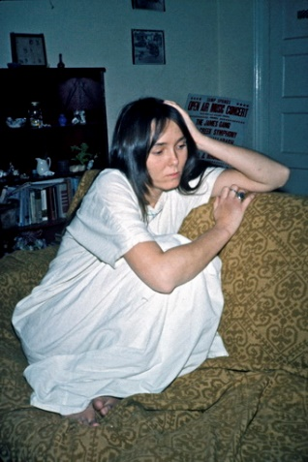  The only picture I took of Sis Thomas in the hobo years, although I took numerous of the city's blacks | 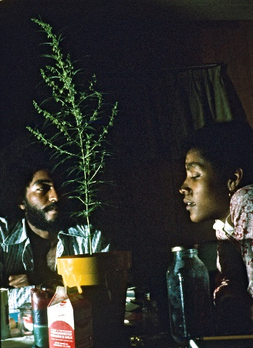  Tony Harris and one of his favorite girlfriends, Piere, by the marijuana
A prime example was the poor white junkie, Sis Thomas, who picked me up and took me home in Greensboro whereby I met Tony Harris and, through his popularity, almost the entire black community. Every time I visited Tony Harris and the ghetto since then, Sis would take me to and from the highway in his flower delivery truck. But I probably exuded more flower power than black power. I felt compelled to stay at her place at least one night every time, which I tried to avoid because she was shooting heroin and I would hitchhike halfway across the US just to stay with Tony. He was surrounded by beautiful black women from university and was always trying to get his excess girls to take me under his wing. But not once in all those years did I manage to pick up any of them, even though they paid me a lot of attention. Sometimes they even shared a bed with me at Tony's, but only to get closer to the handsome and charming Tony.
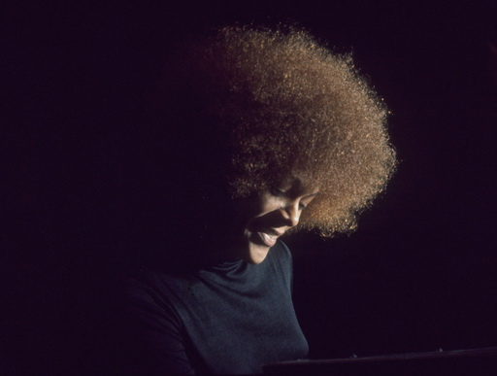  Alfrida, as a friend of Piere, was the one I spent the most time with - even when they smuggled me into their heavily protected Bennett College for black women only. But every time she invited me over, she had to do her homework "before we party". I eagerly helped her write assignments, but even though we spent the night together at Tony's house - away from Bennett's social control - it never amounted to anything else. She wanted to do more, but with her inherent social control, I think she was afraid that word of Tony would spread throughout the city. | 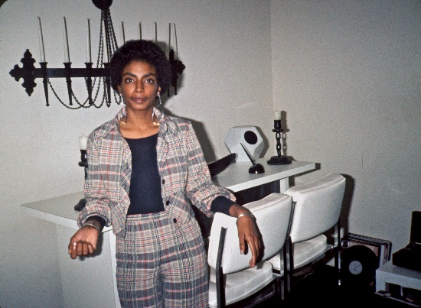  The car is indispensable in the American dating game. As a hobo, I could only take my dates on hitchhiking trips. I managed to lure Angela here from Bennett College on "a romantic hitchhiking trip to New York". But no sooner had we left Greensboro than we were picked up by a well-oiled black lawyer who turned her head about "sticking to your own race". He invited us to his house here in Chapell Hill, where he kept my now brainwashed Angela, leaving me dejectedly calling Sis to take me "home".
Sis was the only one who really cared about me and would often drop by and hang letters on Tony's doorknob "To my Danish pastry." As she wrote to me 37 years later, "Every time you came through Greensboro, we would find each other, have a great time talking, drinking a bottle of wine. When you came, I splurged and bought Mateus!!! The next morning, I would take you to highway 9 usually in the cold or in the snow in the flower truck or back to Tony Harris' house. I was just a skinny hippie girl with a gigantic crush on what my neighbor called my Danish Pastry."

But everything in Sis Thomas' life was a cry for help. After childhood sexual abuse, her open wounds continued to bleed throughout her life. She didn't tell me herself, but I knew from the black drug dealers I hung out with in Tony's father's ghetto bar how they sexually exploited her when they sold heroin to Sis. They referred to her as "a dry fuck". I should have defended her frigidity to them by saying that it wasn't my dry experience, but probably only when she felt raped by them. But I didn't - maybe out of shame that I had to have a relationship with her or maybe because I didn't want the black women in the bar to think that I preferred their company for sexual reasons. They were all drug addicts and prostitutes themselves, and I often spent the night with them, for example Geegurtha, who is well-known from my book, see "About saying yes to prostitutes". As a client, Geegurtha Pennix was so impressed by my lecture for black drug addicts and prisoners in the rehabilitation clinic where Tony taught that she invited me home.

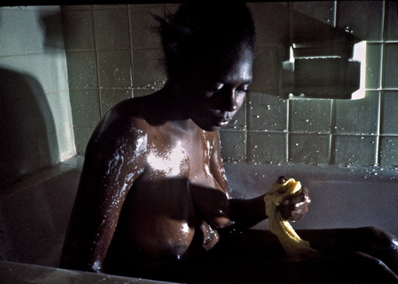  It was Geegurtha's devout Christian sister, Georgia, who persuaded me to move in with Gee at Gloria's house as part of her rehabilitation after years of abuse as a drug addict. As the photos show, we practiced all the near-love and near-intimacy with each other that her therapy now allowed. Georgia took the photo of us in bed, which we shared with Geegurtha's 5-year-old daughter Tania for a week.  . | 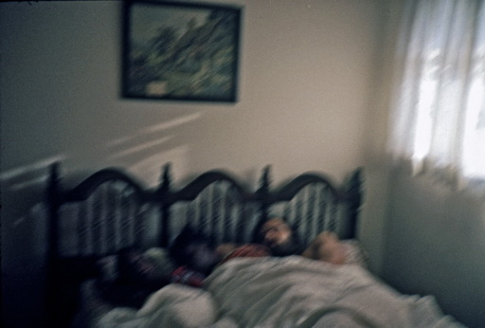  On the Sunday morning before church, Gee's mother in her big church hat was furious to see her "sleeping with a white man after all the white men who ruined your life?"  Gee just laughed at the sanctimonious mother, whose betrayal of her as a child was probably a common thread to her own betrayal of Tania through five years of absence with white men. Tania was born a heroin addict, but was saved through blood transfusions.
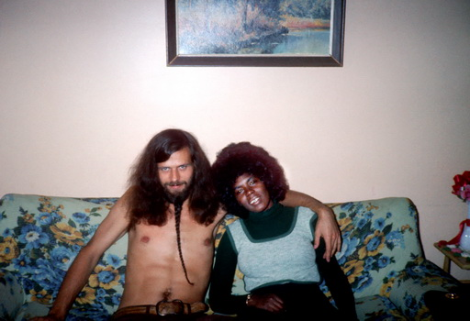  On Gee's dress, I can see that this photo was taken on Oct. 13, 1973, when we hitchhiked to a movie theater to see "Save the Children". A black woman recognized Gee as a former hooker and stopped to scold her for dating a white man again. | 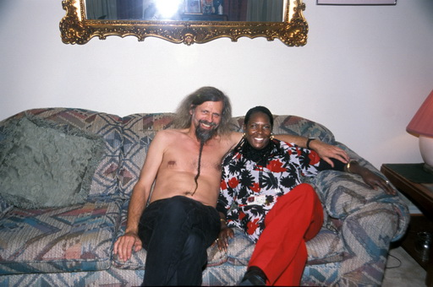  Exactly 30 years later, Tony recreated the old image during a Thanksgiving dinner at Geegurtha's house in 2003, by which time they had both moved to Atlanta. Tony had helped rehabilitate her back then and was now a nurse. She died only a short time later.

To add to the sad irony, when the agreed upon week with the ex-drug addict Geegurtha was over, it was the drug addict Sis Thomas who came and rescued me to Tony's house in her flower truck while I did nothing serious to save her in all my black obsession.
So I really felt like I let Sis Thomas down in her distress even though I couldn't have helped her in my own sense of being a louse between two nails. In my shame I also tried to avoid her so as not to be stung by the lice in her apartment even though she tried to straighten up her life a little for her Danish pastry when it stung her. On October 5, 1973, for example, I wrote in my diary, "She had taken heroin again that night, but said she couldn't feel it. Told me that she had now had the house sprayed for lice because of me."

She spent the rest of her life living a downright shitty life in Tampa, Florida with an abusive drug addict in a rotten shack, but followed my later successful life as a speaker from a distance. Shortly before her death, she found out I was speaking with Tony in Atlanta and contacted me to ask if we could get together one last time. She got her brother to pay for a plane ticket all the way up to Greensboro, which suited me fine as I was picking up my wife the next day in Charlotte in the same state so we could visit our daughter at her university in Asheville. However, I was nervous as a tornado was forecast for Greensboro that night.

It was wonderful, but at the same time shocking, to see Sis as a sick old woman with a walker and almost unable to speak after a blood clot. Her better-off brother told me privately how much it meant to her to be with me again. He entertained us with drinks and good food all evening and gave us his best room with a raised four-poster bed. But it was a night I won't forget. After she had consumed a huge arsenal of pills for all sorts of ailments and pains, I had to lift her up into the elevated bed. We hugged and kissed each other and it also meant a lot to me to thank her in this way, "without you, American Pictures would never have been created."

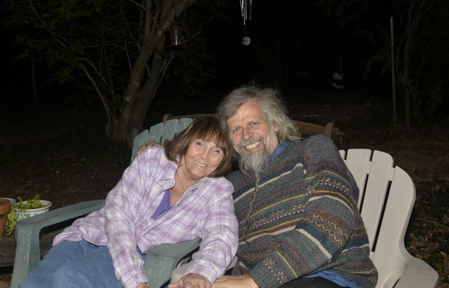  It was a warm reunion and we sat in the garden for a long time waiting for the tornado | 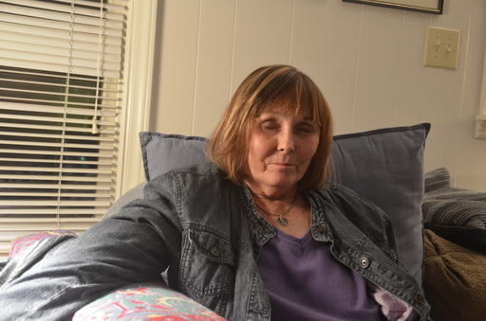  While in the old days I had frequently seen Sis dozing off on heroin, it was now morphine and pills that made her sit and sleep for long periods during my short visit

But just like 38 years before, I had another sleepless night with her. On the one hand, she insisted on having the air conditioner on - noisy and freezing right in my face - in order to be able to sleep. And secondly - and far worse - on the night of April 16, 2011, the largest tornado in North Carolina history passed right over our four-poster bed. Soon I feared I could see straight up into the sky from it, as roofs and trees were ripped open all around us. I thought for several moments that we were going to die together like that and was almost annoyed that Sis was so doped up on morphine pills that she slept through the whole thing, so we couldn't rejoice together that we had finally gotten each other - in death. Nothing could be more beautiful than dying with your saving angel in your arms.
Especially during tornadoes, you often hear about saving angels. In fact, even the New York Times reported the next day that a donkey near us that night was lifted up to heaven and miraculously set down in a field 12 miles away, where it was found grazing peacefully. It was therefore in every way a tearful and life-affirming experience as we said goodbye to each other the next morning in mutual gratitude before I had to wind my way through fallen trees and houses to pick up my wife at the airport.
Sis insisted I remember her without a walker, which is why I took this picture before bed. In her drugged state, she seemed in many ways happier than I remembered her from the only picture I took of her as a young girl. | 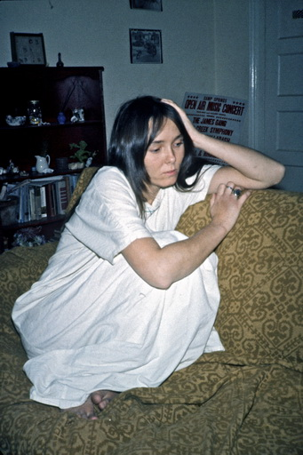

I had thought Sis would die very quickly after that, but it was actually two years before that happened. She was born just 10 days before me, but despite being the same age, our fates couldn't have been more different.

When Sis got my book at some point, she wrote to me, "Reading your book brought back all these vivid memories. Now I have to try not to read very much of it before i go to sleep, for sometimes my hands shake when i start to read it. I can't hold the book. How brave you were to put yourself or rather end up in such frightening places in your body and your heart. I knew you were going to be a great writer, humanitarian, you cared more than anyone I have ever met. Thank you (I think) for helping me to remember my past. Now maybe the future won't be so scary to me."

But she forgot that she herself helped create my book by ferrying me into all these "terrible places" and forgot that she herself was in an equally "terrible place" in the midst of a darkness of the soul that continued throughout her life, "I've fought depression most of my life". And that she did it because she perhaps saw me as the only lifeline in the ocean she was drowning in.
And I, for my part, forgot to care about her as much as I did, for example, the drug prostitute Geegurtha and many other black drug addicts in the city that I hung out with or taught at the local Drug Action Council for prisoners - people I had met with Sis' help. Our Løgstrupian dilemma was a two-way street: whether to sacrifice oneself for the other out of a sense of duty, at the risk of crippling the relationship because the other person is left with an impossible debt of gratitude.
For me, I probably forgot because Sis was white and did not ideologically fit into my image of "the oppressed" at the time - i.e. into my entire ego project.

Afterthoughts for this chapter on Sis Thomas.
When the first volume of "On Saying Yes" was published, a female reviewer wrote, based on the few women I mentioned in it, that Jacob has undoubtedly left many broken hearts, even though the time was different and love was "free".
I wondered about this, as it was not my own impression from my conversations over the years with my old girlfriends.
But when I relived Sis Thomas' idolization of me, I have to admit that in her case it could be the case. And also that despite my self-recrimination above, it could easily look like I was grossly exploiting her by selfishly using her as a driver and sex partner in a situation where all the black women turned their backs on me. As I struggled to face myself after trying to describe our relationship in such an honest but one-sided and generalized way, I realized that it was partly due to my usual tendency to protect black people. The truth was, as always, more nuanced.
For one thing, I was used to being able to get in and out of cities easily and to walking long distances, and I could easily walk the 2 km from Tony's house on Lutheran St to East Gate City Blvd, from where hitchhiking was a breeze, and I also had Tony to drive me to and from the highway.
When I let Sis drive me sometimes it was to make her happy and to give her recognition after my first visit, as we had had a fairly regular sexual relationship with each other for one night. Since she knew full well that I would rather stay with Tony and the others in the ghetto, I didn't want to get her hopes up by staying more than one night with her every time I returned to Greensboro.
And here we come to the more embarrassing side of the story, because from the moment I found out in the ghetto that the black dealers were sexually exploiting her in exchange for providing her with free heroin, it was completely unthinkable for me to have any kind of penis-based sex with her. It was a firm principle for me to never have sex with white women who - perhaps to ingratiate themselves into my black mindset - would tell me that they had recently had sex with black men. It sounds a bit racist, but in this tension between black and white, everyone knew what the facts were: if you went to STD clinics, there were almost exclusively black clients sitting on the benches. So "free" and safe sex in the liberated 70s only applied to whites, while blacks had the double-edged sword so far up their sheaths that they had already reached the unfreedom and anxiety of the 80s (where, incidentally, they were once again far ahead of whites with AIDS). For the same reason, I was only interested in relationships with highly educated black girls from, say, Bennett's College, and not the less enlightened underclass (which is where I mostly hung out), which was probably one of their subconscious reasons for not wanting to get into something so risky with me that wouldn't lead to anything lasting anyway.

So people have often asked, "Well, why didn't you just use condoms?" I never did in those 6 years on the road. Partly because I couldn't afford it, which is why it's also interesting that none of the women I was with demanded them or even had any lying around. Again, it illustrates the incredible "freedom" and carefree attitude we enjoyed in the 70s. Because it could be that I saw the same women quickly learn to protect themselves in the 80s. And partly, but more importantly, because I felt that simply bringing a condom as a traveling guest would make me appear too calculating and selfish by signaling that I wanted old-fashioned hardcore sex when what I mostly just wanted was a place to sleep or maybe some loving intimacy.
My aforementioned "fear of falling" if I started to take advantage of the gifts given to me along the way can therefore be read quite literally if or when a date even brought up the topic of condoms and instantly made me "fall". 😊
For the same reason, I trained myself to never ejaculate when women wanted more of what to me was experienced as "duty sex" - partly out of fear of getting them pregnant and partly to save this best, most lustful and sacred thing until one day I hopefully ended up "falling" for "the one and only."

It is against this backdrop that my relationship with Sis Thomas should be seen. I don't remember if we even had missionary sex that first time, but I know that it wasn't what she was looking for in our relationship as her traumatized reactions to the thirsty point were just like Geegurtha's and other prostitutes I have lived with. Just as I wouldn't have been able to go through with it with my acquired knowledge of her sad black reality, of which she was so easily victimized. Because when I heard so many black drug dealers talk about how they exploited her, some of whom I lived with and who are still my friends today - well, it goes without saying that all it was all about when I was with Sis was trying to give her as much loving intimacy and tenderness as I could possibly muster as a male messenger for the love I myself, through my empathy, was the object of from the men of the ghetto. Incredibly, one of the men who abused her in their transparent revenge against white society, like the rapist Eldridge Cleavers in ”Soul on ice”, ", and who even used the misogynistic hateful expression "a dry white fuck" about Sis, is today one of the city's black recognized psychiatrists (and it wasn't Tony, who, as mentioned, in his own time and place-specific hatred, wanted nothing to do with white women).
So, given this racially charged background, it wasn't so difficult to give yourself to an abused woman when, as mentioned, it was done for selfish reasons spiced with a touch of lice and heroin, simply to avoid regular sex.
And conversely, when, like Sis, you were only used to being exploited through hard, racist sex - and I was undoubtedly the only person she met at the time who represented something different - it didn't take much for her mind to mistake my attempts at comforting affection for something resembling true love in the desperate search for love she was in the middle of her dark hell. In that sense, I probably "broke her heart" in the human-crushingly heartless black-and-white historical intersection we met in - just 13 years after the epochal sit-in riot against white hatred in Woolworth just a block from her house. Psychologists will surely point out the dangers here of "shutting such a person up" and not being able to shut them up again afterward. But what choice did I have?
Ideological blindness, as I called this damned complimentarity principle in my book, because I could easily see these very problems - this hypocritical flaw - in others who end up portraying themselves as or being recognized as "saviors".

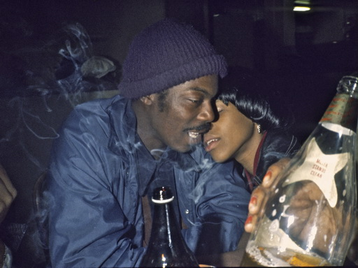  Some of the friends I hung out with at the ghetto hardcore joint, "The Grill", owned by Tony's father. | 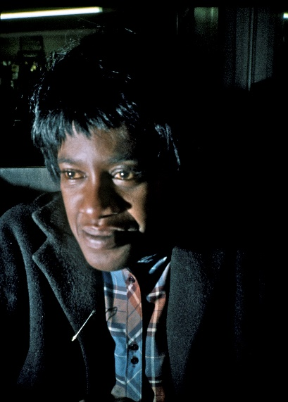
THE BETTER-OFF WHITE WOMEN

Part of this blindness includes not seeing how I may have unconsciously and hypocritically favored the better-off and educated white women - despite my fear of "falling" - over the poor ones like Vicky Fuller, Rosemary Diaver and Sis Thomas with their constant cries for help from the edge of the bed. For many of the better-off were more compatible and better at providing me with the security and intellectually stimulating calm I needed on the road to write and think through my experiences. But even with them, there were challenges that continued to spark throughout my life.
A good example was Sarah Snow in New Orleans. I had just the day before said goodbye to a former girlfriend, Sharon Lee Holland in St. Louis, and had hitchhiked all night with two girls to see Mardi Grass in New Orleans. They dumped me late one night in a dirty, seedy gay commune, but the next day - Saturday, March 3, 1973 - my saving angel came to rescue me. It seems to me today as if it all came from above, because it should be remembered that during Mardi Grass, the streets, hotels and homes are packed with tourists from all over the United States. You can barely elbow your way through the masses. So as I stood among the thousands on Canal Street and must have looked deadly dull among all the colorful costumes, reaching my hands to the heaven of mercy to catch the colorful beaded wreaths thrown down from the floats like the other mortals, - well, then suddenly out of the blue a wonderful white woman came running up, hugged and kissed me. Sarah Snow was out partying with some friends from library school, and from the description, you'd probably think Sarah was one of the usual easy-going women who threw herself at me. But no, April, one of my friends immediately told me that she had never seen "nice conservative Sarah" act so wild and uninhibited before. They were speechless, and it turned out that Sarah was so nicely brought up here in the deeply conservative south that she didn't have the courage to drag me straight home in front of her friends, but instead dragged me around by the beard while I tried to wear the cape on both shoulders so far into the morning that she got both them and my big black cape shaken off. And then I moved in with her on the most attractive street in all of New Orleans, 809 Bourbon St., the street with the jazz clubs where everything was happening in the middle of the old historic French Quarter. But since that particular street is known to be filled with noisy tourists sailing up and down it 24/7 with their "hurricanes", the best thing about it was that she lived in the back in one of the quiet romantic backyards with palm trees and fountains. Here she had a wonderful apartment with a veranda on the entire first floor of the old slave quarters. It was truly like entering heaven right after the cold I came from the North, so when Sarah had borrowed a typewriter from a friend at Loyola University the very next day (which I frequently appeared in as a lecturer many years later with the pictures Sarah helped me take), well, I immediately decorated "my new office" as if I was going to stay here forever.

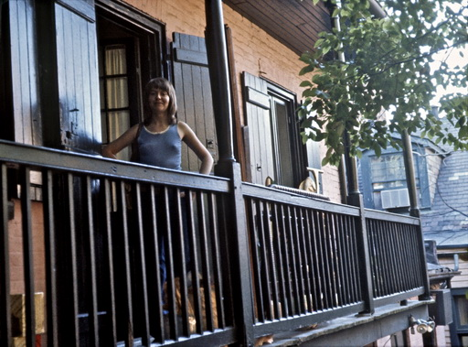  Sarah on our first-floor balcony in the old slave quarter with palm trees in the courtyard | 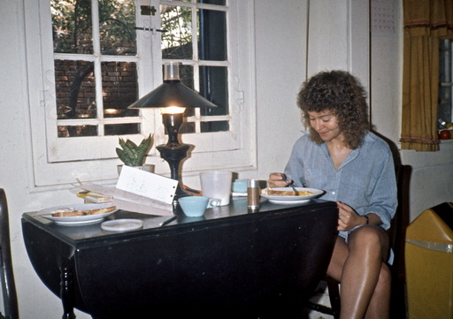  Sarah at our dining table in the living room where I often sat all day long hammering away at my typewriter
For Sarah and I really fell in love with each other, it seemed to me for once. She was from an enlightened and wealthy family in the heartland of conservative Alabama. Her father, Jack Snow, traveled in Asia for the World Bank. Her mother was from a wealthy, enlightened family, but called their black maid "colored". Her grandmother protested wildly when Sarah started wearing curly hair, "because it will make you look like the niggers" etc.

But the times were changing, and with Sarah I began hitchhiking around the old "Gone with the Wind" plantations and through her I found the sugar cane plantations with blacks living under pure feudalism that I described in American Pictures. Many of the black communities were so closed and fearful of whites that I would not have been able to cope psychologically without her safe home base. She was also with me the day we visited the lepers in their special hospital.

But I began to feel guilty again about my luxurious life and more and more frequently took trips on my own, finding black shacks like Virginia Pates far out in the swamps to spend the night in. Because my recurring problem with girlfriends who randomly invited me into their lives during my vagabond years reappeared. Often they had an even more beautiful, intelligent, sexy or exciting friend who I swung even better with. And Sarah had a college friend from Alabama, the four years older and more mature Judy Caruthers, who I fell head over heels for. Unusually beautiful and outgoing, she sang and played piano, flute and guitar in public in the city and surrounding states. I loved Sarah endlessly, but Judy had it all and all three of us knew she was the one I should be with instead.

But to survive as a hobo, you have to have strong moral principles. Intuitively, I knew that if I started to betray and violate the hospitality people gave me by giving in to the impulses of the moment, I would end up on a slippery slope that would eventually manifest itself in my character and charisma. I had long since become completely fanatical about adhering to these ethical kingdoms. And they were precisely what the warm relationship between Judy and Sarah and me suffered from. My embarrassment at not being able to take my eyes off Judy - and vice versa - when we frequently met for coffee or dinner, meant that in my heartache I had to go on longer and longer "unwashing chastity journeys" into the ghettoes of the ghettos, which probably only made my pictures from there all the more inspiring and their image of me all the more mysteriously alluring. In my guilt, I couldn't even bring myself to photograph Judy's beauty. I wanted to keep them both (which I ended up doing for the rest of my life), but in their conservative Southern eyes, I had to make a choice (which I'm notoriously incapable of doing with my tendency to think of women as my pickle jar water trophies, "hey, I'll be back, see ya").

I had been following the Indian battles at Wounded Knee with Sarah every day in the media and was now using this uprising as an excuse to break up with Sarah and Judy after almost two months of staying. On April 24, I said goodbye and hitchhiked the 1,500 miles in the snow in just a few days to Wounded Knee's supply camp, where I again had to choose between two people in love with me, this time a grieving Indian widow and a gay Indian leader, as described in my book.
As I said, I always returned, but Sarah had unfortunately seen my departure as a breakup, so when I finally returned on December 5, she had found another girlfriend, so I now had to sleep in the living room.

Now, I had a free hand with Judy Caruthers, but the point of this section is that I always maintained my principles afterwards and felt that it would violate Sarah's feelings, our previous loving connection and my own integrity if I moved in with her best friend instead. So every time I returned to New Orleans since then, I decided to live elsewhere and simply meet Judy in the city. The feelings between us didn't diminish over the years, however, and even after Sarah got married, I remained faithful to her - even during the many years that Judy was working on her doctorate in Madison, Wisconsin - a city 1,000 miles north where I frequently lectured in the 1980-90s. However, even at this distance - and over 20 years later - Judy and I continued to maintain a flirtatious (non-sexual) relationship and to toy with the idea that it might be us one day (even though Judy knew I was now married in Denmark).

But it wasn't us! Because when I came to New Orleans on my lecture tour in 1996 with the Norwegian author, Eli Saeter, in the car, Eli wrote about this depressing experience in his later travel book "An American Journey with Jacob Holdt". Here I called Judy Caruthers to meet her again, but for the first time she said no, "You will never see me again. The next time you come, I'll be dead." She had terminal cancer and was so badly affected by chemotherapy that she didn't want me to come to say goodbye. She wanted me to remember her in all her beauty. We said a silent goodbye to each other and both shed a few tears. I was completely distraught when I told Eli about my long-term relationship with Judy at the breakfast table. The pain of love often becomes excruciating when you delay relationships for so many years, and I've often cursed my rigid old hobo principles of saying yes - especially when, as with Sarah, that yes means saying no to others! Our last conversation took place as the Mayor of New Orleans proclaimed a special "Judith Caruthers Day" in recognition of her importance to the city, even though Judy lost her battle with cancer 5 years later.

But this, my "faithfulness" to Sarah throughout her life, may have borne some fruit after all. On the fall tour that same year, 1996, I wanted to drive down to Baton Rouge to visit Sarah again after a long time. But wise beyond my years, this time I called first from a nearby restaurant. The first time I visited her and her husband Tom was in 1978 to give her my book, which she had been so instrumental in creating. I had driven all night to get there in my eagerness and therefore slept in the car outside their house to catch them at breakfast on Sunday morning just before church. But Sarah had now become the archetypal Republican, churchy type with her hair up, and as I had never met her husband before, she was so embarrassed that he had discovered that she had been in a relationship with another man before him that she hid in the bedroom for the entire visit, so I ended up just sitting and chatting with her understanding husband. He - Tom Gillis - was, oddly enough, now a consultant at the very same leprosy hospital in Carville that I had hitchhiked to with Sarah five years earlier. It had surprised me that there were so many lepers in the United States and that we could freely give the patients "a hand" and look them in the eye with the prejudices I had from my father, who in my childhood had collected for India's lepers - at a safe distance. Now I ended up talking to him mostly about lepers while Sarah - unlike them - remained both "untouchable" and invisible tucked away in the bedroom quarantine, which had not been the intention during my attempt to hold on to an old girlfriend. Of course, if Sarah's reaction had been typical of my visits to old girlfriends, I wouldn't have surprised her like that, but luckily I usually get an overwhelmingly warm reception. Not least from their spouses, with whom I have often become better friends later in life than my old girlfriends.

I didn't want to embarrass Sarah again, so when I wanted to see her 18 years later, I first called to see if it was okay to visit them again. But when I called Sarah, she was in the middle of working on a speech to be given the next day at the university where she now held a senior position in 1996. Therefore, I could sense that a visit was not a good idea. On the other hand, without her husband's presence, we had the opportunity to talk freely for the first time, and it's amazing how, 23 years later, you can still fall back in a short time to the warm feelings you once had for each other, and which she could now show uninhibitedly. Hearing her charming old Southern accent again made my legs go soft and afterwards I went up to Helle Vibeke Risgård from Denmark’s Radio
, who I had with me on this tour, and said: "I think I've fallen in love again!" And that's how a good relationship with old lovers should be - although in Sarah's case, it mostly continued for a few years via email, partly due to the distance to Louisiana.

When I decided to stop my lecture tours in the US in 2008 after 30 years, I went around to say goodbye to all my old friends, as I never imagined I would return to America. So, I made an unannounced visit to Sarah and Tom in Baton Rouge. But Tom Gillis, who was now an internationally recognized leprosy researcher and had cloned the first monoclonal antibody against Hansen's disease, as the disease is officially called, told me that they had divorced and smilingly added, "Now you can have Sarah back. She's moved up to her childhood home near Marion, Alabama."

Oh, I didn't have time to drive up, but the miracle happened that the Louisiana Museum in Humlebæk for my exhibition "Faith, Hope and Love" the following year sent me to the state of Louisiana to update my American Pictures, which is why I now had the chance to also update my faith, hope and love for Sarah by moving in with her and resuming our relationship, so to speak.
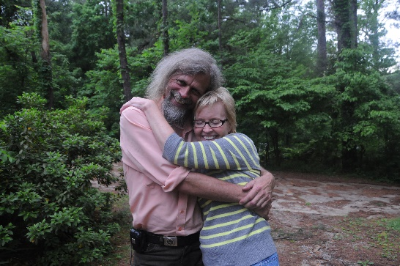  My first reunion with Sarah Snow in her birth home on May 4, 2009 (photographed by my fellow Danish traveler Marlene) | Summer idyll in the garden deep in the Alabama woods when I had set up an office with Sarah on April 10, 2011
It was wonderful to finally hold each other after 36 years of physical absence and I set up a permanent office with her again, even on later work trips. It wasn't easy, though, as the wonderful Elysion mansion "we" had inherited from her parents was so far out in the woods that there was no cell phone coverage. But the lack of social media gives so much more time for socializing, so funnily enough, the snow-white Sarah Snow again helped to create my black images. While most of my old black friends had long since moved from the rotten shacks into plastic trailers, through Sarah and the forests around her I found my way to the Elysian opposite of Hades, where black souls had been kept in a desolate darkness all these years. In completely forgotten communities, they lived in the same old rotten wooden shacks I had photographed in the 70s, like museums from the time of slavery. That museum exhibition later traveled around Europe's other art museums and was responsible for me receiving both the Fogh Prize and the Danish Arts Foundation's lifetime grant - thanks to Sarah, among others. So when I always say that it "pays off" to invest in lifelong relationships, I mean it quite literally in dollars and cents.

FOUR WOMEN IN ONE DAY

But as we all know, all long-term "marriages" have their trials and tribulations, and I also experienced this with the deeply bourgeois Sarah when I returned to her in 1973 after six months to continue the relationship in some form or another. It gave me an experience I've always been too shy to talk about, as Sarah had now found a girlfriend. So I had to find somewhere else to live and was invited to the home of Mary Ann Westbury, the daughter of an oil family. She had worked for her father the year before on the new drilling platforms in the Dan Field and knew that Danish men were different from the ones she knew in her own macho, greased-up industry back home. So the first few nights I was allowed to sleep in peace in her bed, but then things went wrong. I actually told the story of the beginning in American Pictures, describing how violence always led to sex or violent infatuation. I told about the night Mary Ann took me to the black club, Seven Seas, where she, with her interest in psychology, hung out and played pool with the blacks. Here we were playing pool with Butch and while it was my turn, he stepped outside the door for a moment and murdered a man. When I came out and photographed the murdered man, I almost got arrested myself as the police drove off with Butch. I described how we were so shaken that we went home and made love all morning even though we had been lying side by side for days without sex.

This is where the story stops for good reason in American Pictures, because I didn't have the nerves at the time to honestly tell you what it led to.
Because on the same day, December 10, 1973, I had decided to move on, but wanted to say goodbye to Sarah at 11 o'clock while her new girlfriend Tom Gillis was at work. But even though Sarah is one of the most monogamous people I know, she suddenly got sentimental and dragged me into the bedroom. This isn't unusual when reuniting with old girlfriends, but to me it seemed odd, given the violent events of the night and the encounter a few hours before with another woman. And even more so, as I noted in my journal, "she had three orgasms and said "You don't know what you are missing not taking me."" (I didn't remember us having such a good sex life before, but maybe she had learned something from her girlfriend in the meantime). However, I was touched myself, as I had been both sad and relieved that Sarah had found a new girlfriend while I was away.
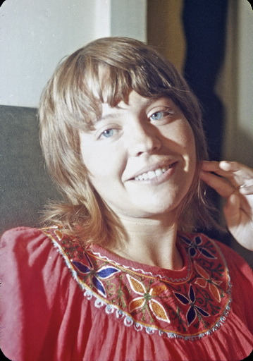  Sarah when I returned in December 1973 | 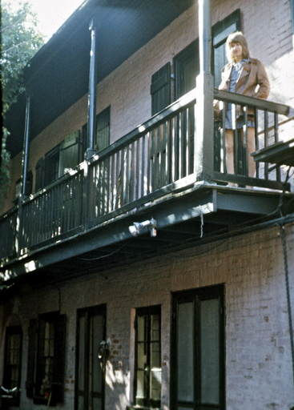  Sarah as we say goodbye to each other on December 10th

In the afternoon, I hitchhiked through the swamps towards the ghetto in Baton Rouge a couple hours away, asking people if there was a university other than the white LSU where I was dropped off, as it was getting too dark to find someone to stay with in the ghetto. "Oh, the nigger university on the other side," said a man at a gas station. So I went into the white university to find someone to drive me over there. From the diary: "At LSU, I first talked to a girl from Thailand. Among other things, she talked about sex and said that she didn't agree with all the free sex here in the US. She said that Americans were not friendly to her. Later I asked around for a place to stay." I often heard this kind of reaction from foreigners, but if it had been in today's very different America, I would have been surprised to hear it from a Thai girl.
Anyway, two nice girls immediately came over and offered me to stay with them. From the diary: "First they took me to a restaurant and gave me a whole load of roast beef while they talked to the others inside. They were the self-sacrificing good kind. One guy was after Ellen Emmich and she took him home to talk to him. Later he left offended."

Ellen, in particular, I found something recognizable about and felt drawn to her motherly caring nature even though she was only 19. The two white girls lived together, so when it was well past midnight and they were trying to decide which one of them I should sleep with, as best friends they couldn't agree. Here during the sexual revolution of the 70s, I knew that I wouldn't get through a night like that without sleeping with one of them. But when I honestly felt that I had gotten my wish that day, I remember how I absentmindedly grabbed a book from their bookshelf and started reading. It was Erich Fromm's popular "The art of loving" and I could well need to learn it in my tired and worn-out state right now, as I had to agree with Fromm. Love is indeed a bit of an art that you not only can, but must learn ..... apparently several times every day. First and foremost because it's not just about finding the right person and being loved, but about loving those you meet along the way. Yes, I suddenly understood why Erich Fromm had become a bestseller among the youth of the day.
But the fact that I seemed literary and completely uninterested in girls in this way probably made this Scandinavian hitchhiker even more attractive in their eyes.
For they could see that I was working diligently on my personal growth, as Fromm demands, and in this way trying to satisfy self-love first in order to be able to fully love the second, the third and perhaps now also the fourth person. For only by developing one's total personality into the ability to love one's neighbor with "true humility, courage, faith and discipline" did one gain the ability and inspiration to experience true love.
In any case, they engaged in increasingly subtle psychological games with each other to solve their little girlfriend problem, which they were unable to talk about openly. But, as they had read again in From, "If two people who have been strangers... suddenly let down the wall between them and begin to feel and discover each other, this will be one of the most exciting experiences of their lives."
Then suddenly, at five in the morning, Ellen had a bright idea: "Let's go skinny-dipping!" I knew from other American students that this was done in the nude and she probably imagined that in this state the embarrassing situation would be resolved. So we hopped in the car, but on the way to the river, they spotted a lone hitchhiker in the dark - and picked him up to prove their love-making skills. He had just been released from jail after a minor traffic violation and wanted to get back to his car abandoned on the highway somewhere. But the two fresh-faced girls asked him if he wanted to go swimming, and as the evening had already been a bit strange for him, he said yes, slightly taken aback. Down by a tributary of the Mississippi, the girls immediately stripped off all their clothes and ran down and threw themselves into the river, which they swam across with ease. At the sight of their gorgeous, well-toned bodies, we two boys didn't want to hold back, but the moment we put our feet on the icy ground, we had to change our minds. It was impossible for us to stand for even a moment on bare feet. I have only once since experienced ice on the ground in Louisiana and was stunned. It was unthinkable for us to run the 50 meters down to the river, let alone swim across. Exhausted, we sat in the back seat and waited for the girls. They, on the other hand, were refreshed and, after a few teasing remarks, sat in the front seat without a care in the world. At the sight of the two naked girls who started to drive us around the city, our hitchhiker got all worked up. I'll never forget the way he sat there rubbing his hands and winking at me "We are going to have a ball" while wondering what his friends would think of his story of first going to jail and then being picked up by two naked girls. It was the year that streaking in universities was starting to catch on across the US, so I wasn't too surprised.

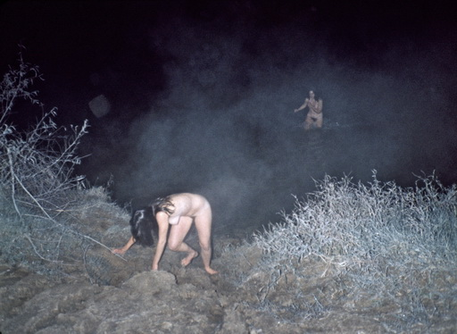  As an excuse for not jumping in the water myself, I may have used the excuse that I wanted to photograph it.  So I must have gotten myself together to run from the car to the riverbank to take the two pictures I have of Ellen and Toni's winter swim. | Ellen the next morning after Toni had left for university.

But I've often had to realize that the world's goods are unequally distributed. After some naked driving around town, the girls suddenly dropped the disappointed hitchhiker off at his car almost immediately after he had whispered to me how "horny" he was. By the time we got home, the knot had dissolved so much that the other girl, Toni Dinkins, said, "Jacob I like you. You are so relaxing to have around" and they agreed to place me in the middle of the waterbed between them, all naked, so they could share me. Hm, now I feared their interpretation of Fromm's, "Love is an activity, not a passive effect." Both girls were definitely attractive, but in my tiredness I remember it as just another "duty sex" I had to go through. It was always against my bourgeois upbringing and modesty to get involved in group sex, so nothing happened with the more aggressive Toni until Ellen fell asleep. But "when I chased Toni up to the Spanish test in the morning just by staring at her", as I wrote in my diary, it suddenly became difficult to keep Ellen at a distance, and so, with a little help from literature, I learned the "art of making love" with four women in a single 24-hour period.
But remember: it's the will that counts here - not whether I was technically capable of living up to the enormous but unavoidable travel costs.
If you look at the numbers with today's more conservative glasses, the story seems like a sordid affair. But now that I write down the details and think through the plot, I think it's actually a very nice story - at least if you remember that it was my policy never to say no to anyone outright, thus avoiding seeming judgmental, prudish, distant, etc. Without such acceptance of people as they are - in time, space and development - I would never have made my show. Because each of these four young white women left a distinct mark on my images of racist America.

So what were the four women I met that day really like? In reality, far more middle-class than myself, I can say with certainty after having followed them later in life. For a brief moment in the early seventies, they were in a rebellious state of "looseness" that they have long since left behind.
The first, Ann Mary, was, as mentioned, a bleeding heart type from a wealthy oil family, and the image of the man Butch murdered, to whom I directly owe her involvement with black people, has been in all my art exhibitions ever since.
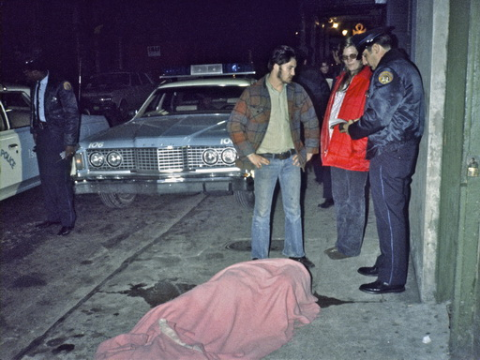  The man Butch murdered when the police arrived. Used in American Pictures | 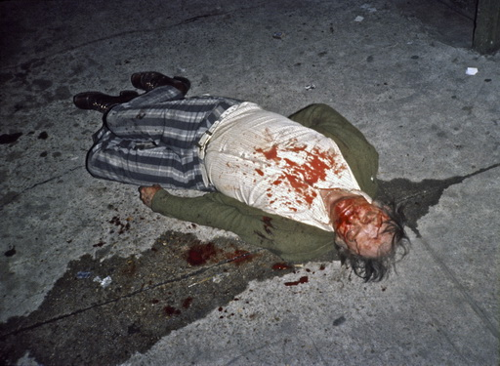  The image of the murdered man that was later exhibited as "art".
As a lecturer, I often stayed with Ann Mary in Gainesville, Florida, in the 80s and 90s, where she became a psychologist.
About the murder, Ann Mary Westbury wrote to me on Facebook as late as April 11, 2009, "Yes, I remember that night well. All my ex-girlfriends have always complained that I have the memory of an elephant, because I do. If I hadn't stepped in at the right time, you would have been arrested for taking the pictures. I can still see Butch's face in the back of the patrol car. I had spoken to him often at the bar, he never gave me any trouble, and I remember his statement that he had never been out of jail for a single Christmas since he was about 10 years old. As your diary shows, he lived up to this also this Christmas by murdering the man in the street. I remember looking at him sitting there in the back of that patrol car and he shrugged his shoulders as if to say: "I told you so." Very sad. If I had been a psychologist at the time, I would have taken him on as a client. Something you didn't know at the time was that psychology had been my interest for a long time. I decided to work in the ghetto in New Orleans to gain experience that I could use in the future. I did it the hard way. I don't remember if I ever told you that I was arrested twice and faced a possible 5-10 year prison sentence. But I have used my experiences from New Orleans many times since in my clients' treatment. I also remember when we met again three years later in Copenhagen. At that time, you had not yet published your book and had so many doubts about the validity of your travels and experiences. Look at you NOW! I am proud of you and all you have accomplished.
In continued love, Maryann"
Mary Ann passed away on January 21, 2016 shortly after this our last correspondence.

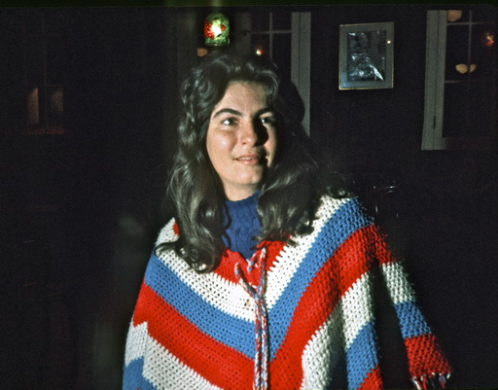  Mary Ann Westbury as I photographed her in 1973 | 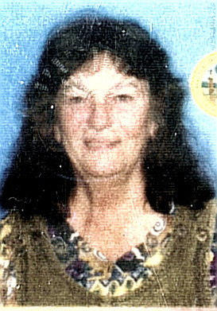  Mary Ann Westbury as I remember her in later years and the last picture of her on Facebook
Sarah from that - to me a bit of a square day on December 10, 1973 - came from a nice conservative upper middle class family.

And Ellen Emmich was from one of the finest and wealthiest dynasties in historic Vicksburg, Mississippi. Her father owned both Emmich Home Financing Company and Emmich Insurance. And the next day, after Ellen had initially hidden me because her mother came to visit, but I ended up moving things for her mother in her Mercedes, I suddenly realized by looking at her facial features what seemed so familiar about Ellen and why she was the one who had taken the initiative all along. It was a Jewish family. Her father had even financed the expansion of the oldest 175-year-old synagogue in Mississippi, Anshe Chesed Synogogue in Vickburg.
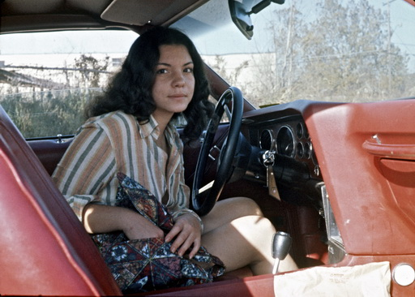  Ellen Emmich as she eagerly drove me around Baton Rouge to photograph the ghetto of Baton Rouge, which I always called the largest village in America | 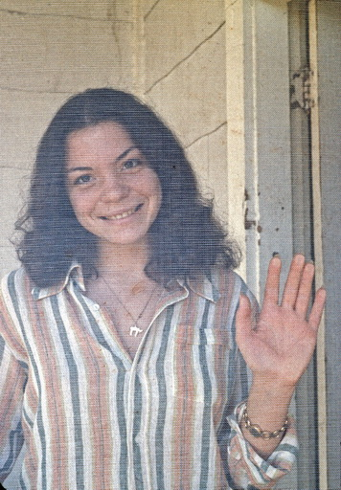  Just as I loved photographing her Jewish beauty

I always used to say that if there was a single Jew in a state, that Jew would immediately find and seek me out - and was proven right again even in this racist redneck south. And in the tradition of Jewish involvement in the civil rights of other minorities, Ellen also became invaluable to my photography, driving me around to photograph all the black shacks that sit just below the rumbling highways on cement pillars in the middle of Baton Rouge. When I photographed there again for my exhibition in Louisiana in 2009, I discovered and re-photographed one of the families that Ellen had driven me to 34 years earlier, still trapped there under the high-driving whites. There had been absolutely no upward mobility for this lower-class family all those years, even though Obama was now president and the now 65-year-old Ellen herself is president of a large company in Mississippi.
The images Ellen Emmich helped me create in 1973 | 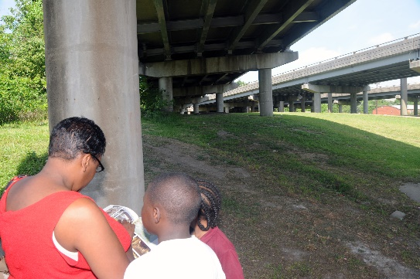  Family in the same shacks look at the photos of them in my book 34 years later
But the last of the four women from that day, Toni Dinkins, arguably had the most impact on the success of my images. Curious about her background, I hitchhiked down the following year to stay with her wealthy family in Ocala, Florida, where her father was a successful businessman, recipient of the Republican Business Man of the Year Award, city council member, etc. So I took pictures in their home of their black nannies who had been taking care of Toni and now her little brother Bobby.
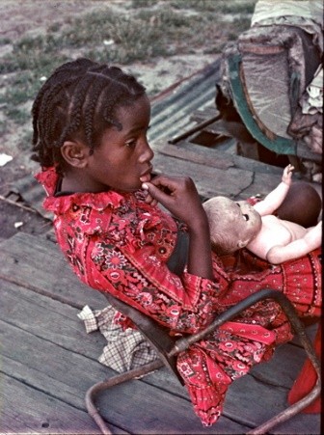  Linda Jenkins and her family, who I found in Toni's car on the deserted side roads | 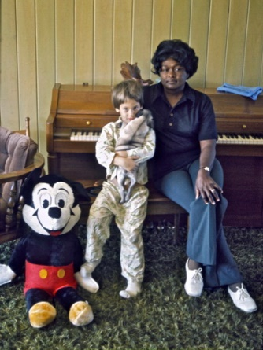  Toni's little brother Bobby and their nanny

But Toni's biggest impact on my slideshow was when I borrowed her Mercedes one day to drive a couple of hitchhikers to Jacksonville. On the way, I discovered the poorest shack I had ever seen and started spending my time there. It became the story of the girl Linda in the red dress, who got kerosene from me for the oil lamp and light for the first time for the rich family money I brought with me - the story of America's great inequality that both in my traveling picture books and later as a lecturer made thousands of Americans burst into tears.
But Toni also helped me effectively visualize this inequality for my audiences when she took me to a slideshow about coal miners at her new Santa Fe College. one day. It was the first time I had ever seen such a multimedia show. There were pictures, speech and music, and although it was very primitive, it worked extremely effectively by rapidly changing images to make it almost cinematic.
So by allowing myself to be dragged around for a day of human multitasking by these four wild amazons - like Apollo in his Quadriga - they ended up, on Women's Day itself, March 8, 1974, informing me for the first time and on the same day using the new term "multimedia demonstration" in my diary. This is what two years later became my long-standing "multimedia show" performed by a similar quad of four Kodak projectors, which in Apollonian enlightening fashion - the god of light and music - could effectively demonstrate class, gender and racial differences as visual contrasts on multiple screens simultaneously.

The point here with these four women is not to try to say that I was the selfless and disinterested party in these sexual relationships. Because I had long since learned that I was ultimately always rewarded for flowing along without resistance. Without even realizing it at the time, I always ended up in the favorable situations that added new unknown layers to the show of oppression I could feel I was putting on. Therefore, I was always as panic-stricken about cutting myself off from further expansions of consciousness by making myself too precious as these women themselves were about not being "set free" in the hedonistic treadmill of time with its all-pervading demands for immediate desire satisfaction - even on such crazy "square days" as the ones mentioned.

Of course, we could all see that this superficial life had certain costs in the long run. In my diary, for example, during my second date with Toni Dinkins, I have already noted this from March 4: "Toni flirted with everyone when we were out. I was tired of it but was patient. She drove home with a couple guys around 2am, so I slept alone in Toni's bed." (Just as she had done the other night in Baton Rouge, which is why, to my relief, I had my Jewish Ellen Emmich all to myself). The next day, I wrote in my journal here in Florida, "When she came home from school, she cooked and talked about her sex life. She wasn't getting anything out of it anymore and had stopped sleeping with anyone and everyone." So it was a mutual liberation for both of us over the next week to share a bed together and to develop a much deeper relationship with each other - now freed from the superficial sexual demands of the era. In Fromm's words, she was already on that "escape from freedom" just like many of the others I followed afterwards. For many, this new freedom to "artificially love" with its responsibilities and the choices that came with it became a straitjacket. Without concrete attachment and anchoring, it was experienced as an unbearable emptiness that created the reaction of the 80s, with demands for more boundaries, firmer identities and anchoring in traditional values.

I've since seen Toni Dinkins take on the same conservative values as all the others mentioned, building on her father's "Republican business life" by now "self-actualizing" instead as "Toni Dinkins Reality" (real estate agent), which she's still running in 2020.

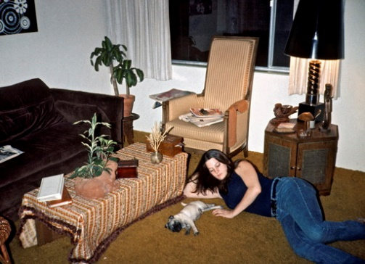  Toni Dinkins in her apartment at 4400 NW 39 Ave, Gainesville, FL | 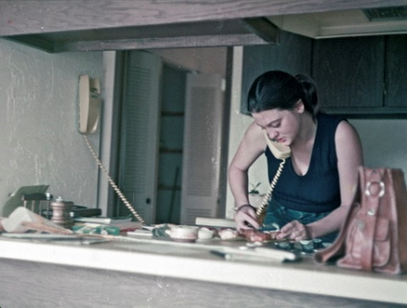  Now with new chaste values

CONSEQUENSES OF YESTERDAY’S UNDERSTANDING OF SEXISM

I've often tried to interpret how this brief era of rebellious liberation fits into the concept of sexism with a contemporary eye. The word was first used five years before our escapades in parallel with racism, "There is recognition abroad that we are in many ways a sexist country. Sexism judges people by their gender, even when gender doesn't matter. Sexism is meant to rhyme with racism."[9]
Used structurally, especially in universities, the term has probably been used to a large extent as an attempt by women of the time to rebel against the systemic historical oppression of women, especially in the South. In the era after the contraceptive pill, free abortion and equal access to education, they had to demonstrate that they were now "masters" of their own bodies. In the environments I moved around in, I saw Eric From mentioned more often than Simone de Beauvoir on the shelves. Only among the better educated do I remember that inspiration came partly from literary feminists such as Gloria Steinem, Betty Friedan and Bella Abzug, whom I occasionally saw in demonstrations against the Vietnam War. This war's ultimate John Wayne macho symbolism probably fueled the sex rebellion's excesses under "make love, not war" more than sexism's domestic economic male oppression, oddly enough without questioning its sexist gender discrimination when shouting "bring our boys home". Our hated opponent, the anti-feminist Phyllis Schlafley, did, however, who had the idea that politicians were planning to send women to war. Again, the zeitgeist was so much on the side of liberation that even Nixon and the Republicans voted official equality between men and women through Congress on March 22, 1972. But using the ubiquitous suffering of war and lying demagoguery that women would now also come home in body bags, this conservative suburban woman who wanted women bombed back into homes and bedrooms was responsible for the defeat of their 1973 civil rights "ERA" to make sex discrimination unconstitutional. While blacks had long since gained legal equality and civil rights, women, to this day, never have.

So it was hard as a man to just sit on the sidelines in what I perceived as their more personal/body ("Our bodies, ourselves") rebellion against the many ways historical sexism controlled and owned women. As I myself often felt more attracted to the reactionary women, especially in the South, with their charming accents and uninhibited flirting than the more measured ideological feminists in the North and the Bay Area, it felt like small infantile victories when I ended up with them. I remember it was when one of the women delegates to the 1972 Republican convention let me share her room in the Nixon headquarters itself that I first coined the phrase "sleeping with the enemy."
The frequency with which I had to navigate between the clumsy, unreflective bed rising of youth against male chauvinism and the deeper systemic sexist oppression (which I was later forced to "sleep with" as a speaker) is clear from the diary. For example, on the same day, April 24, 1973, that I decided to leave the aforementioned Sarah Snow in New Orleans, I ended up in the evening at the home of a cousin of Mississippi's arch-reactionary Senator Stennis of Jackson, John Van D. Stennis. Here, as often happened in the South's upper class, I was immediately handed a list of names of women I could choose as dates for the night (typically divorcees who, in their new insecurity, aspired to marry upward through sex to more financial security). John's friends egged me on, but of course I couldn't choose "blind dates" right after the tearful goodbye to Sarah. As I wrote in my journal, "Later they came home from a bar including a girl they were fucking. But they put me in touch with Kirsten Carroll, a divorced Danish woman who I moved in with instead." With a Danish woman, I knew I would be safe from the tyranny of male chauvinism, and even without sex, Kirsten and I are still connected on Facebook 47 years later.

During the May uprising in 1972, I photographed this feminist message at the Conservative Women's National Headquarters in Washington for the "Daughters of the American Revolution." | 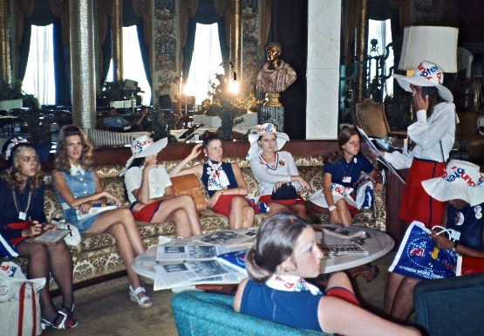  On August 21, 1972, I moved straight from the jungles of Guatemala and roomed with one of these Republican women at Nixon's headquarters in The Fontainebleau, but was kicked out the next day by the Secret Service
So it was hard as a man to just sit on the sidelines in what I perceived as their more personal/body (”Our bodies, ourselves”) rebellion against the many ways historical sexism controlled and owned women. As I myself often felt more attracted to the reactionary women, especially in the South, with their charming accents and uninhibited flirting than the more measured ideological feminists in the North and the Bay Area, it felt like small infantile victories when I ended up with them. I remember it was when one of the women delegates to the 1972 Republican convention let me share her room in the Nixon headquarters itself that I first coined the phrase "sleeping with the enemy."
The frequency with which I had to navigate between the clumsy, unreflective bed rising of youth against male chauvinism and the deeper systemic sexist oppression (which I was later forced to "sleep with" as a speaker) is clear from the diary. For example, on the same day, April 24, 1973, that I decided to leave the aforementioned Sarah Snow in New Orleans, I ended up in the evening at the home of a cousin of Mississippi's arch-reactionary Senator Stennis of Jackson, John Van D. Stennis. Here, as often happened in the South's upper class, I was immediately handed a list of names of women I could choose as dates for the night (typically divorcees who, in their new insecurity, aspired to marry upward through sex to more financial security). John's friends egged me on, but of course I couldn't choose "blind dates" right after the tearful goodbye to Sarah. As I wrote in my journal, "Later they came home from a bar including a girl they were fucking. But they put me in touch with

Kirsten Carroll, a divorced Danish woman who I moved in with instead." With a Danish woman, I knew I would be safe from the tyranny of male chauvinism, and even without sex, Kirsten and I are still connected on Facebook 47 years later.

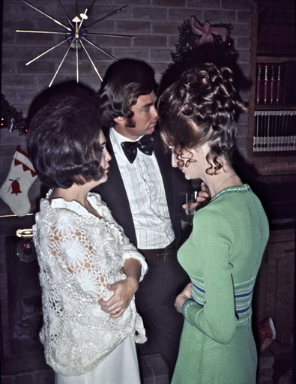  Typical "Southern Belles" at a party at Senator Stennis' cousin's house | Danish-American Kirsten Carroll at the same party
But the very next day on my way to Wounded Knee, things almost went wrong again with the black pimp in Greenville, who that night gave me the choice between his "hoes", "Choose what ever pussy you want," as described on page 127. That chapter was called "On Saying Yes" in American Pictures, although it is actually not about saying yes to such active subjugation of women, but about passively saying yes to their liberation. The pimp Ed "had studied the white man all his life, but never met one he trusted." So only after I had passed his test did he open up to me with a harrowing description of the underlying racial and female oppression.
And just to continue the time description, I hitchhiked the last 5 hours through South Dakota's endless snow-covered prairie, deprived of both the view and hope of finding a single human being as far as the eye could see. But in Rapid City, I walked into a bar and was immediately picked up by Indian girl Diane Tyrrell, who was throwing a big birthday party. She felt I was the right birthday present, so in my tiredness she immediately drove me home to her bed and then went out to party with her friends. It wasn't until late at night that she came home and unwrapped her birthday present in bed. The next morning was my own 26th birthday, so we quickly decided to exchange birthday presents. Since we really enjoyed each other and it was Sunday, she didn't understand why I wanted to leave immediately "to fight with the Indians at Wounded Knee". As a man, I seemed to her as hopelessly non-progressive as history's millennia-long sad line of men who went to war rather than sleep with the beloved, "make war, not love", than the hippie lover she had been seeking. For she had nothing but contempt for the rebels, and since she was proud to be my first Native American girlfriend, the redskin, with the seductive battle cry of the rebels, "Better red than dead", tried to smear herself with the most fragrant red ointments she thought could entice a naive pale face. While her red lips were still on my cheeks, only two hours after saying goodbye, I was shot at by the goon squad as I pulled into the driveway of the reservation in the car she and her connections had helped me get - not knowing it was smuggling guns in the trunk.
I have no doubt that her disillusionment with the Indians rubbed off on me precisely because it was lovingly given to me by a "red" and thus came to color my 4 years later written account "Defeat at Wounded Knee?" Because that depressing experience became the turning point where I finally abandoned my previous left-wing ideas about saving humanity through utopian systems, and instead gave myself over to humanity as it appears - here and now - in all its pain and beauty.
The moral, which the wise Diane gave me that morning as a birthday present for my book, was that I might as well have stayed with her. Because since violent oppression is everywhere, it cannot be fought with violence. I experienced more shedding of red blood with her than in Wounded Knee when I sat with her in the basement below us during the revenge showdown afterwards between freedom fighters and snitches and mourned with her aunt at the pool of her son's blood, which she wouldn't clean up because it was the only remains she had of her son. Alas, when will we men learn to listen to the loving and wise advice that generations of sad women throughout history have tried to give us - to save us from ourselves?

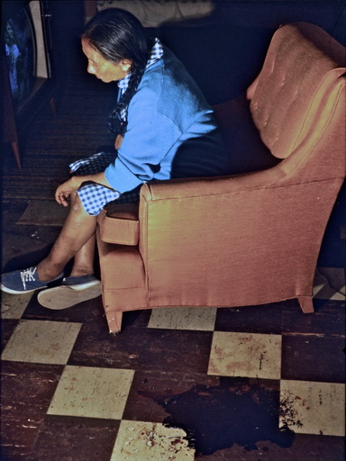

SUBJUGATED BY COWGIRLS
After my book-described "trials" and "choices" in Wounded Knee, I hitchhiked west to see cowboy country, but the same day I left the Indian Diane Tyrrell, cowgirl Joan Jensen captured me in a local saloon in Spearfish filled only with male cowboys, quite literally with her lasso, and took me home, as I wrote, "I got a bedroom first, but later a cowboy cousin of Joan's came and walked right into her bed with cowboy boots on. So she came into my room."

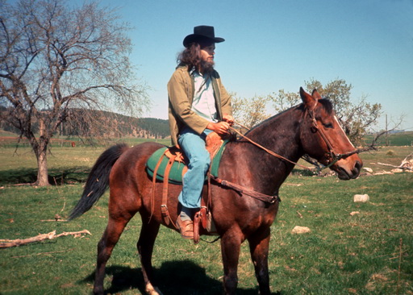  I get lessons in the art of being a cowboy |  | 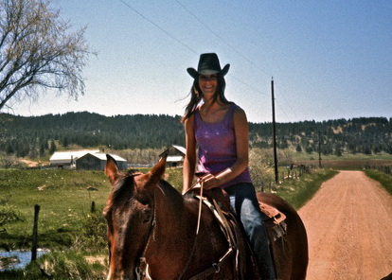  Joan Jensen on her horse
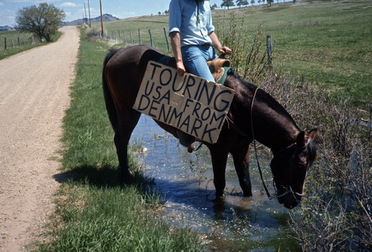  I completely lost my head to the energetic cowgirls | 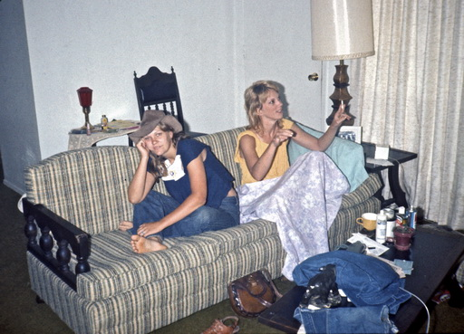  Typical cowgirls - but here's Bonnie, who I stayed with in Texas.

After a few days of submissive instruction in the new cowgirl position and my equally headless attempts at the "art of love" on horseback, I continued on to Billings, Montana. The girl who picked me up that day, Pat Janowsky, was on her way to gymnastics and told me to wait and watch. And that was a bit of a turning point for me, because as I stood looking out over the large hall with the many graceful women in long rows, I took the time to count them. It seemed like an enormous number, but when I had counted them all 69, I suddenly realized that it was as many as I had already been with in America after only about two years of travel (while I had been completely dry in the country just north of Montana - Canada Dry).
I feared that continuing this crazy cowgirl ride here in the Wild West would destroy me mentally and that I would have to turn around and flee back to the frigid black ghettos. I probably don't need to tell you that the return trip was just as grueling between, oddly enough, a cowgirl and an Indian girl in bed alternating every night in this seemingly totally deserted desert.

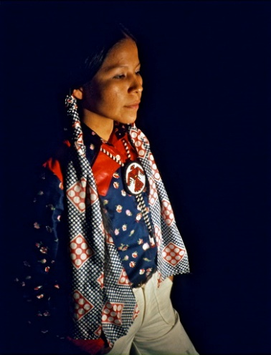  Bobby liked to uphold the traditions of the Chippewa tribe | 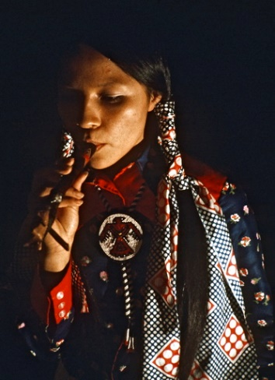  We also smoked peace pipes at home
While I had slept with the Indian widow Morningstar in her teepee, I fell in love with the beautiful Chippewa girl Bobby Smith during her murdered husband's funeral. However, the jealous gay Indian leader Thunder Hawks had prevented our romantic flirtation over the coffin from developing, but as I later wrote to my parents after my escape from the Wounded Knee supply camp, "I am now living with an exceptionally beautiful Indian girl whom I met at Wounded Knee. When she and some other warriors tried to smuggle weapons and food to the rebels, she had to give up halfway in, wearing only her high-heeled red shoes. On the way back, she was followed by the FBI. She has a three-year-old son and we stay with her married sister, who also has a kid. But all the red romance of Wounded Knee has quickly turned into smoke signals. Because it gets on my nerves, the constant diaper changes and the kids screaming and pulling my beard when they leave me to look after their kids all day while they themselves love to go to shopping malls. Although I am very fond of her, I don't know how long the relationship can last."

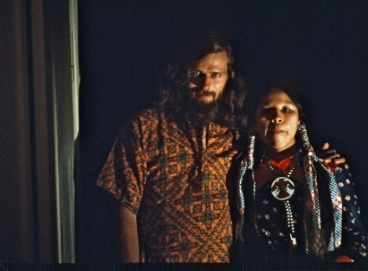  With Bobby, who I had met in Wounded Knee | Bobby with his older sister and the boy I looked after all day
Only with Kierkegaard scholar Elizabeth Vicker in Fargo, SD did I get a more philosophical "either-or" choice in bed. "You can choose to get a long lecture from me on Søren Kierkegaard - or get it over with quickly by sleeping with me." I was so tired that I thought we would both fall asleep the fastest by plunging into The Acts of Love. Because in the spirit of the times, I understood so much of her interpretation that love should not be bound by emotions, as this would degenerate into unrequited love.
No, "free love" was something about committing to the eternal. And the eternal, in my non-religious understanding, didn't extend beyond "for life", which is why I kept going off the beaten track with my "Goodbye, see you soon".

Of course, I wasn't so naïve as to believe in my heart of hearts that I could create lifelong relationships out here in these remote cowgirl states, nor did I dream of it. I loved the mentality of these free and rebellious cowgirls, but still felt alienated and bound in their white macho culture, completely bereft of the magical black and white mystique I loved in the rest of the country.
But the miracle was that later in life I often flew to lectures in these human dead states and found my old wild cowgirl girlfriends with their fluttering windblown hair - now often as diametrically opposed bound, conservative, church-going Republican women with tightly coiffed hair in as large knotted bundles as they often appeared to be. As Danish poet Søren Ulrik Thomsen wrote, "When the zeitgeist shifts, it really requires that you hold on to your common sense, because the zeitgeist determines so much, and when it is gone, you can hardly understand why we thought that way."

DID I MAKE MISTAKES SOMETIMES?
What they all have in common, however, is that I have never heard them complain or regret that we did something wrong in our promiscuous youth, although today they would undoubtedly crack down on similar behavior in their own daughters. Personally, I only remember one sexual relationship I regretted. It was the very first year on the road, when I was still inexperienced and had hitchhiked with a beautiful but slightly introverted 18-year-old hippie girl Laurie Immekus up in Wisconsin. We partied until 3 a.m. on a farm and had taken several "downers" and "uppers" in addition to alcohol. When we got to bed, she seemed to be hitting on me as she snuggled up close to me, but I was in no mood to do anything. It wasn't until we woke up the next day that we had sex almost automatically without me noticing anything unusual. But later in the day, she suddenly complained and said that she hadn't meant for us to have sex, only intimacy, and looked even sadder. Although we may have been under the influence of the night's drug abuse, I felt enormously ashamed that I had misinterpreted her signals so badly. I didn't write about her reproach in my diary, but of course, when I remember this particular misstep 48 years later, it's because I so frequently had the experience recalled during my 30 years as a workshop leader for women, when they tearfully recounted their "date rapes" in universities. Each time, I was forced to ask myself if my own mistake that morning had also constituted a kind of rape without consent or voluntariness.
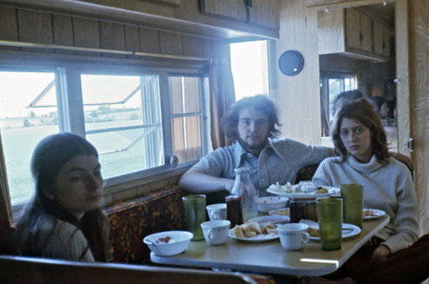  Laurie Immekus on the left with the sadness that always hovered over her | 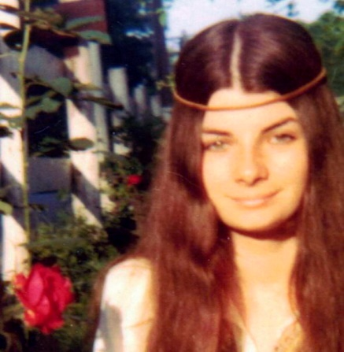  Laurie as the happy hippie
Laurie didn't take it quite so seriously herself. In the days that followed, she tried to take the initiative, "Well, since we've started, we might as well keep going." But for me, the damage had been done by my "moral blindness - the loss of sensitivity in the fluid modernity of the zeitgeist", as Zygman Bauman would call it. Today, I interpret the misstep as a manifestation of my misanthropic radicalization at the time. I went straight from her to Guatemala to fight for an unrealistic utopia but was ideologically blind to the needs of the people around me. Guatemala was a turning point, just like Wounded Knee, where I realized that instead of changing people, I had to empathize with them with all their flaws in the here and now. So when I came hitchhiking back to Madison the following year from my aforementioned Wounded Knee cowgirl ride through the Wild West, I'd had enough of that sort of thing and wanted to move back in with the quieter, cleaner-living Laura Immekus, who was now living with her sister Linda down in Milwaukee. She was delighted to see me again, but immediately said, "You'll fit in much better with my sister, who I've told a lot about you." We quickly agreed, as I write in my diary from June 1, 1973, "Couldn't find Laurie in Madison now, but got a ride from a girl down to Laurie and Linda Immekus in Milwaukee. Talked with them. Linda unusually sweet and innocent. Walked with her along the river. In the evening I danced in the home bar with Linda to music until 2am. Slept with her on the floor."
Laurie was right. The beautiful Linda and I resonated much better mentally and politically, and she introduced me to Milwaukee political groups like the VVAW and the Black Panthers. But while we were really attracted to each other, my problem was that I had gotten into a sexual thing with Laurie the year before, and it was against all my principles to have relationships with girlfriends' siblings as much as with their girlfriends, even when, as here, they both approved. So there we lay drooling and paralyzed next to each other while I inwardly felt that I was now receiving my well-deserved moral punishment for my assault on Laurie the year before.

Linda Immekus shortly before her death in 2020 | Laura Immekus in 2019
Over the years since, I've often thought that Laurie was in fact a lesbian at the time, but didn't yet realize it herself, raised like most girls to have a man and passively submit to his wishes even if you don't feel like it at the moment. I haven't asked her about it. But for various other reasons that follow, I also wonder if she had felt that she had been sexually assaulted that sad morning because she had already been sexually assaulted in her childhood. In any case, she wrote many years later that she was now taking courses on "How to free myself from pain, suffering, sorrow, anguish, etc" and has lived alone, unmarried and very overweight throughout her life, while her still slim, beautiful sister Linda's Facebook page is a cornucopia of happy family life and active outgoing left-wing politics.

The deeper compulsion behind many of my so-called "free relationships"

These two causal factors, I realized through my continued friendships, were the reason why a large number of my former "girlfriends" had thrown themselves into relationships with me during these casual, but for them - as it turned out - compulsive "free" years. In their inner unfreedom, they sensed that I represented something safe and "female" in the midst of their well-founded fear of violent American men. In fact, it was from these often overly forgiving, caring and understanding women that I learned early on to see and understand the pain that lay behind the lost composure of these unresponsive men. It was deeply moving and inspiring for me when sitting with battered and bleeding women to witness their "defense" and eagerness to give their abusive husbands both a second or third chance by moving back and exercising their deeper (female) need for forgiveness with their lives. Often after we had discussed what they could do preventively to not "provoke" the anger behind the men's pain again. Through these women, I learned to develop the empathic "preventive forgiveness" in my thinking towards violent men, which made it possible for me to survive in the midst of their violence (at least non-committally for a shorter period of time, unlike these women's deadlocked relationships). In other words, I won both women and men over to my side as a result of the deeper sexist societal oppression they were both victims of.

The blacks were not so shy about showing their violence, as they had internalized that "this is how the whites already see us." Through its passive acceptance, such white racism directly reinforces their violence against women.

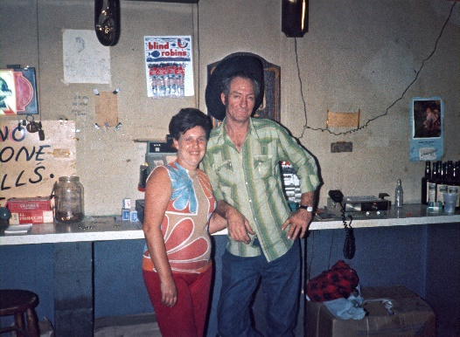  I witnessed a lot of psychological and some physical violence against women. But when I tried to photograph it in action, the white men in particular stood up and presented themselves from their nicer sides, like here. In this way, my photographic 'intervention' helped to save many women in the moment. | 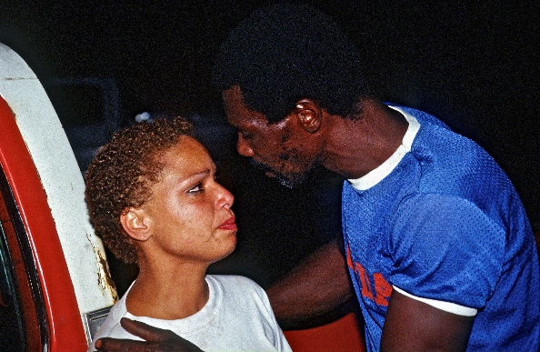  The blacks were not so shy about showing their violence, as they had internalized that "this is how the whites already see us." Through its passive acceptance, such white racism directly reinforces their violence against women.
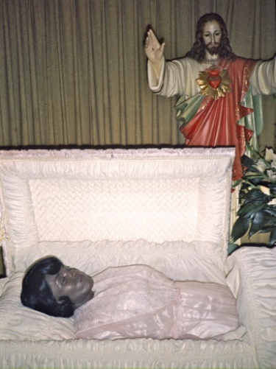  This 26-year-old woman in Baltimore was shot by her unemployed husband. |  | 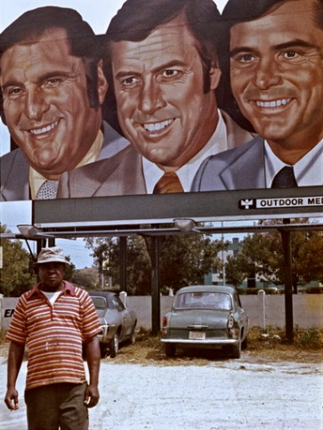  In my vagabond years, there were many liberal theories that the black man's violence was due to his emasculation under white racism. These well-meaning explanatory models undoubtedly strengthened my inner empathetic thinking, which enabled me to survive the violence myself.
It also explained why these - our mutually "artificial" and unnatural sexual relationships - ended unsatisfactorily, even though we both enjoyed the intimacy and safety. And why I - without knowing it at the time - ended up in the incredibly many lesbian relationships that I talk about in "About saying yes to lesbians" ...... so many that I was later teased by them myself as being a "closet lesbian."
But in retrospect, I would describe my relationships with lesbians as happy, unlike many of the victims of incest and sexual assault, who did not open up and tell me about it until they were in their 50s and 60s - usually now as enormously overweight women after years of self-destructive "compulsory overeating" (comfort eating). However, the incest victims had usually sent me far more unmistakable signals than the unknowing lesbians when they invited me home and sought intimacy with me in bed.

I'll never forget when, to my astonishment, 18-year-old Sandra Johnson was one of the first and only black women to try to start a relationship with me. She had even met me by chance in a crowd of people on the streets of NYC on July 1, 1973 with her family and - without a home of her own - invited me into her family's home without any social control issues. But then suddenly she "froze" and couldn't go through with the sexual relationship she attempted with me on the living room floor when the others had gone to bed in their crowded ghetto home. Not even the next day. I interpreted it this way in my diary, "Spent all day with Sandra Johnson, but she was a lesbian. When she wanted to, I tried to loosen her up by telling her about the girl in N.O. But Sandra could not be converted. After everyone in the family had gone to bed, she came back in - now in a nice nightgown, but the same thing happened." I remember how frustrated I was because, as I mentioned, it was impossible for me to find black girlfriends and Sandra was smart, slim and sexy.

But thank goodness I didn't overhear her confused contradictory "hints to the contrary", because over the years I noticed that she no longer attended family parties, weddings and even her own father's funeral. No one in the family connected with her anymore and only once in 1986 did I get to meet her with my father and son at her financial firm on 5th Ave in Manhattan, where I noticed her growing obesity. She was doing well in the business world while I watched her two sisters, Carolyn and Kassandra, go downhill. When I was filming with PBS at her aunt Lela's house, Lela warned us to keep a constant eye on all the photo equipment because the two sisters were crack addicts and stole everything around them. But Sandra lived all these years as a hermit in hiding. It wasn't until February 5, 2006 - 33 years after we first met - that she contacted me and asked me to come to her apartment in the Bronx to confide in me. I was shocked when I walked in and saw how enormously overweight, she had become. She was now tearfully telling me how both she and her two sisters had been raped in turn by their father throughout their childhood and adolescence. Their mother Julie had turned a blind eye, as my picture of Sandra and her mother from 1973 almost reveals.

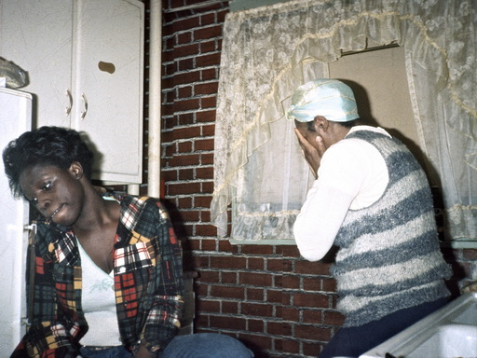  Sandra and her mother Julia in 1973 | 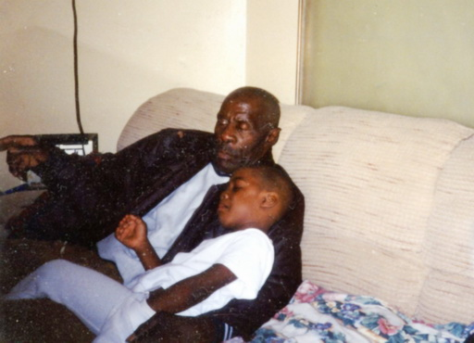  Her father Woodrow in childhood
It had ruined her whole life, although unlike Carolyn and Cassandra, she had not become a drug addict and criminal, but by shutting everything and everyone out, she had been able to concentrate on getting a business degree. She regarded her father as evil without, like me, asking questions about what he himself had once been exposed to. It turned into a long weekend of redemptive conversation, as after many years of working with incest victims in my workshops, I was now equipped to help her a little and now knew the patterns I had been blind to as a young person. When we went to sleep, I expected her to invite me into her big bed, just as I had experienced that many of my other incest-stricken old "girlfriends" usually wanted to continue some form of intimacy. But no, throughout her life she had never been able to be with men - let alone share a bed with them. Not even until she had met me on the street at the age of 18 and insisted that I go home with her. This, she now realized, had just been a clumsy spontaneous cry for help and an attempt to be released from her fear of men, "because you didn't look dangerous".

Her sister Kassandra, when she tried to steal our camera equipment as a junkie in 1996 | 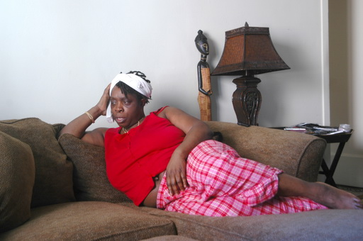  Sandra in 2007, when she told me about the abuse she suffered throughout her childhood
I told her about a young, exceptionally beautiful Muslim Pakistani born Muslim woman in Detroit, Shazia Chaudhry, who after a few years of friendship with me suddenly disappeared because she was locked up at home before being forced to marry a farmer cousin in Pakistan. During my workshops at her university, we had felt a strange harmonious chemistry between us and she found out that we shared the same birthday. One day she called me and managed to escape to my car, where we had a long tearful session about the abuse she had suffered at the hands of her uncles and now that she had reached sexual maturity, she missed the physical embrace of her father from childhood. We had nowhere else to be on a freezing winter's day but in the big bed in my trailer, which I drove next to the factory where her father worked, asking her to think of him deeply as we hugged, tears pouring out of her. The story is much longer - including trying to help her escape to Denmark - but she is now happily married in Connecticut, where I continue to visit her and her husband and wonderful children.
Shazia as I first met her in 1986 | During our tearful car session in 1988
Shazia happily married with her daughters in 2009 | Photographed by her children in 2012
I never had any ready-made solutions in my relationships with such traumatized women, but the most important thing was - although I always tried to let the women take the initiative once a deeper trust between us was established - not to ignore these deeper cries for help. Especially when, in their inner confusion on the surface, they so frequently expressed them in the form of clumsy attempts to get sex when it was about something else entirely.
Although, as I said, even now, 33 years later, Sandra Johnson was so damaged that she was unable to even accept comforting - usually redemptive - embraces from me as a man, she nevertheless put me on a test and deep inner journey through such a redemptive bed scene. When I brought a film crew from Copenhagen Film in 2015 to make a documentary about my life and the lives of my lifelong friends, I had told the director Niels Ole Rasmussen about Sandra and he suggested that we try to film a talk about her ruined life. But since Sandra had retired to Florida and we were in New York, I came up with the idea of using her sister and soulmate Carolyn instead. However, she was living in too much of a mess in her ghetto apartment filled with younger drug addicts to be filmed there, so they decided I should bring her to our hotel. And when I had told the crew about the bed session I hadn't been able to get with Sandra, they had made up a large double bed for me and Carolyn without my knowledge. This was a bit of a departure from documentary filmmaking, as I hadn't had an intimate relationship with Carolyn in my youth.
Therefore, I was probably not quite real as I thought it seemed a bit artificial to lie there and cuddle a completely different old, albeit almost as fat lady, although over the years I had spent far more time with her and Kassandra than with the missing Sandra.

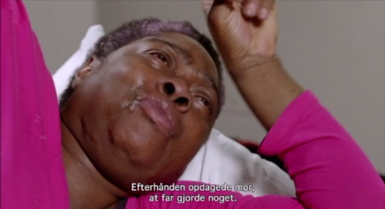  Carolyn in our staged Film session in 2015 | 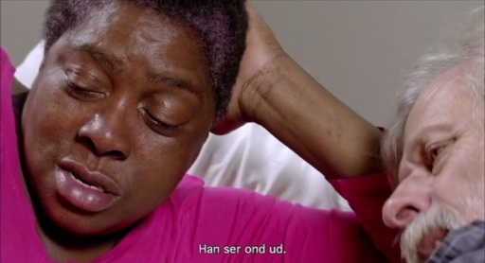

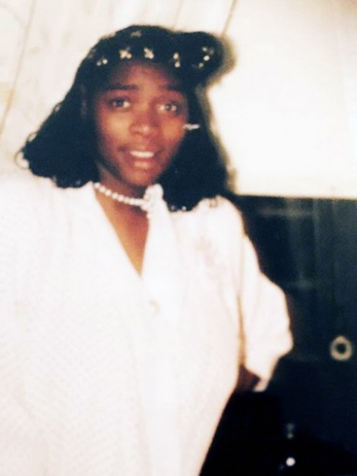  The still vivacious Carolyn Johnson I remember from my first visits in 1973 | 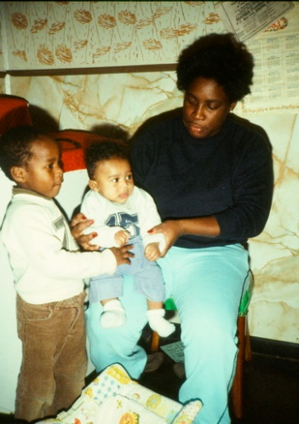  Carolyn in 1996 as a junkie and welfare mother to two children, whom she left in the care of her mother Julie. This is the youngest Shari I have as a Facebook friend today.
But with the hard life Carolyn had led, including drug prostitution, she had no problems herself. And the film crew got it right with this cinematic grip or assault. With the emotions that come with such intimacy "with the whole world watching", Carolyn opened up and tears poured out of her eyes as they talked about her father's rape. But she had already been in therapy and to my surprise, she suddenly switched roles and we swapped roles as therapists or "co-counselors" as we called it in my workshops to emphasize that you don't need any training to do this.
"I have tried for years to put it behind me - to try to heal. The pain is all around us, but nobody sees it. Everybody has to seek a journey in their life. So, Jacob, what made you go on your journey?"
I was confused and replied, "I was kicked out of high school for ADHD....so I couldn't get an education...it was a huge setback for me...."
Carolyn immediately interrupted," No, no, you are avoiding the question which really turns me off. What was the MAIN thing which set you on your mission?" Without putting my answer in the film, the film crew then cut straight to a violent session at my mother's grave, where all my emotions suddenly welled up inside me about the psychological abuse she had subjected me to in childhood, but during which I also achieved a kind of reconciliation with her by suddenly realizing that without this pain from her, I would not have sought out the pain of others on the road.

Since she opened up to me in 2006, Sandra has also been in therapy in her exile in Florida and is now finally able to see the pictures I took of her "evil father" over the years. In the process, she has even been able to lose weight and when we text almost daily, she proudly and flirtatiously sends me sexy pictures of herself at almost 70 years old with teases like, "Look what you missed out on when I tried to seduce you at 18, but you shut me up like a dead oyster."
Yes, yes, I reply, but we ended up together anyway - as lifelong lovers.
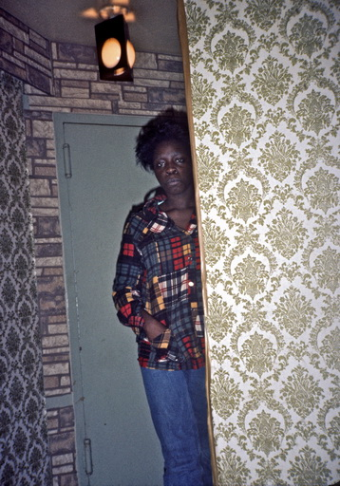  Sandra, when she tried to seduce me as a slim 18-year-old | Sandra as a 70-year-old, when she tries to seduce me today - at a safe internet distance

Did the forces of darkness control many of my relationships?
Unfortunately, astrologers have often interpreted the fact that I had a few too many lifetime girlfriends on the same tragic basis as being astrologically "Plutonian" with a lot of Pluto in my horoscope. One astrologer, Donna Cunningham, who was also a social worker, discovered that many of her clients such as drug addicts, homeless people, criminals, incest victims, etc. had an incredible amount of the dark planet Pluto in their aspects, which apparently made them "victims" of anxiety, high mortality, grief, violence, aggression, anger, destruction and self-destruction, etc. But according to her explanations, some lucky Plutonians - such as myself as a "victim" of my oppressive mother and grandmother - are able to turn this shadow over their lives into something constructive by feeling attracted to these dark sides of society, criminals, ghettos, etc. and through their empathic attraction are able to help the victims to some extent. In any case, we will be mutually attracted to and seek each other out, which explains the many failed sexual, but in other ways mutually enriching human relationships I had on that account.
As Donna Cunningham writes in “Healing Pluto Problems”, "Plutonians are born mentors, so they tend to attract socially disadvantaged people. Plutonians of the more negative variety, however, make themselves indispensable and subtly convince you that you would be helpless without them. You can't understand why you've come to resist them and you feel guilty because they do so much for you. Somehow the balance of power in the relationship has shifted, so you do things their way all the time and feel guilty if you don't. Women are more likely than men to use this kind of manipulation to gain power. Because power and control are the underlying problems of the planet Pluto, simply put."
When I read Cunningham's dissection of my past "underbelly", I immediately recognized the patterns and understood why my passive yes philosophy of letting women control the relationships they had variously pursued with me worked so well for both of us during our vagabond years. For the many of them who later turned out to have been social "victims", it gave them a certain liberating sense of empowerment to sacrifice themselves for me, the lost homeless and will-less (i.e. ADHD-afflicted) hobo, who conversely would never have been able to survive without them and through their insight be able to create a work about the forces of darkness.

Oddly enough, many admirers of American Pictures have often praised me "for all you do for those people" and sometimes when I was in the limelight and had not been in contact with "those people" for a long time, my admirers probably lulled me into the misconception that I had really sacrificed myself for "those people". This could lead to an acute disappointment in my relationship with "those people" that I had come to love and bond with during my vagabond years, unless I constantly made an extra effort to remember and understand the true nature of the relationship. For if I was not constantly wary of the illusion of my own role as the selfless party in my love relationships with both women and the ghetto people they had so often brought me into contact with, as "the eternal giver who sacrificed himself for the other", - well, this whole self-deception of mine would "be my downfall".

WOMEN OF THE STREET

Over the years, I've tried to analyze - and discuss with myself - how many of the women I ended up in the arms of during my vagabond years consciously or unconsciously sought me out - or vice versa. It's easy enough to see that the former was the case with those who picked me up as a hitchhiker, where I didn't have the opportunity to choose them. But as female drivers' anxiety about picking up men increased rapidly in those years, so did my need and ability to seek them out in other ways for accommodation. It perhaps says more about American hospitality than it does about me that even in the smallest peaceful village or the most dangerous city I ended up in, I could usually find someone to stay with - even after midnight - in less than an hour. Most of the time, I simply walked up to people on the street and typically struck up a conversation that went something like, "Hi, I'm a traveler from Denmark. Do you know of a place I can stay?
Answer: "Oh yeah, there's a motel this way or that way."
Me: "Well, I'm traveling around studying American society, so I usually stay privately to talk to people."
Answer: "Well, yes, that's interesting that you're from - what did you say - Sweden? Well, I know/have an uncle around the corner who has been there. Let's go and talk to him about whether you can live there."
Along the way, it so happened that the person I had met found me so interesting (especially in areas where there were never any travelers) that they took me home themselves.

But since this section is about my relationship with women, here's my honest confession. When I always consistently said yes to the first person who invited me home, I didn't want to gamble on the chances of it being a man. This was due to my experience that single men in particular were messy and not very nice to live with, often gay men or men with gay men, people I had to drink or get high with, etc. Rarely did I stay there for more than one night as I couldn't find the peace to write with them.
With women, on the other hand, I found all the care and interest in the "female" values we often shared, as mentioned above. And so it became a rude (i.e. not very democratic) habit for me to always first go up to women on the street and ask - even single women on the street in the dark after midnight - unless I was really desperate and tired late into the night. This meant putting both them and me to the test, remembering how American women had already "lost the night" - the freedom to move about freely without fear of violent assault. I knew that if I thought selfishly about myself and my own need for a bed, they would never open up and overcome their justified fear of a strange man. Only by empathizing with their immediate needs on the spot would they become "victims" of my non-violent communication. Yes, yes, I admit it seems just as calculated, but it's not quite, as even psychopaths can't just decide to trust women. I'll save that talk, though, as I was constantly exposed to psychopaths myself. No, I'm more interested in investigating why they almost always succeed - often with the first woman I asked on the street. Because I probably haven't asked just any woman - for example, ladies in mink fur with gold bracelets (although I do remember cases where they succeeded - even on Palm Beach - as upper-class women were often loving women of excess).

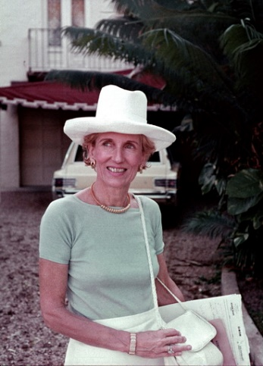  This woman on Palm Beach - home to the wealthiest families in the US - I asked on the street for a place to stay and she immediately invited me in. | 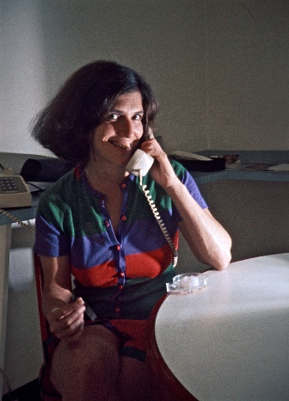  Susan Kennedy of the Kennedy family in Boston I asked on the street for a place to stay. She ended up giving not only shelter, but so much money that I mentioned her in the colophon of my book
If there were more people on the street in the late hours of the night, I probably had or developed a nose for who would say yes and asked them first. But the question is, did I have a nose for my potential "victims" because they themselves gave off signals of being "victims"? In other words, because we, as plutonics, were both crying out for help? Because it takes courage or necessity to open up to a complete stranger on the street at night in a society without mutual trust.
Maybe you would think that it doesn't take much to seem credible when you, like me, traveled around the first year with a backpack with a Danish flag and a "cool" Danish accent. So that's why I think especially about the times when I didn't and without luggage looked like any other Charles Manson. Let me recount just a couple of such nights.

While I was staying with my friend Tony Harris in Greensboro in 1973, he was working on the release of black prison inmates. One night he was taking some of them to a black rock concert in Chapell Hill and invited me along even though he knew I had no money. However, with my "white privilege" I managed to talk my way in for free, where I got a lot of female attention by photographing the beautiful black girls. This annoyed Bob, who was driving the car, so much that on the way home in the middle of the highway he suddenly stopped the car and threateningly said, "Hey, honkey, you've gotta get out, you understand!" Tony turned around and signaled with a resigned shrug that there was nothing else to do but get out. Because as he later explained, "Bob is a double murderer. He murdered both his wife and her lover and he hates white people. So I wasn't taking any chances with his explosive temper."
My problem now was that my backpack was at Tony's house, so I looked like anyone else as I walked the long way from the highway back to Chapell Hill after midnight in a snowstorm. It was almost deserted, but a young white girl came up to me and pulled my beard like the lost snowman I now looked like. I immediately asked if she could help me find a place to sleep and soon after she took me "home" - that is, down to a basement where we shared the narrow single mattress she slept on as a homeless runaway from an abusive father. She was clearly seeking intimacy, but I don't remember how sexual it ended up being, as the boundaries were a bit blurred in those years. Just like smoking marijuana together when you were picked up by cars before they asked your name, you typically had sex together without asking each other who you were. I just remember that in the dark we hadn't really been able to see each other, which is why I was surprised when I saw how young she was the next morning. I asked and was told that her name was Dorcas Hamm and that she was only 16 years old, the youngest I had ever been with. The night I met her, she had seemed outgoing and energetic (maybe after a few drinks), but when she told me about her life, she seemed sad and introverted - even in the picture I took of her on the mattress we had shared. I don't remember today if the violence she was fleeing also included incest, which was not talked about with others at the time, just that she needed help. Apparently, during my own escape from a violent man - a black double murderer - we had both needed each other.
When I later began working with incest victims and had a similar experience one night in Alabama with a Klan leader's daughter, Christie, a drug addict, who called me into her motel room in the dark, I had a similar experience. As I watched her curl up protectively over and over again during a long sleepless night, it gave me visions of Jody Foster in the movie "Nell", so I suddenly asked her out of the blue if she had been abused as a child. It turned into the most harrowing incest story I'd ever heard, which I'll have to wait to tell until "Saying Yes to the KKK", as it led me directly to the Ku Klux Klan people who had attacked and burned the freedom rider buses in her town.

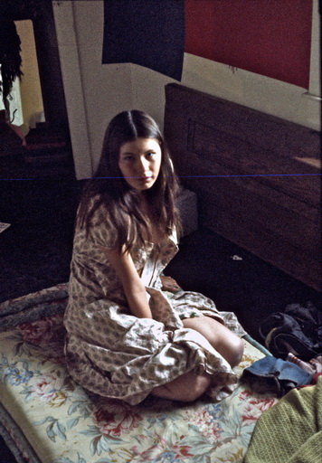  Dorcas on our mattress in the morning, where I realized how young she was | 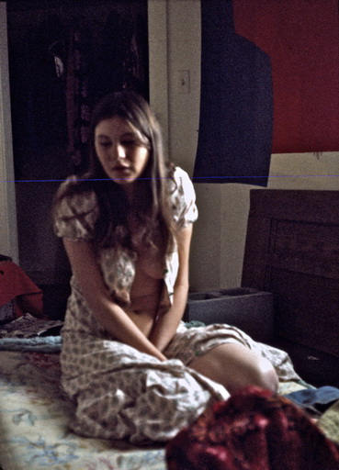  I could hardly ever afford to photograph the white people I stayed with, but Dorcas' story touched me so deeply that I took these three photos.
The incest-stricken clan leader's daughter, drug addict Christie, in one of the rolled-up poses that revealed her past to me. Although she was completely destroyed by drugs in 2005, she later managed to get a university education under the protection of the community | 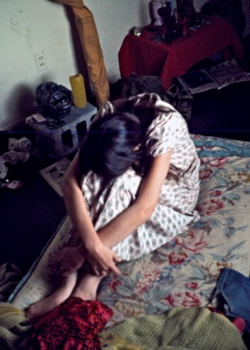  One of Dorcas' "protective" positions that later led me to suspect the same causal relationship.
Dorcas became my youngest intimate relationship.
I met my oldest, 46, in a similar way late one night in New York, where I had spent most of a night sitting in the Bellevue Hospital emergency room among screaming, hysterical poor people trying to get them to admit a black homeless alcoholic who had asked for help on the street because he was delirium tremens. I eventually escaped the screams and hopelessness of the emergency room while the self-sacrificing lesbian girl I was staying with, Erica, tirelessly stayed to help him as he urinated and vomited all over the place. It was too much for my male caring gene, especially when she lovingly kept tucking his penis into his pants every time it fell out. I'm not going to get into Freudian penis envy, but all day long Erica sat and made dolls (and still does today 47 years later where there is still something penis-like about them), and I had long since learned from my lesbian hostesses that they didn't like penises - at least not mine.
Now it was pouring rain and soaking wet in my shirtsleeves, I approached the only person I saw on the street, a rich woman in mink fur, Patricia Appel. She took me home and immediately insisted on sex, but in my distraught state of mind of betrayal, I might as well have continued my lesbian relationship with Erica at that point. No sooner had we started what I called "duty sex" in the morning than she stopped us mid-act and broke down in tears. She apologetically explained that she couldn't feel anything because her uterus had just been removed during surgery for uterine cancer. Now she had hoped that "a young prince like you" could give her back the vitality of her youth, but as I said, my male caring member didn't go that far.

To me, a 46-year-old at the time seemed like an old woman (for most of my life I thought she was 56 at the time), so the experience seemed more transgressive than a poor girl of 16. Although this was obviously also a cry for help, disguised in mink fur, in her disappointment she immediately tried to demonstrate youthful vitality by jumping out of bed and putting on Stravinsky's "The Firebird". And then she danced around all morning in her flowing blue nightgown with a feather in her hand - in addition to the one she was wearing - to try, like the firebird in the ballet and fairy tale, to awaken her young Prince Ivan to fight against the urges so demonized and petrified by the evil sorcerer. "The firebird came flying and landed among them with flaming wings of fire. "You wretched creatures of the night," it thundered, "will you dance for Prince Ivan? Now I'll let you dance until you die!" The whiskey made me dance wildly for a while, but unlike the ballet's "Prince Ivan went further into the beautiful garden and came to a big old wrought-iron gate," the gate still didn't open, freeing "12 young girls, each more beautiful than the last" - and I eventually died in my desperate attempt to finally get some sleep.
As I recall, Patricia Appel described herself at the time in 1973 as the United Nations High Commissioner for Refugees, but after her defeat with me, she herself fled New York and, as a citizen of the world with a joie de vivre for art, music, books and travel, spent her later years mostly behind wrought iron gates in fashionable St. Chamas in Provence until her death at 78 in 2006.
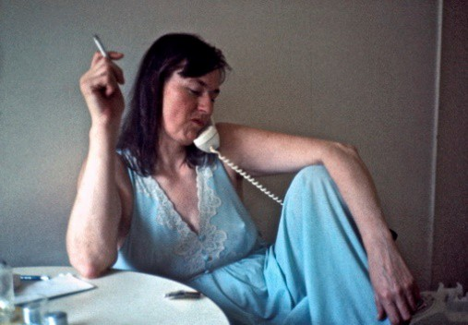
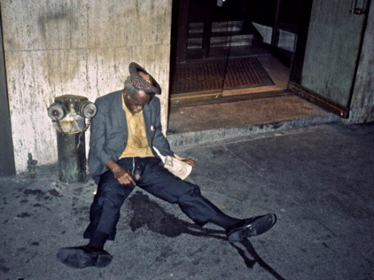
Patricia the next morning, as she recounted the night's fiasco to a friend | The man with the penis, whom Erica, with incredible female sacrifice, Erica insisted on help into an emergency room.

The art of picking up rich women on dark streets I learned in my first year - also in the "naked state" without a confidence-inspiring backpack. I had arrived on April 19, 1971, I had come hitchhiking with a carload of protesters from Detroit to the big Vietnam demonstrations in Washington with one million participants. They settled into sleeping bags on the vast National Mall, which was already crowded with hundreds of thousands of long-haired protesters. I didn't want to do that and left my backpack with them in the car as I headed out into the city in an attempt to find private accommodation. It seemed hopeless as the city was filled with thousands of other young people on the same errand. How was I supposed to distinguish the few locals from out-of-towners? So I walked up Connecticut Ave towards the residential neighborhoods to the north and settled into the first young girl in Indian skirts I met in the dark side streets around Dupont Circle and quickly convinced her to take me home. And what luck, because the 19-year-old millionaire's daughter Helen White lived with all female students in a charming 4-storey building at 1714 19th St NW, so with so many protective eyes around her, she wasn't afraid to take a complete stranger home with her when, as it turned out, he claimed he had just hitchhiked 5000 km from San Francisco to demonstrate against Nixon's war in Vietnam. Immediately during dinner, I felt the interest of some of the other law students and more conservative women on the upper floors, but even though I hadn't yet started dating Helen, I knew that from now on I wouldn't be able to choose when she was the one who had proudly found "my great Dane". It was past midnight, and I was tired and wanted to get the sexual stuff over with quickly, but when I told her I had my backpack in the car at the Mall, she insisted I pick it up that night - apparently afraid that without it in the house I would run away from her. So, late that night, she called her curly-haired friend Dave and had him drive me down to the Mall. And what luck, because when I went down the next day to check on my friends, their car had been stolen in the night, which would have meant I had lost all my diaries, tape recorder and entire identity.

That's how Helen hooked me up in her safe women's commune, where I received loving care and licked my wounds for the next few months during the biggest and most violent demonstrations I had ever been to. On my 24th birthday, her father, Perequine White, drove us out to celebrate at the family mansion in Potomac, surrounded by congressional golf clubs. I was deeply impressed because, as president of the National Academy of Sciences, he had come straight from a morning meeting with President Nixon himself, against whom Helen and I protested daily. On his own, he had even bought me a large birthday cake with a Dannebrog flag from the Danish bakery in the belief that I was to be his future son-in-law. Perhaps I believed this myself at the time, because when I returned a few months later, Helen told me that she had become pregnant with me but had chosen to have an abortion in order to devote herself to her education as a classical violinist. It came as a shock to me as I barely remembered us having sex, but only remembered - even today - how she had lovingly tended to my bleeding wounds when I came home from the fighting during the attempt to shut down the Pentagon and played me to sleep with her violin. I regretted my carelessness, but was glad for her choice in this time of liberation when abortion was not a big moral issue, which led to the Supreme Court ruling two years later to allow abortion. Until then, this was only reserved for rich women like Helen. It was my eternal fear of being tied down by an unwanted child that would put the brakes on my continued travel project. Today, however, it makes me wonder if I was unconsciously discriminating (or protecting myself) against the poor since the only two women I impregnated in the 6 years of traveling were both daughters of millionaires?
Helen and I remained good friends over the years, often staying with her in her lovely house at 2814 Adams Mills Rd. with the amazing view across the river to Nixon's Mao peace-diplomacy pandas at the zoo. And if she hadn't saved me with her abortion, I might well have stayed there to this day. She went on to win numerous violin competitions on her tours in the US and Europe, but always had a passion for the underprivileged and founded The Junior Appalachian Musicians to bring classical music to the poor children in the mountains. She died here at the time of writing at the age of 69.
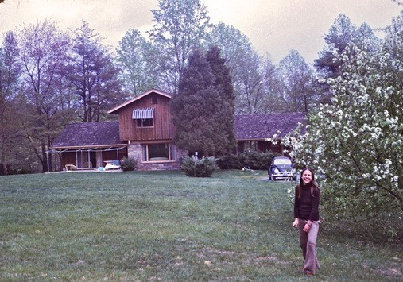
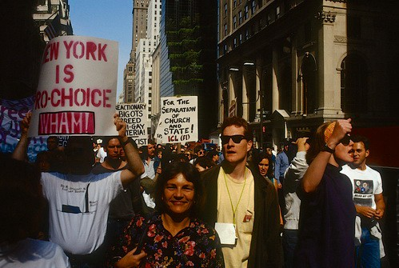
The only photo I took of Helen White - and probably only because I was impressed - and probably only because I was impressed by her parents' millionaire villa in the fashionable suburbs. | One of the many pro-choice demonstrations I attended - here on Fifth Ave in New York
MY MOST OUTRAGEOUS AFFAIRS

Among many of the prejudices about the liberated sharing economy of the 70s, the one I've heard most often is the one about collectives where people slept around and swapped fuck partners. Maybe in Denmark, but in the US I experienced more serial monogamy outside in the traditional bourgeois settings like the ones I've described here than inside in hippie communes like the famous Kaliflower in Height-Ashbury. (Since students typically live in shared apartments in university towns, the idea and boundaries of the collective were not as revolutionary as in Denmark).
At least in the two I got to experience before they disappeared into the dustbin of history. In one of them in California, only a few days after my arrival, I experienced exclusively old-fashioned "bourgeois relationships" within the long-haired and acidic confines of the collective, even though they each fucked just a little too close and loudly against my bed.
In the second case, I'm a little more dubious. It was that first summer, when I had just left the aforementioned Helen White's bourgeois women's commune and ended up one night in a disgusting hippie commune at 3616 Springgarden St. in Philadelphia. All the couples were screwing all over the bottom floor, so I was relegated to an unmade single bed in the back room, which I think was normally used for dogs, because it was covered in dog poop all over the floor and bed. But, ok, I'll find another place tomorrow, now it's just a matter of getting a good night's sleep, I thought. However, it was hard to be seduced by Hypnos and Nyx as there was no door to the living room with all its Dionysian sex sounds. When I was finally about to fall asleep, I was suddenly surprised by a heavily pregnant woman, 8-9 months pregnant, who seductively, like an Aphrodite, sat on top of me and continued the sex with me that she had just had with the baby's father in the living room. Unfortunately, she hadn't brought Eros with her, so I felt completely paralyzed, but honestly don't remember today to what extent she aroused me, as for good reasons she didn't become a lifelong girlfriend. To my relief, after a while, somewhat disappointed, I think, she went to sleep with her own husband, who probably hadn't noticed her absence. I just wrote her down as Diesa Milos, but this time, in the misty Erebos of my soul, I may have mistaken her for Aphrodite of Milos and one of the other ball ladies, as I never visited the scene since. However, ever since then I have associated the word "springgarden" with a "spring garden" full of the big round molehills I planted at home in the vicarage, which I felt I was a little too rounded in these unchristian surroundings.

Another prejudice I have often heard is about how neglected the children were who grew up in such collectives - sometimes based on the children's own statements later in life. I don't remember if there were children in my Springgarden collective, as I was only there at night. Undoubtedly, I experienced the more or less stunned, acid-tripping parents' neglected children in collective settings, but it was my clear impression that they were subject to much more loving care from their more present surroundings. But it is equally important to remember that many of those who came together in such communities or in the liberated rebellions of the time were fleeing the violence of the strict bourgeoisie of earlier times. As I have pointed out in this chapter, it was as a result of neglect, especially from alcoholic, violent or pedophilic parents during my childhood in the 1950s that so many women sought me out in the 1970s. Conversely, as a lecturer in the universities of the 1980s and 1990s, I found that the young people who were the most open-minded and inquisitive were those who told me that they had grown up in a collective setting - either as "army brats" raised on military bases around the world with blacks and minorities or as children of hippies. The latter could laugh at their parents' earlier hippie days, but almost always expressed gratitude for the love they had received in these settings in my workshops, where the truths of betrayal always came out. And if we go a couple of generations further back, today I hear harrowing stories in the Exit Circle's care work, which I host in Copenhagen, about the violence and neglect young people growing up in the neoliberal competitive state of the 90s have been exposed to by career-prioritizing parents, especially in the whisky belt's executive homes north of Copenhagen.
So the sum of neglect and outright violence from parents is, in my experience, constant from generation to generation. And one factor is constant throughout history: the children of artists have always felt neglected and overlooked. For example, those who told the stories of growing up in Mao's Lust and Christiania. I've personally experienced this all my life and it's one of the reasons why I hate it when people call me "artist", as I immediately feel affected. I was reminded of this again the other day when I watched the movie "As long as I live" about the musician John Mogensen. When the scene came where he returns home from a 5 week tour and asks his wife, "Who is that girl there?" and she replies "That's your daughter," my wife and I looked at each other and didn't know whether to laugh or cry. Because it was exactly the same words that fell between us once I returned home from a six-month tour in the US and asked who the little girl on the living room floor was.
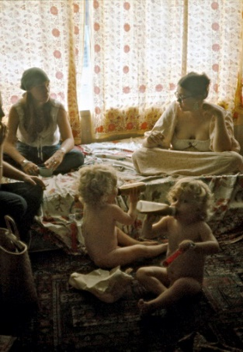  The "hippies" Lis and Diana and their children who I often stayed with in Toronto. Hippies in lifestyle for a short time, but later an artist and educator. Lis was the only Canadian who tried to seduce me, but failed during an LSD trip. | 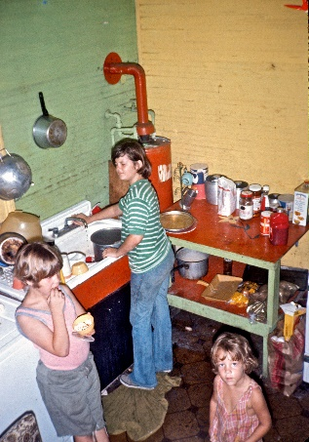  Bonnie Belwood's poor children in New Orleans were definitely neglected but were lovingly cared for by all the black men and me she sheltered. Featured in American Pictures in "Jacob's Letter"

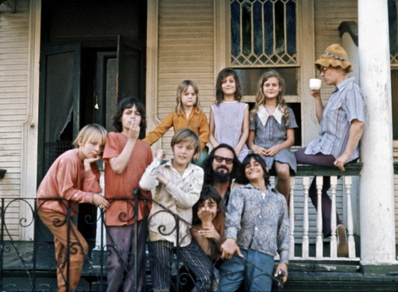  Collective in New Orleans where I shared a bed with Joy de Jesus, who is not pictured. | 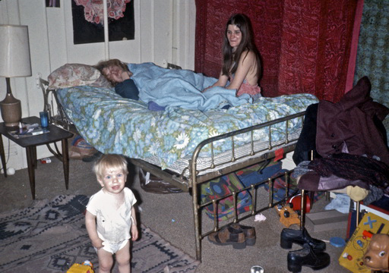  I shared this bed with Melitta and Mildred, the child and the cat in a homeless shelter in San Francisco, but were they "hippies" or just poor single moms?
So the hippie phenomenon was just a microscopic part of women's attempts to take control of their own bodies in the 70s. However, it's important to point out that not everyone in their youth was equally caught up in the frivolity of the time, even though they were all influenced by it. I saw this especially among the Catholics, oppressed by all their guilt and shame. A typical example was a couple of Catholic girls I met on a freezing cold December night in a laundromat in Manchester, New Hampshire. In the winter, I often went into the heated laundromats where it was easy to strike up a conversation with single women. I described it this way in my diary:
"At the laundromat I talked to Ann Irsyk and her friend about a place to stay. They took me home and as the evening went on they were more and more enamored of me, but conservative Catholic bank girls. Ann came in late in the evening in her nightgown and it was clear that she was interested in me. Even though she had a girlfriend who had just visited. She said that what made me attractive was that I didn't seem to be interested in girls. I knew with Catholic girls that they needed a little affimative action to help them out of their "sin and shame" upbringing and so, to her loud amusement, I gave her a loving hand on the living room floor. But suddenly Ann stood up and said she had her period, so I carried her into bed with relief. Finally, I could get a good night's sleep.
Saturday, December 29, 1973 - 402 Central St. Manchester, NH at Ann Irzyk's house,
The next morning her parents came and hid me while I wrote a letter to Tony. In the afternoon they said I had better leave. It was dark when I finally hitchhiked out of the city's meter-high snowdrifts. I was immediately picked up by two 16-17-year-old girls who eagerly called their parents to ask if I could stay the night. But no. Then got a ride all the way down to Cambridge, MA, to "The Plough" where I got talking to Ted Kennedy's cousin, John Fitzgerald Kennedy, who invited me to stay at his house."
(End of diary quote).
Here was a clear example of girls who were indoctrinated to confuse "the penetrating act" with "Penitential Act" (in Latin "Actus Paenitentialis" also called "Penitential Rite" during the years I traveled).
So, as a direct result of being virtually kicked out of a Catholic home for being unable to distinguish between the Pope's mortal and venial sins, which always confused and paralyzed Catholic girls, I was rewarded on the same day by ending up with the most famous Catholic family. By standing, as mentioned in "American Pictures", entertaining my experiences with Ted Kennedy's forgivable sins right after his mortal (killing) sins (the murder of a woman) without realizing that I was facing his own cousin, I was invited into his, shall we say, forgiving carnal family.

As this example also shows, virtually all American women were influenced by the implicit and pervasive demands of the zeitgeist that they should engage in "free sex", but not all were equally free to embrace the liberation from parental and religious upbringing.

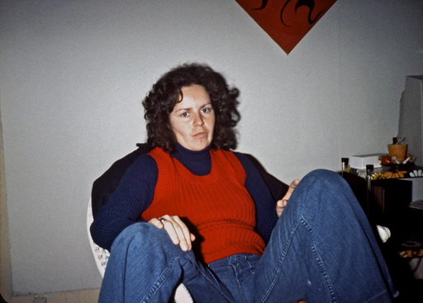  Ann Irzyk the next day, unable to face herself and her parents out of fear and shame for having gone too far in the night | 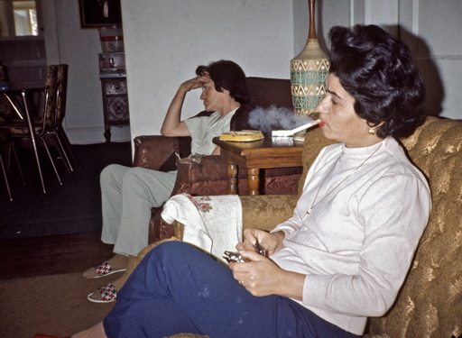  There was always something heavy about Catholic families - usually working class and without books in the home, like this Cathy Dekel family I stayed with in Gainesville, FL
I learned a lot about different religions by observing from my bedside their divergent reactions to the liberationist trends of the time. To put the self-torture of the Catholics in perspective, I'll briefly describe their diametrical opposite, the Jews, and tell you about a couple of my Jewish experiences that seem completely crazy today. A Jewish woman in Baltimore picked me up and immediately invited me home to use me as her bachelorette party before her wedding a few days later. If I remember this one-night-stand at all today, it's probably mostly because she insisted that we both inject heroin before having sex and thus the whole yes/no dilemma she put me in because in her case I felt really attracted to her - both by her body and Jewish teasing humor - not least towards her future husband, whom she sincerely and lovingly believed she could best serve in the future by acquiring as much sexual experience as possible. But she also teased me by insisting, in her most delicious petticoats and fragrant ointments, that there was no such thing as dipping one proboscis without also dipping the other when I was lucky enough to be her last free loved one before she was to be forever shackled. I was used to saying yes to all kinds of drugs, but sticking myself with needles and heroin was deeply repugnant to me, even though I had occasionally faked snorting smoking heroin. As I remember it, I waited until she lay with her eyes closed in pleasure under the influence of the heroin and to the New Age tones of the Sephardic Jews' almost psychedelically seductive old romantic songs, during which I slowly and empathetically, along with the sounds of the brown crystals in the silver paper, melting in the tinkling burning spoon held over our romantic candle, pretended that we had now, as desired, shared the love potion. Experience makes perfect and I had been through the ritual so many times with black drug addicts without it leading to anything more than, well, continued unromantic emptiness among their women.
Our entire exciting, mysterious, candlelit night of lovemaking was so successful that not only did stars and possessions seem to fly around and explode like a true bachelorette party, but the next day she insisted that it all continue by having me drive her to her wedding in New York. Feeling guilty about having cheated my way into premarital sex, I now feared being punished by her canceling the wedding at the last minute and taking me instead. I was used to Jewish women first dragging a black girlfriend home to their terrified parents to soften them up and then, to their relief, dragging home a white "gentile" whom they preferred themselves. And if, to their great sorrow, their parents didn't accept it either, well, then only at the very last minute to come home with the one thing they didn't want, a Jewish man. And all too often I had been chosen to play the second act in this long Shakespearean comedy before Mendelssohn's Wedding March.
But otherwise, her "offer" - or as I hear it "demand" when it comes to the ruling Jewish women (who for the same reason don't like "the ruling Jewish men") - suited me just fine as I was going the same way and wanted more romance on the trip up through "the shithole of the nation", as we hitchhikers called New Jersey. And so I also got a wedding party out of having faked the prelude to the actual act during which we now faked "old friends" to her chosen Jewish groom (which is why I won't mention her name here).

The reason I was traveling up from the South was to attend another Jewish wedding in Boston - my first Jewish girlfriend Marly Sockol's wedding to Gary, a doctor. I had hitchhiked up almost every month to stay with them because they were storing my photos, and each time Marly had treated me to gefilte fish, bagels and New York Jewish delicacies. It had been 4 years since my breakup with Marly, but we missed our amazing sex life together. We had once cheated on Gary by hitchhiking up to her parents' house in Boston to get back together under the pretext of picking up her guitar. And occasionally Marly had recommended to her friends that they try me sexually, but chemistry and chemistry are different. Her Jewish friend Beth Kaplan, in particular, I remember fleeing far away after a frustrating night where neither of us worked despite the 6-star recommendation. So I was a little wistful as I stood there as probably the only non-Jew at their wedding in the garden of the Brookline villa I had once been promised if we got married. Everyone knew I was Marly's former Danish girlfriend and asked if I knew how a Jewish wedding worked. "Oh yes, I was at a big Jewish wedding the day before yesterday," I answered boldly. And to Marly, I couldn't help but teasingly whisper in her own Jewish humor that "the bride was just as heavenly in bed as you!"
They were secular Jews, so I was a little disappointed at how quickly the traditional wedding ceremony under the chuppah and ketubah signing went this time. And then it all went wrong. I have no idea how many of the goodies I killed, but I managed to put such a big lump of shit in the wedding's only toilet that it completely clogged. Despite all the banging on the door, I tried to save the situation with my hands, but eventually had to call the father-in-law I had once been promised and had driven around with in their motorhome. My mood was already not too high about the bride I had stood up, and now I was so embarrassed about my attempt to sabotage my old girlfriend's wedding that I quietly sneaked out on the highway where I belonged. In just 5 hours, I hitchhiked back to New York, where just before midnight I walked into the Broome Street bar, still sadly fashionable. But no giant turd is so bad that it's not redeeming for anything. Because here was the most beautiful and adored black woman I'd seen in a long time, simply waiting for a man to free her from her deep childhood pain. And unlike all the other black women I had met who didn't want a poor white man who could offer nothing but hitchhiking for his dates, I had no problems this time. For late into the night I could now tempt Annie with "Let me take you home to my luxury apartment with a great view, so we can talk it over" as I now had Marly and Gary's apartment to myself while they got married in Boston. And so I got a little teasing revenge on Marly by spending my first night with my future wife in the bride and groom's own big bed with its amazing view in the morning sun over the East River to Brooklyn - here on September 2, 1974 - the same day I met my next wife Vibeke only three years later. Only a week later, Annie and I were hastily married as described in the first volume of "On Saying Yes", and when the registrar wouldn't marry us because I didn't have a jacket, I had to borrow the Frenchman's, who stood in front of me in line at City Hall, after which Annie and I were invited to his and his Jewish pro forma wife's wedding party in the evening.
The moral of the story - if modern eyes can see any moral at all - is that by "saying yes" to this kind of bachelor party, you are rewarded with no less than three Jewish weddings with Mendelsohn's Wedding March and free after-parties in just a week and a half in this 70s feminist version of "A Midsummer Night's Dream." Even the devious court jester Puck with his "I am that merry wanderer of the night" was rewarded with his own - admittedly black - wedding.
Or - as a less mischievous, more honest vagabond might put it - punished for his petty cheating in the process by having his beloved freedom on the road finally curtailed by his own marriage.
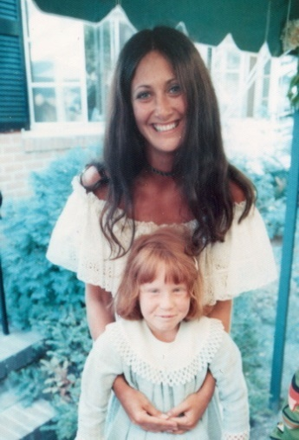  Marly as a newlywed during the chuppa with a relative. After three failed marriages, in 2005 she asked for my help to find her fourth husband, who she still visits every summer in Denmark. | 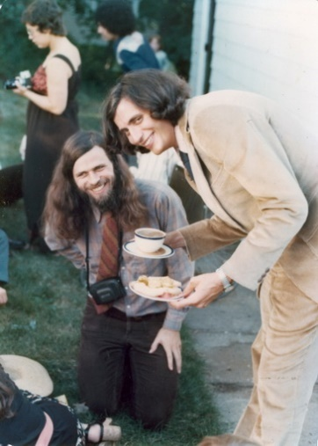  Groom Gary serves me at the wedding. Note my nice shirt that I always wore to events and still do.
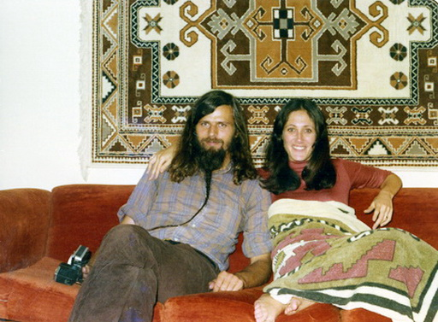  With Marly when I hitchhiked to New York every month to see my latest photos with her and Gary | 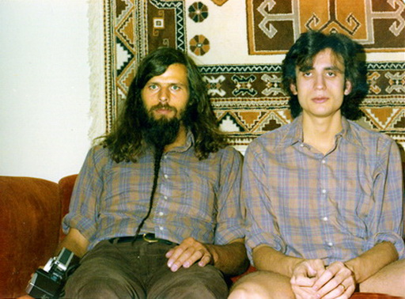  Marly always bought double the amount of clothes. Partly for her new girlfriend, Gary the doctor, and partly for her old girlfriend, "because without me you'd look like a lazaron as a hobo."
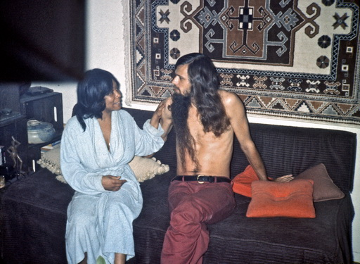  With Annie in my "luxury home" with Marly and Gary in the days before we got married | 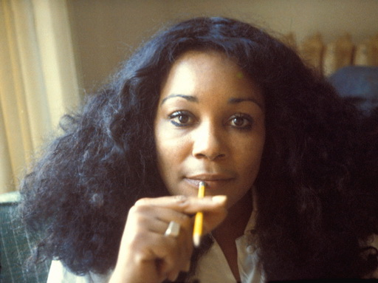  Annie a month later in the ghetto of San Francisco where our marriage began to fall apart.
And thus ended my vagabond years during this experimental era. At the end of my 5 years of hitchhiking through this wild time, I was able to conclude from my sociological records that although Jews make up only 2% of the population, over 25% of my girlfriends had been Jewish, while the opposite was true for Catholics; they made up 25%, but only 2% of my girlfriends.
But if I and my accomplices in the excesses of the time had believed - and we really did - that the time picture described here represented a new step up in the evolution of humanity's emancipation, we were soon to be disappointed. We were no more "liberated" than those before us, but merely slaves to a given era, for better or worse. Our liberation would soon be met with condemnation.

"If we shadows have offended,
Think but this, and all is mended:
That you have but slumbered here
While these visions did appear.
And this weak and idle theme,
No more yielding but a dream,
Gentles, do not reprehend."
Puck's final line in A Midsummer Night's Dream
____________________________________________________________________________
PART 2:
THE CHANGING ATTITUDE DURING THE LECTURING YEARS
When I returned to the United States as a lecturer in 1982, the youth had completely changed. They were now enslaved, first by fear of incurable STDs, but soon much more by AIDS. I felt it immediately when my book was published in the US and my "lifelong girlfriends" began to seek me out, maddened by unreasonable thoughts that I might have given them HIV. "Why?" I asked. Well, they'd read all my stories about the gay guys I'd been with. "Nonsense," I said, "AIDS didn't come to the US until four years after I left you, and I practiced little intimacy with gays, never anal sex except for a single rape in San Francisco 8 years before the AIDS wave started right there in the Haight-Ashbury-Castro district. And by the way, my rapist is alive today and just as scared as you are. I just gave him a conciliatory hug."

But fear is irrational, so for a long time I acted as a closet heterosexual with my old girlfriends; now they locked me in the closet instead of the double bed when I visited them. This is how I experienced that there was no longer freedom of expression in this new politically correct America. In any case, it meant punishment to talk openly and honestly about what we had done in the previous era, which - remember - was only 6-7 years ago for me.
In the intervening years back home in Denmark, I hadn't felt the difference quite as much - partly because the liberation of the 70s hadn't been so artificial and forced here and partly because the subsequent fear and guilt was therefore not as great. The transatlantic difference caused me problems when I returned to the US with my slideshow. I had given my photo editor Kitte Fennestad a free hand to select the images for the show, so in the spirit of Danish liberalism, she had chosen lots of images of half-naked women and men. But this certainly didn't go down well with the judgmental new American women's liberation, unlike the previously understanding, outgoing and body-experimenting women's liberation that my pictures from the 70s actually revealed.

Skinny dipping had been "as American as Apple pie" in the 70s USA - here in Texas | 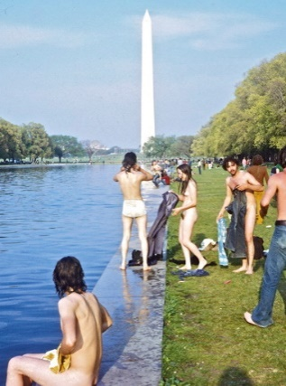  Skinny dipping even in front of the White House in the 1970s. Today, they would be immediately arrested.

The relaxed attitude to nudity in the 70s - here millionaire Tommy Howard in North Carolina. | 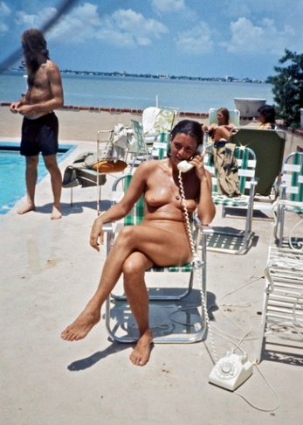  Here in 1972 Carol Realini, who had had sex with Jerry Rubin, Abbie Hoffman and John Lennon, in a millionaire's home on Miami Beach, where I stayed with just such celebrities during Nixon's convention.
Now, especially in feminist progressive strongholds like San Francisco, some called this my "sexism", which is why my black employees were busy removing about half of these images quickly before my arrival (directly from the Africa of naked breasts), even though they had not reacted negatively to them while working on the show in Denmark. Ok, so we had to move and censor the show, because as Søren Ulrik Thomsen wrote, "When the zeitgeist moves, it really requires that you hold on to your common sense."
The funny thing was that I only had a few intimate images of black women in the show - women who, in most cases, I had never had sexual relations with (which is why the misguided notion of sexual exploitation of "oppressed" black women was probably the real stumbling block of white feminism). While nowhere in the show did I have pictures of the numerous "liberated" white women I had been with, which otherwise should have warranted a debate about sexism that was also relevant to me. Incidentally, I initiated this debate myself with this passage in the show:
"The greatest freedom I know is to be able to say yes, the freedom to throw yourself into the arms of every single person you meet. And yet I soon learned that there are limits - for example, when hitchhiking as a man. Since white American women can be unusually open, they become extremely vulnerable. It's important to let the woman set the boundaries of a friendship if you hope to circumvent the sexism you received from society. From our earliest childhood, we were never given the choice to be sexist and racist or not, but only to try to counteract the most negative processes that our suffering can cause. If you are not aware of your suffering, you will inevitably hurt the oppressed with your "master vibrations". And yet, like when I'm picked up by male drivers, you can't just say yes and float along to the point where hurt feelings can arise. Even the most skilled hobo makes mistakes here. Not least because you're so vulnerable yourself, and the rigors of the road often make you fall in love with people you would otherwise never open up to.
So being a good hobo - not to mention politically correct - is harder than being a tightrope walker."

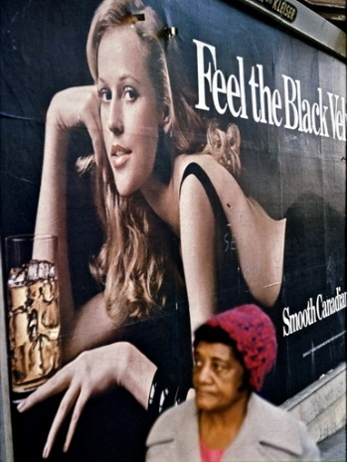 | 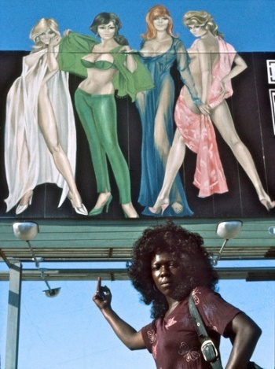
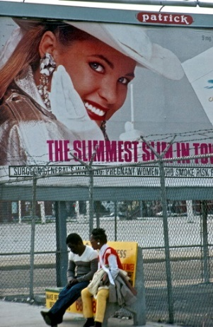 | 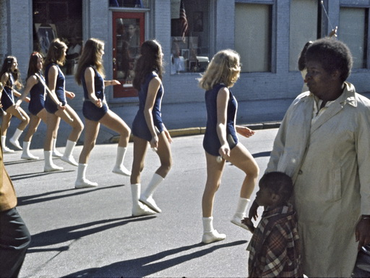  In American Pictures, I had focused on the impact of white sexism on the black psyche and other minorities who couldn't live up to the ideal image.

I had long since learned that in order not to create rejection with my use of the word racism, I should always start by addressing my own racism, and it worked even now with my parallel acknowledgement of "my sexism". At the same time, feminists felt that I understood them through this equalization between the two forms of systemic oppression. And since Jewish women were the most eager to give large sums of money, the word "anti-Semitism" quickly came up (or was it in reverse order?) as did "homophobia" here in the gay stronghold of financial support for American Pictures even from the Log Cabin Republicans (homosexual republicans). So, while the most vocal and articulate criticism of "American Pictures" came from feminists, they were also the ones who most ardently supported us (i.e. us male viewers) because they saw the show as a consciousness-raising tool for their own agenda.
Therefore, the criticism was mostly about making this tool even more perfect and powerful, which is why a myriad of dedicated feminists lined up to help me in my lostness just like the women in my vagabond years. Ironically, the whole image of these hard-working feminists doing all the clerical work for us black and white men, traveling around and taking all the credit for putting on the show, was itself a picture of classic sexism. They were even the ones who, during our cashless start-up, had to work off all the men's unpaid traffic fines through hard floor-scrubbing cleaning work for the city government. Having arrived in the US with no money after sending all our European profits to the fight against apartheid in Africa, we wouldn't have made it out of the ghetto in our sudden poverty in the first year without this feminist helping hand. In particular, the idealistic Jewish feminist Amanda Berger got the show on every American campus and saved my entire 30-year American career when, as my tireless publicist and office assistant, she moved with me into my new headquarters, which she procured in New York from a group of lesbian feminists.
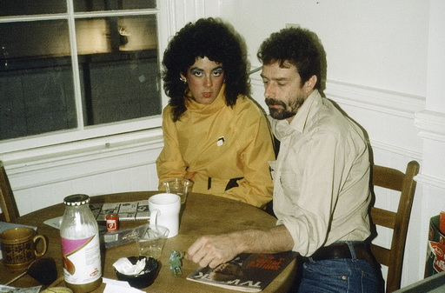  Amanda Berger in 1982 with volunteer activist during the publication of American Pictures in San Francisco | 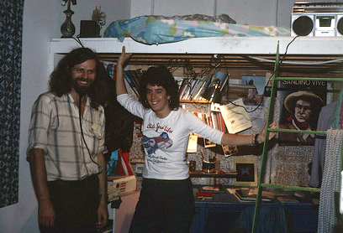  Amanda in 1984 at our feminist collective in New York. I owe Amanda my entire American speaking career
BEAUTY IN THE DISGUISE OF UGLINESS

I also owe my American success to another important feminist. It was Mog Decarnin, who I had noticed as a writer for feminist and gay magazines, attacking the show for sexism, but at the same time defending and praising it to the skies. When we finally got our own theater in the Mission ghetto after six months of trying to get the show off the ground with no money in San Francisco, in a country where success is all about money, we had no money for furniture and decor. But then I started seeing nameless posters all over the city asking people to donate furniture to us. Eventually, I discovered by chance that it was Mog Decarnin who was behind it and went to see her to thank her. But what a shock it was. Where I had imagined it was an outgoing and social intellectual giant who had written all those articles about us, I now discovered that it was the most shy, introverted and self-hating gigantic fat white woman who literally dragged her belly down the street behind her and in her shyness always wore sunglasses and her face hidden under a pulled-down cap - when she even went outside from her bed in the messy smelly apartment in which she was obviously even poorer than us. The smell came from cooking soup from butcher's discarded bones, canned cat food, etc. Yet she herself had put up posters all over Haight-Ashbury asking people to donate theater chairs and "emperor size" beds to our upstairs residence. In fact, she was such a huge hidden admirer of mine - despite her criticism - that for the first few times she sat awkwardly almost with her back to me in a clumsy attempt to cover up her gigantic meat mountain. In order not to embarrass her, I only dared to take a picture of her a couple of times.

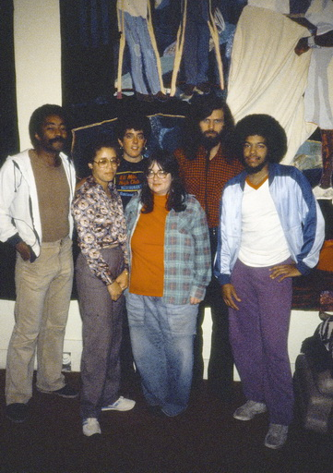  Mog in the middle with Tony, black volunteer, Amanda, me and Howie at the theater in San Francisco | 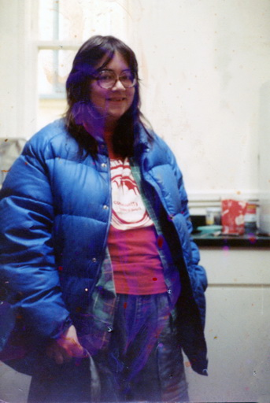  Mog in our newly remodeled apartment above the theater. In today's overweight America, I don't understand my prejudiced view of her back then as "fat".
But it was this woman who saved my book in the US, because when I had already realized what a brilliant intellectual and perceptive feminist she was, I asked her to help me rewrite my Danish book to fit into this new politically correct America, where I myself felt a bit alienated - yes, it was as if I had to rediscover America anew and throw away all my knowledge from the 70s.
A good example was one day when I invited her to the movies to watch the feminist film ”Yol” about the abuse of women and honor killings in Turkey. We were both deeply shaken, but outside I was the first to say, "Well, you have to admit that we have come a long way in the feminist struggle in the West after all." Mog immediately shut up like an angry oyster and wouldn't speak to me for three days. For her, the movie confirmed just the opposite, all the parallels in women's oppression. As I had so often experienced in my workshops how all the women in front of a topic saw red where men saw green, I immediately thought that Mog should help me, as an absolute "green" in feminism, to make my book "red" and edible in this new zeitgeist.

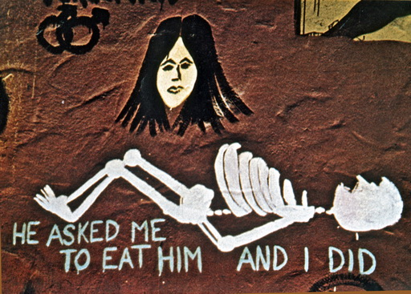  I photographed these feminist murals in the 70s, but their aggressive message belonged more in the 80s | 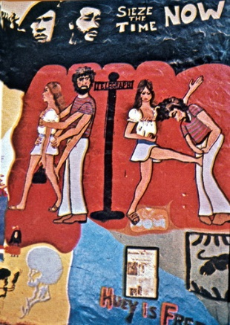

So the following year I invited Mog Decarnin to Denmark for 9 months on full pay so that we could work on the book together. I thought we were a fairly spacious work collective in Købmagergade, where we housed travelers and refugees from all over the world, but it became quite an ordeal for the other employees to see Mog dragging herself around the kitchen every morning as she cooked a huge pot full of meat bones that made the whole house stink so "disgusting" that the others went and held their noses when they saw her. We could accommodate Africans, Arabs and all sorts of other refugees, but not a white "disgusting" American.
So, for the sake of the tolerant housewife, I soon had to borrow a cottage down by Svinø to work with her there. It was only here that Mog realized by a funny coincidence that what she and the feminists in the US had seen as my "sexism" in the show instead represented a Danish cultural trait. When I finally coaxed her out of bed one blazing hot summer day and onto the beach in her American garb, she got thirsty and went to the beach grocery store to buy one of the large colas Americans like her use to fill up their volume. But it was a nightmare she would never forget and certainly had never experienced in the US. In an endless long line of naked and half-naked people and breasts, she was the only one dressed - even in her shabby, worn-out blue work clothes of the kind my friend Søren Ulrick Thomsen usually wears on the streets of Copenhagen (when he's not performing). She probably rightly felt that all the "beautiful, slim, naked" Danes looked down on her and only thirst kept her from escaping this liberated image of Denmark in 1983 before we ourselves became Americanized.
It annoyed me that I caught myself being prejudiced against Mog. I had been used to sharing beds with all kinds of scum in the US, but now I feared throughout my stay that Mog would try to have sex with me as perhaps the first in her life. That it didn't happen was probably because one of the things we argued about most in the book was my empirical postulates that American women can't share a bed with men without it ending in sex, while I claimed that this was not the case when I shared beds with women in Europe. Mog saw it as an attempt to get back at American feminists - to blame my many sexual relationships on "the aggressive American woman", as I wrote, even though she knew that with the lack of trust in men in the US, no woman would dream of inviting a man into her bed without a prior desire to have sex with him. But she saw men as pigs all over the world and although she wanted to see me as the "innocent" party, she was so American herself that she wasn't convinced by my explanations: i.e. that I didn't automatically get sexually involved when I shared a bed with European women!

Since we were getting nowhere in our long ideological bed fight, we decided to put it to the test. I was about to hitchhike down to the big book fair in Frankfurt to coordinate a large-scale joint re-release of my book in 7 countries. Since Mog could read German and for several years I had received boxes of fan letters from mainly German readers, I asked her to pick out some of the ones that looked the most groupie-like. She spent several days sorting through stacks of letters and then selected a smaller stack of about 10. With these addresses in hand, I took to the road and on the way to Frankfurt, "randomly" and unannounced, knocked on the door of some young girl who had once written a moving letter to me - often four or five years earlier when the book was published in Germany in 1978 - to ask for shelter on my journey. Fortunately, they all lived alone, except for one who lived with her parents. But even in her case, I was invited to share a room with her, which in the US I only experienced with Jewish families. In two cases I was put on the floor on a mattress in the girl's room and in three cases I shared her bed for lack of another sleeping space. Everyone was delighted and surprised to see me, but in no case did they make the slightest sexual advance. I, of course, was as passive and politely expectant as I had always been in the US. I reached five before the book fair started and felt that I had won the bet with Mog. But as a check, she had selected a single letter from an American living in Germany. And it was only there - at the home of black divorcee Jessica Riddelbaum in Nuremberg - that things went wrong. After putting her child to sleep on the second floor, she came creeping down to me in the dark in the bed she had made up in the living room and started the kind of one-night stand I hate because they always fail. But even though my basis for comparison was statistically too narrow, Jessica ended up being the final proof that my theory was correct. Also on another point, because while black women in the US were usually under so much social control that they wanted nothing to do with me as a white woman, Jessica had apparently freed herself from this internalization during her long stay in a white country. Just like Tony Harris and my other black American employees, who only in Denmark allowed themselves to have white girlfriends.
Mog was fully satisfied with my vagabond scientific study from the highways and byways of Europe, knowing that I had been honest about the outcomes of all my visits. And so I ended up winning the battle to get one sentence (for it was all about one sentence) that I had fought to get into the American book. Through hard work and Mog's help, I was able to silence the white feminists and make the book so politically correct that it could be used in American universities.

Our collaboration continued until death do us part as America constantly went through new eras. When I did my final "Harvard edition" of the show in 2000 - with most of the 20 professors and sociologists I assigned to edit the show coming from Harvard - I chose Mog as editor-in-chief. In my Christmas letter to old friends that year, I mused about how much you can fall in love with a woman who presents herself as the beauty in the body of the beast, though I'm not proud of the prejudices I revealed:

"But her interior is one of the most beautiful things I know, and everyone who corresponds with her over the Internet - where you never have to see or smell each other - falls madly in love with her. That's when you realize how much we really discriminate against those who don't look too pretty. Mog writes so incredibly beautifully that I always fall madly in love with her and immediately rush up to her in Hollywood when I'm back in LA. But every time I'm hit with the disappointing shock of facing a lump of fat that gets bigger and bigger over the years, with her belly literally dragging along the sidewalk .... the few times she comes out of her darkened, smelly apartment where she lives on big boiled bones ..... with dark sunglasses and a cap pulled down over her face in embarrassment of herself. And then suddenly we can't find anything to say to each other beyond empty pleasantries - even though 3 years ago I calculated that our total email correspondence had already reached 1 Mb - as voluminous as a "Gone with the Wind" novel. I am deeply in love with Mog.... and yet I had to sneak out of bed every night when we shared a summer house for months while writing the book, for fear that she would suddenly rape me physically just as she did mentally during the day. And I'm not usually squeamish when it comes to my body. In my defense, the reason I was being a bit precious was because I didn't want to jeopardize our continued friendship. There is always a risk associated with physical intimacy. It usually loosens things up and leads to a deeper and more enriching form of communication. But it can also go wrong, and the latter - the fear of losing a loved one - is what keeps many of us from taking the full step into what should be the easiest thing in the world: physical touch." (From the Christmas letter in 2000)

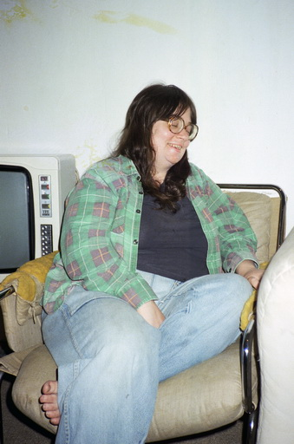  Mog working in Copenhagen in 1983 | 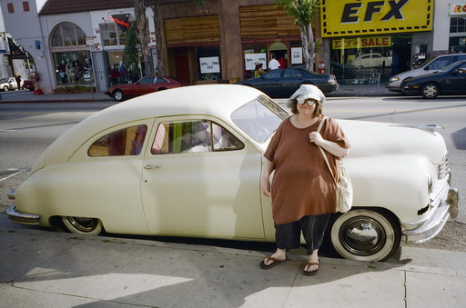  Mog during a visit in the 90s when she had moved to Hollywood to be near the "stars"
As this chapter was written in the midst of the Corona era's ban on physical touch for fear of death, while my entire friendship with Mog had started as a reaction against too much physical intimacy and freedom in the past, it felt like a huge betrayal on my part that I never even cuddled with Mog, even though we shared a bed for a long time. But I was convinced that she wouldn't have been able to handle it because of her disgust for her own body. As for this tangible betrayal of a woman who had never experienced love, well, I also let her down when, just before her death from cancer, she sent a cry of distress to come and visit her in the nursing home. But I was working on another ego project, my big exhibition in the Louisiana museum, when I got this last message through a friend:
Sendt: 3. januar 2010 23:45 Til: Jacob@Holdt.us Emne: Mog Decarnin
Hi Jacob: I'm an old friend of Mog Decarnin's and I've been asked by Mog to let you know about her current situation. As you may know, she is now living in Kalamazoo, Michigan, having moved from Los Angeles. She was diagnosed with cancer and underwent chemotherapy. She was in remission for a year, but the cancer is back and has spread. She is currently in a nursing home, having suffered a stroke. She would very much like to hear from you. I am in contact with her almost daily, so I can relay messages, or you can write to her at this address:
Mog Karen Duff c/o Plainwelll Pines Nursing Center, 3260 East "B" Ave. Kalamazoo, MI, 49080 (Denne mail kan naturligvis udelades)
I managed to call her, but only a week later she died on January 8, 2010 - the day I went around photographing homeless people in Old Delhi and only three days later gave a lecture about my life with American Pictures in Louisiana's packed concert hall. All my life I feel like I've let down the people who meant the most to me. In her obituary, one of the most important things she had accomplished in her life was:
“Karen was the American consultant and special editor for "American Pictures" and in 1986 won first place in the Writers of the Future awards.”
What I didn't know was that she had also published poetry collections in her youth. Her sister wrote that "in second or third grade, Karen was accused of plagiarizing a poem about a little wren because the teacher thought it was too good to be written by someone so young. All of us who knew her as Karen the writer, Mog or Camilla, know that she was at least as good and probably better than her teacher."
But to this day, I communicate with well-known American writers - especially gay writers like Samuel R. Delany - about how much Mog meant to them. One reason she wrote under many pseudonyms was that she was a long-time spokesperson and writer for NAMBLA (North American Men Boy Love Association). She believed - despite her feminist sensibilities - that healthy sexual relationships could be established between adult men and boys, which was the only point where I had doubts about her judgment, as I had started hearing too many incest stories in my workshops. It may have saved me from a sexual relationship with her, as I soon found out that it was my son Daniel she was completely (but covertly) in love with since he was 2 years old in San Francisco.

As I said, I owe all my success in America over 30 years to feminists like Amanda Berger and Mog Decarnin, but the thought now strikes me while reflecting on Mog as to whether she was, in a way, really seeking me out as a cry for help like so many of the women I met in my vagabond years. For a similar pattern was now beginning to repeat itself in my workshops in universities. This exciting chapter will have to wait for "Saying Yes to American Students," but let me just mention here an example that is somewhat similar in body volume to Mog's.

Because how dangerous it would have been in my relationship with Mog to mix the artistically creative with the intimate, I often experienced during my lecture tours if I accidentally mixed the therapeutically liberating with the intimate. A funny story illustrates this nicely.

On the fall tour in 1987, I had the refined and beautiful poet Pia Tafdrup in the car, but dropped her off with some family in Chicago to take a couple of flights to universities on the East Coast. With the different attitude of Danish women, I always tried to invite such a Danish watchdog along on the trips as the best guarantee that I "didn't get into trouble." Because then any groupies would conclude that I already had a girlfriend. With my old hobo philosophy, I had a hard time saying no to female aggression, as I had learned not to consider my body as something precious. Getting my soul, my love and attention was a completely different matter, which you don't have time for as a speaker, which is why it is irresponsible to get involved in intimacy by virtue of the artificial power you have as a speaker. The problem was - even in these new PC times - that when you're in show business in America, you're particularly vulnerable to female sexual aggression. As Tom Wolfe wrote in the contemporary bestseller "Bonfire of the Vanities":
"These goddamned girls in colleges - you wanna know why people go out on the lecture circuit in this country? The girls wanna get laid by Authority... Power....Fame...Prestige...by their fathers, if you believe Freud."

Well, as far as fathers go, even my divorced 68-year-old father found a new wife in the first university I took him to, MIT, just by standing by my - the lecturer's - side.

With this in mind, coupled with my plutonic attraction to "victims", you will understand the trouble I got into without Pia Tafdrup's protection when, on September 25, 1987, I flew from Tufts elite university in Boston to my next lecture at the U. of Wisconsin's branch in Janesville - a university mostly for the poorer working class. After the lecture, I had my usual workshop, which in such poorer schools often ends up resembling AAA meetings for alcoholics and drug addicts. Already in my initial teaching, I can usually sense if someone has been subjected to various forms of oppression. Alcoholics, incest and rape victims, who know all the psychological traps that follow, also understand much faster than others what it means to be racist, sexist, homophobic, etc.
After the workshop, two women who had been crying during my session came up to me and said that they were deeply touched by all the patterns in themselves that I had touched or brought to the surface. And they asked me, somewhat earnestly, if I would go home with them so we could continue to "nurture each other." As it happened, the organizer had not been granted money by the poor university for hotel accommodation for me, and after my "yes-philosophical" sermon, I could not afford to say no, even though I knew it was dangerous to go home with someone whom I had just as strongly "opened up." They were both extremely overweight in the Mog weight class, which is why even before they started talking about it, I suspected them of having been subjected to incest and then rape. They had since acted out the pain by becoming alcoholics, heroin addicts and endlessly comfort eating as "compulsive overeaters". They had met in some kind of healing self-help project, where they had first realized how many of the other fat American brothers were also incest victims. It was therefore also a strong emotional experience for me when they shared their own methods of "healing" each other with me throughout the evening (I am so used to using the American terms "heal" and "nurture" that I have a hard time finding something suitable in Danish, also because Danes are so much worse than Americans at working with our deeper emotional layers). We both cried and laughed as we cuddled and rolled around with each other on the living room floor, and it was in many ways a warm deja vue with many of the experiences I had had with just such poor women in my vagabond years, but which I had now distanced myself from in the elite universities and lonely hotels for the many better-off young people I usually taught here. I could feel that this had been a deep loss during the clinical but politically correct distance I had now gained to women by virtue of my lecture success.

But by morning we were tired and although they didn't normally live together, they insisted that I sleep between them in the only bed, a huge waterbed. And it was truly a rocking experience between the 400-pound Cheryl Rompa on one side and the 200-pound Lisa De Mars on the other. But even though, unlike my vagabond years, I rarely had the opportunity these days to enjoy the freedom to "let go and float along" into such educational experiences, I was now completely submerged in fear of what would happen if one of them suddenly disembarked and the whole ship capsized over either starboard or port. And who would I prefer to capsize with, the gigantic but lively Rompa, who was lying in the stinging sea with her eggy, wiggling butt right up in my abdomen and felt she had the starboard green light as a resident of the house? Or the quiet, slightly more "edible" dark girl from Mars, who, a little more Venus-like and polite, was lying in a puddle with port red lights, knowing that she didn't have much to claim in this rocking house.
To my horror, Lisa woke up at 9am to go to her school class. And no sooner was she out the door than Cheryl quickly buried her bulging arm underneath me and, in one swift move as if I were a feather, flipped me on top of her meat mountain and held me there with her strong arms. Now I was lying on top of two rocking water beds and became completely seasick. If only at the thought of what to do next, even though the seasickness alone actually answered the question by making me so impotent that not even the best I could remember about "duty sex" could be used as a lifebuoy. First of all, we had long since left the non-committal freedom of the 70s for fearless play. Now, like most people, I was paralyzed by the fear of AIDS. Using my knowledge of this subject from the USA, I had written an article in the Danish newspaper Politiken that summer about "AIDS hysteria in the USA and in Denmark", from which I knew on a rational level that my own fears were unfounded as I was not part of the risk groups. Lisa and Cheryl, on the other hand, with their long lives as intravenous drug users, did. Furthermore, it was a firm principle NEVER to use my artificial power as a speaker to obtain sex with women right after they had been mentally "raped" by my show. But what paralyzed me the most was the guilt of never being able to turn on women who had such large dimples that you had no sense of whether you had penetrated the right place, to put it as insensitively and discriminatingly as it can be said from the deepest slimy throat of the subconscious. Because I wanted to see and recognize all people as equal - even when their shapes felt a little too unequal, so to speak. So the worst part of this experience was all the guilt I felt.

During my vagabond years, I had learned to love everyone as they were: crooked, angular, round, flat-chested, flat-chested and, not least, the spacious, all-embracing, etc. and in that sense had developed a democratic view of women as opposed to the small-mindedness that advertising and class indoctrination had given me as a child. The fact that I had once again strayed into a narrow, parochial and elitist view made me feel guilty and "afraid of falling" by not accepting the gifts that were given to me. Had I become too posh and spoiled by my association with the many smart, slim and rich students to indulge in the frequently abused and anathematized victims of the lower classes, which was what my lectures were all about? Would Cheryl, with her low self-esteem, be able to avoid thinking that the only reason I didn't want to have sex with her was because she was too overweight? Because she wasn't actually ugly. Quite the opposite. I was simply so afraid of disappointing and hurting her deeply when we had just the night before had had such a beautiful and intimate time with each other that had touched us both deep in the heart. Ever since then, I have used this situation as the best argument for never engaging superficially sexually with people you have nurtured something as non-superficial as intimate therapeutic interaction and close contact with. As I recall, I ended up saying all this to Cheryl, and to my own emotional and her corporeal relief, she ended up understanding without hurt feelings.

But for many years afterwards, I felt so guilty about it that I kept visiting her again and again, something I was rarely able to do with former students in these remote parts of the US, where a return visit required days of driving. One reason she became a sort of "lifetime girlfriend" in this sense was that through her therapies, she eventually came out of her role as a victim and eventually got into the elite U of Wis. in Madison, where I frequently had performances. As a result, I was able to continue living with Cheryl without the issue of sex between us ever coming up again - perhaps because she had now become a professor of sexology for the medical students. Through her healing, she had also come out of her compulsive binge eating and appeared so "edible" even to a chauvinist like me that I no longer had any inhibitions about photographing her. However, before her death at the age of 63 in 2015, she had once again become such a gigantic meat mountain that it probably killed her. And today, as I communicate with her equally overweight lesbian daughter, Basia, whom I knew from the age of nine, it reinforces my suspicion - also from following many black lifetime friends - that traumatic memories can be passed down through generations, for example through a mother's painful experiences (See here and here and here).
Cheryl with her daughter Basia after losing weight | Cheryl in 2010 when she had given up the fight against obesity
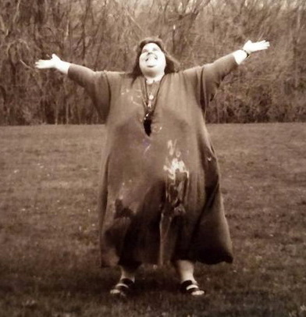  Cheryl from a later family photo | Daughter Basia at her lesbian church wedding in 2019
The somewhat younger 22-year-old and more enigmatically introverted Lisa I also kept visiting a few times. The last time, she lived as a timid hermit in the dark woods of Wisconsin, in a cross between Laura Ingalls Wilder’s and Hansel and Gretel’s house with vines spilling in through the cracks.
She clearly hadn't gotten over her childhood incest and adolescent rape and fear of men. And if I had feared that she would also have had "backboard sex" with me that first night, I now realized that it had been completely unfounded. Because when we slept together in her double bed, she made sure that her big black Vietnamese pig lay between us. "You'll have to put up with it, it sleeps in your place every night." And - spacious as I am - it wasn't difficult for me to find my inner, equally black-eyed pig when it lay there all night long, scooping me in the face and alternately rolling around and giving her and me juicy kisses. In these politically correct times, it was a rather staid way to continue juicy intimacy with women. No, far worse was her gigantic black Great Dane, who was also used to lying there, and was now so jealous that I had taken over the space that throughout the night it stood meter-high on its hind legs at the end of the bed with its front legs firmly planted on my stomach while it drooled all over me. It was impossible to sleep, but Lisa slept just fine with these animal defenses against her nightmares of past human rapes. Without the protective Cheryl, she was no longer going to enjoy any of the "nurturing" and "intimate" therapy.

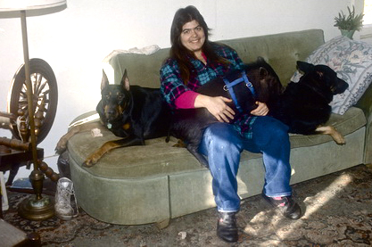  Until I found this picture of Lisa from 1988, I had forgotten that there were actually two dogs plus the pig | 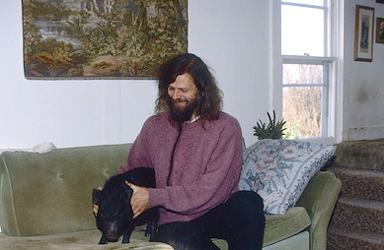  If you want to practice inclusiveness, sleeping with pigs is a good exercise
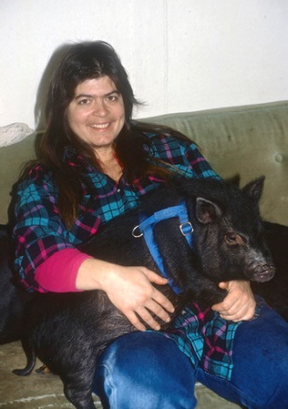  In 1988 Lisa was still quite plump | 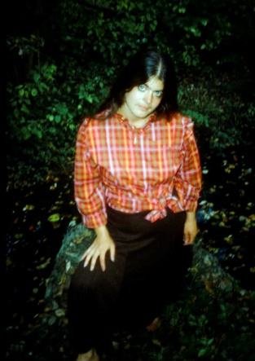  But by 1990, she had gotten so much control over her shape that she seemed to be flirting with her new self-esteem. She attributed the transformation to the therapies she had undergone
Strangely enough, the experience later became important for American Pictures, because when I picked up Pia Tafdrup in Chicago the day after my first visit and told her about my rocking experience between two fat mountains, to my surprise she didn't see the humor in it, but reacted with deep disgust. Oh, she's probably just jealous, I thought, as she wrote her latest poem in the car, here's an excerpt:

The heart beats behind yes
Awake to the sound of Chicago
through the open window
impossible to sleep with Boston
Philadelphia Washington and New York in my blood
minerals of joy
rivers of incomprehensible trembling.
Where did the uneasiness come from
that drove me forward
and where to?
Clearly it had created some turmoil in her, because when we woke up in the guest bed the morning after my next lecture on September 27th at Albion College, Pia told me that she had had a terrible nightmare during the night. It was after she had seen me in a new university every day for a month defending both the black as well as their white racists in my lectures. Now she told me that the dream was about a horrific scene of a very large, overweight, terrified black woman being stoned incessantly by an angry mob around her. Suddenly I appeared in the crowd, but instead of helping the poor screaming fat woman, I stood eagerly photographing her as she was being stoned.
I was deeply shocked by the accusation in her dream, because I knew that as a conflict-averse person, I had always hidden behind the camera instead of taking action and intervening. When you experience the people behind both sides of a conflict - and feel that you yourself contain elements of both sides - you don't like to hurt the feelings of the oppressors by directly criticizing them. It's easier to blame the system they all suffer from: racism, anti-Semitism, Islamophobia, sexism, homophobia, etc.
So ok, in that way I might have escaped responsibility in my vagabond years by hiding behind a camera and not getting involved, but at least in my workshops I was at least trying to alleviate the pain as in the case of Cheryl and Lisa, right? But then again, just by telling the story and actually distancing myself from them by exposing my deeper disgust for their obesity, I had (have) once again created entertainment at the expense of the intimate confidentiality that all palliative healing requires. In other words, I had once again made them my victims?
Perhaps also by later countering the frequent criticism from blacks by retelling "Pia Tafdrup's nightmare" when I was subjected to "kill the messenger" attacks over my "blaxploitation" in American Pictures. However, this "confession of my sin" usually had a disarming effect on blacks.

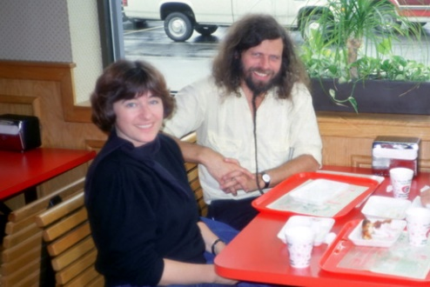  With Pia Tafdrup photographed by my father when we ran into him in Maine with his new American wife | 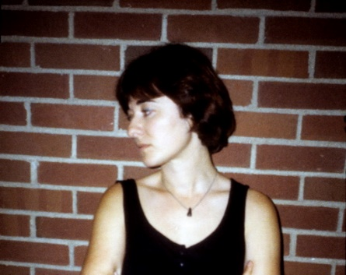  Pia blamed me for not taking more photos. It was one of the only ones I took of her on the trip right after her nightmare
Still, it was Pia Tafdrup herself who started more blaxploitation when she wondered why I had stopped photographing people since my hobo years. Which to me was an accusation of not being interested in them anymore. After all, I hadn't commissioned anything else since "creation" other than to rest on my laurels without having time to "build bridges" to the ghettos. I hadn't even thought of that until Pia brought it up, which is why I immediately went out and bought a new modern SLR camera and started photographing again - 10 years after I had stopped.
Why do I find Monet so alluring
on this side of the Atlantic
the blazing bright light in his images
the eternity captured in the passing.
How can the sun shine
through centuries here
intoxicate
across time
the ephemeral fluid and spiritual few existence?
My journeys, movements towards light
nothing more
than the prayer for a bridge
the many embraces I received
by whites and blacks.
Seconds
between heart and heart.

In doing so, Pia Tafdrup actually helped me to renew and extend the life of the show and all my work in the US well into the 90s and 00s - even the "black lives matter" movement - at a time when some of my images were becoming too "70s".
And thus also to hold on to my photographed friends from the 70s by making lifetime stories about them during my continued visits and through this, my renewed inspiration and internalized anger from the ghettos, not to burn out as a lecturer. In other words, I owe it to Pia Tafdrup that my "old girlfriends" were now upgraded to "lifetime girlfriends" - if only to prevent her "nightmares" about me from coming true.
Again, what I don't owe the loving intervention of women in my life!

Turn on the tingle
rhythms of light in me
the light of the day and the decades
so that I may glow through the centuries
changing color
like maple leaves in the forests of Canada
when sugar processes break loose
the first autumn nights
where cicadas' swaying membranes reach stars
that strike out
and open
for death
can pass
without pain.
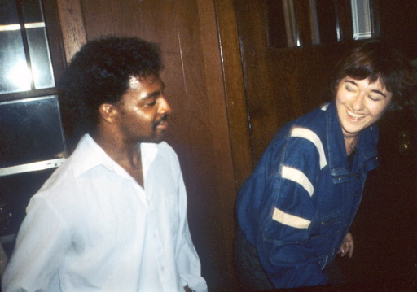  Pia Tafdrup dancing with David Wilck, organizer of my racism workshop group at U of W in Madison in 1987, where Pia herself gave a presentation with her poems. | Pia in Mary Darlene Kelly's shack with 24 residents in Sardia, Georgia, when she persuaded me to resume photographing black people two years later. Oddly enough, in the same windbreaker as two years before.

14 WOMEN IN 17 DAYS - OR WAS IT THE OTHER WAY AROUND?

Because "the heart can also stop beating behind a yes" and burnout was always my worst enemy when I stood on stage day after day for years and couldn't help but repeat myself. Nothing illustrates this better than another woman's story.

On my fall tour in 1990, I felt so burnt out and uninspired after over 400 repetitive talks day after day that I became more and more withdrawn. I had fallen into a deeper depression with head pressure and felt like I was unable to connect with others and that I was "talking past" people. Although I frequently faced audiences of 1500 - often 80% of whom were women when I was invited for the 2nd or 3rd time to a university - this mental state manifested itself in increasing feelings of loneliness. I never got close to people anymore and although I spoke to "female values" I still felt a frustrating distance from women.
Eventually, I was so distraught that I called an astrological friend in Denmark. Lisbeth Schneider had previously counseled me with great psychological insight and even predicted what I would encounter, e.g. on which days the stars would expose me to angry "kill the messenger" attacks from lonely black women in the middle of a "starstruck" white audience.
"What's wrong?" I asked.
"I'll tell you what's wrong," she said without a moment's thought and immediately launched into a long, incomprehensible astrological explanation.
"But that will all change from this weekend," she finally said without explaining how.
This was perhaps the clincher. I remembered how she had previously told me that you could challenge or influence your starry destiny and realized that I had to do something transgressive myself to break out of my stagnation. When I had just flown into New York and had a long weekend off, I first thought that I had to be brainwashed out of my mental American ghetto by taking a liberating flight to the Bahamas, Puerto Rico, Jamaica, etc. But then I discovered that a "men's liberation workshop" was being held in Seattle that very weekend. It was organized by the RC-groups, that work with co-counseling, a self-help method for liberation from pain accumulation. My co-worker Tony Harris was affiliated with the groups and had previously in the 80s gotten me out of an inspirational stalemate by using the theory in my workshops, but in my crazy busy schedule I had never had time to try out the method in practice.

So I immediately flew the 3,000 miles out there, rented a car and drove out to the beautiful retreat site under giant red spruce trees in the redwoods of Washington state. There were over a hundred men gathered of all ages, from 8-year-old boys to senior citizens, from the unemployed to the richest CEOs, black and white, fat and thin. But what they all had in common, unlike me, was that through the daily practice of co-counseling, they had learned to process not only the injuries of childhood, but also the slow accumulation of pain in life in general. Now here they were - two by two - helping each other to "discharge" the pain build-up through laughing, crying, shaking, yawning, etc. - something you apparently got better and better at the more you practiced the technique. Although I had never had the necessary training, I had been allowed to participate as many people knew my work, which on a theoretical level was parallel to their own. Tony had shown American Pictures at the headquarters in Seattle, where the manager Harvey Jackins had said of me afterwards, "That man thinks just like us." And since then, after almost every performance across the country, I had been asked by someone in the audience, "Are you familiar with RC?" and the answer, "Yes, but I feel like a Stone Age person for never having practiced it."

And I was not going to regret getting my act together. Rarely have I met more loving, attentive and outgoing people who took all possible time to "counsel" with me about my obviously accumulated pain and gradually - despite my built-in skepticism and to my own great surprise - got its knots untied and released them in various forms of releases in me. In addition to the pairwise counseling with alternating partners, there were also exercises in learning to make physical contact and exploring the sides that a sexist, competitive society has suppressed in us, as Western men have a well-known fear of touch, anxiety and loneliness towards other men, etc. Sometimes we all lay in one big lump on the floor and rolled around. We had intense courses, personal counseling and liberating games. During the violent outlets that we all seemed to get for the accumulated knots, I often felt such intense love for the men I 'worked' with that I felt, at least for a while afterwards, that I never needed women again. So it was a true liberation in the best sense.
Any outsider would have looked at the whole thing with extremely skeptical eyes, but the result was unbelievable. After three days, I practically flew out of there like a bird released from its cage. Although it was about men's liberation, at no point was it about relationships with women, which we didn't even think about during the whole thing.

Still, I immediately felt a change as I drove into the streets of Seattle in my rental car to find a hotel for the night. Although hardly any women had approached me for almost an entire year at university, it was now as if they were being sucked towards me on the streets. Before long, one came up to me and asked if I needed a place to stay. And I did, even though, unlike my youth as a vagabond, I would never have dreamed of asking a woman something that could so easily be misunderstood.
And when I flew to Indianna University the next morning to meet Tony again, the miracle happened that the most beautiful black woman, Lori McGee, came and offered me a place to stay. I couldn't believe it because it happened in the middle of his always seductive workshop and even though it was always Tony that the black women were attracted to.
And the next day at the elite Northwestern University in Chicago, it happened again; the tall, beautiful Jasmin Kelley invited me home after my workshop, in which I now realized that I was expressing myself with brilliant clarity and presence to the students' questions without giving worn-out automatic answers.

Lorei McGee at Indiana University. She later became my frequent resident and organizer in Berkeley | Jasmine Kelley in 1990 as a brand new student at Northwestern U. from where she dragged me to demonstrations in Washington against the Gulf War, helping to update my outdated images in "Why do we call them the enemy?" on the show
Jasmine Kelley in 1995, as the only black medical student at the elite Tufts University in Boston, where she always dragged me to the opera | Jasmine Kelley as a new doctor in Phoenix, Arizona, where she helped organize the show at the university to lure me out to this remote desert as well. In the meantime, she had visited us in Denmark during several trips around alone to study European culture (while all her siblings were still stuck in the Chicago ghetto).

And the next day, the same thing happened at the next university. Now I started to see a pattern and thought it was important to be as passive as possible to "objectively" investigate how long this paradisiacal state and inner magnetic force could last. What I found most fascinating was that almost all of them were the most educated and beautiful women who suddenly felt attracted to me. All of them went on to become lawyers, doctors, actors, politicians and the like. There were white, black, Chinese, Jewish and even a Catholic girl. And it was the Catholic girl who proved it all, namely that it had nothing to do with my artificial power as a speaker, but rather the liberated present energies I was now radiating. For the Catholic was a black flight attendant on a small, all-white businessman flight from Chicago to Toledo. Although I was hiding behind my New York Times as usual, she, Tara Adkins, kept bringing me drinks and treats - as the only one on board - without me asking for them - indeed, at first I was almost annoyed that I had such a short flight to read my newspaper. Eventually, she came and sat down next to me and invited me home - somewhere in the Midwest where I was looking for a good place to stay. She was surprised that I was "famous" and later invited her entire Catholic family to my talk.

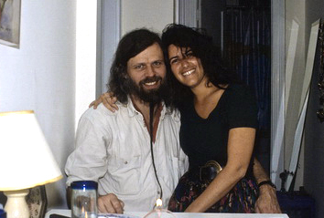  Mimi in one of the many cities where I have stayed with her over the years | 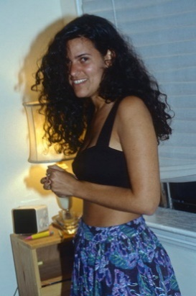  As a young girl, Mimi loved to pass herself off as a Hawaiian woman.
And at Boston University, the beautiful Mimi Lind from Hawaii "attacked" and started following me around from university to university with her Jewish motherly care - yes, as late as 22 years later she saved the movie with Søren Pind and me after a military base canceled the planned filming and within 24 hours Mimi organized an audience for us in the home of one of America's richest Jewish gay millionaires in Hollywood.

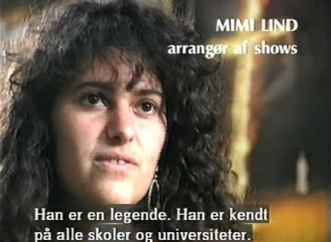  Mimi as she appeared in DR's film "Jacob Holdt in the USA" in 1992, when she organized lectures for me at UCLA and in Hawaii | 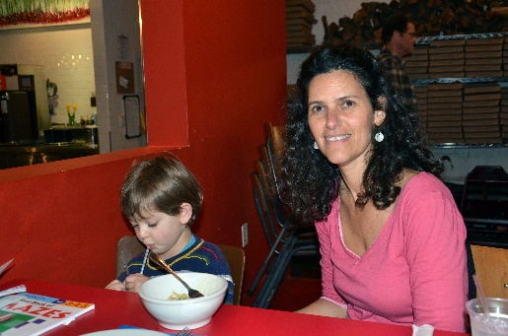  Mimi 23 years later as a lesbian mother in 2013, when she again helped Danmarks Radio by organizing lectures for Søren Pind and me.
Another was the well-known black performance artist and artist Ayanna Spears in Hartford, CT, who - because she had her son with her - came running back after seeing my show to give me a note that I could move in with her later. It also became a permanent residence for me in the years that followed, during which time I found out that she, with her big generous heart, had given a large scholarship to one of the people pictured in my book from the ghetto in the same city, Leslie Manselle, solely because I had told Ayanna that Leslie was my "old girlfriend".
Ayanna Spears during one of her solo dance performances in Hartford in 1991 | 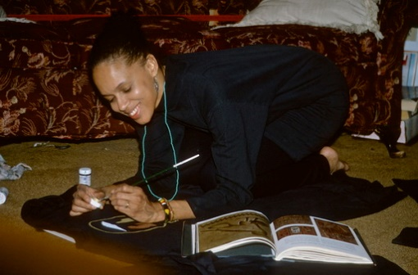  Ayanna working on her art in her Hartford apartment in 1993

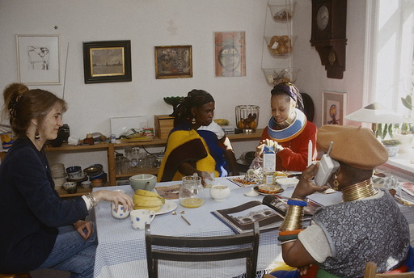  Vibeke and Ayanna with two South African Ndebele princesses in our kitchen in Denmark during the Images of Africa festival organized by Vibeke in 1996 | 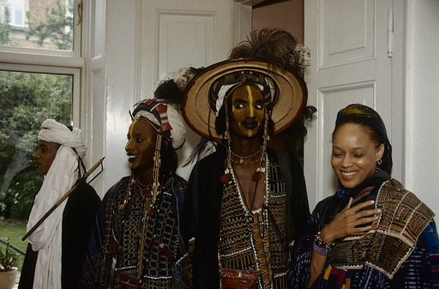  Ayanna especially fell in love with the Woodabies, whom Vibeke had flown up from Niger to participate in the largest African festival ever outside Africa
I won't go into each one in depth here, as they all became lifelong friends.
The last of them was the beautiful, outgoing Chinese Christina Sun, when I returned to New York after almost three weeks before returning to Denmark. I was exhausted from my liberation when I met her in the same random way as the others - standing in line at a post office, lost in my own thoughts. Suddenly, she rushed to cut in front of me, but remembered her mistake and turned to apologize, recognizing my face from my performance years before at Cornell University. "Oh, aren't you Jacob Holdt?" and in the very next sentence: "Do you need a place to stay?" As I was about to move out of the large loft I had shared with 6 lesbians, I immediately said yes - and moved in that very night. Since no one can accuse either her or me of having been able or in the mood to send out flirtatious vibrations in our post-house frenzy - me buried behind a load of book packages - it was again a case of something completely mysterious, as if directed from above. She was a bit too spontaneous, as she didn't even have her own apartment at the time, but was staying in a bunk bed with a friend. But soon after, we got our own "Lower East side" apartment at 217 E. 10th St, and when her rich boss, fashion photographer Raymond Meier, proposed to her a few years later and asked her to move in with him in his huge two-story Penthouse on top of a high-rise building with its own rooftop gardens and views of all of New York, she said, "Only if Jacob gets to move in with me." And that's been my free headquarters to this day - just as my "liberation" included Raymond's big, amazing mountain resort in Switzerland.

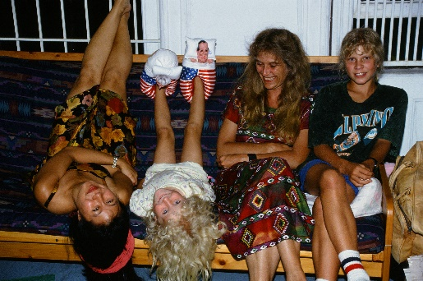  In our old slum apartment, Christina shows Vibeke and our children on their US vacation in 1992 how the Chinese walk upside down |  | 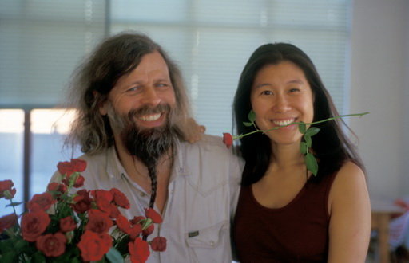  I bring red roses for house warming in 1997 during the move into our new rich man's home with Raymond Meier
Christina in our penthouse with roof gardens in 1997. Soon after, Raymond bought the equally large apartment downstairs for me and the cat |  | Christina dancing at the 2004 housewarming party in the Swiss Alps where Raymond flew in his models from all over the world
Only an hour after landing with jet lag, Christina pulled Anker Jørgensen onto the dance floor at my 60th birthday party in 2007 | Christina cooking a feast for Søren Pind in our Hudson River apartment in 2012 (after we evicted Raymond). Seductive as Christina is, it was an evening Søren will never forget
I won't go into detail about each one here, but simply mention that the end result of my "liberation workshop" was that for the next 17 days that November in 1990, I ended up sleeping with 14 different women. I could write a whole book about the conspiracy between these 14 wonderful women who suddenly decided to invade my life and become a permanent part of it in all corners of the country, but it should rather be about the dark sides of myself that meant that not a single woman had invited me home throughout the entire year before. In that sense, both they and I were neutral elements in the experiment, which was, after all, just about "dressing in love" again - the ability I had become so good at developing and mastering in my vagabond years through the love of others, and with which I could "open up" motorists, blacks, criminals, women and other closed or wounded groups to me. It was the ability that had been lost to me as an increasingly insensitive privileged man in my later life's blind career race in universities, which is why it is perhaps part of the point that it was the redeeming hands of loving men that had now helped it back under the name "men's liberation".

Today, 30 years after my reverse Redwood workshop - ”hugging people instead of trees” - many of the same methods and courses under different "mindfulness" names have gained ground among business leaders around the world. So, to a certain extent, you can influence the outcome of how other people react to you - if you get a little help from above. The outcome of my little course trip to Seattle was even the result of being open to and unknowingly combining two contradictory self-help methods, as co-counseling strongly rejects all astrology.

My little nationwide experiment - where the numbers were probably somewhat influenced by the fact that I had to fly and not drive from school to school during the 17 days - had a funny little aftermath when I came home and told my wife that I had "just been with 14 women in 17 days, or was it the other way around? I don't remember because I was so dizzy."
Since the birth of our daughter during the tour with Pia Tafdrup three years earlier, she had belonged to a birth group that met every month to share experiences. Vibeke hadn't really intended to tell the other mothers about it, but when one of her friends started talking about how she was thinking of divorcing her husband because she had found a condom in his pocket after his trip to Greenland and he had confessed to having had an affair up there, Vibeke suddenly couldn't contain herself any longer. "What kind of nonsense is this to get caught up in? My husband has just returned from the USA, where he was with 14 women in 17 days - or was it 17 in 14 days - and our relationship is better than ever!" Then they all burst into a liberating laughter that ended up saving the other person's marriage, which is what true liberation is all about: sharing it with others.
When Vibeke had hesitated to tell them about it, it was of course because she feared that without this, my long background explanation (or sea explanation, if you will), they would have a hard time understanding it - let alone accepting it. And the fact that Vibeke was able to laugh about it all was precisely because the large number was no threat to our relationship - in the same way that a single extracurricular infatuation would have been for a deadlocked, conflict-ridden marriage without mutual trust.

It goes without saying that most of these, my far-out-in-the-woods liberated/liberating women, have continued to this day to be my friends who, through their work and influence, have helped me enormously. And when many of them have since visited us in Denmark, Vibeke always befriends them and says almost every time, "You had such good taste!" To which I always reply, "No, they chose me, not the other way around. Just like when I met you. I just said yes and amen as always with women."
WHY YOU CAN'T DO WITHOUT LIFETIME GIRLFRIENDS

Aside from these illustrative examples, the stories of the lecture years' completely redefined relationships with the women in my path belong in "Saying Yes to My American Students." As the examples show, these years made far greater demands on me as a man of power than the impotence of the vagabond years, but since I almost always now had thousands of eyes on me or witnesses with me, it was not so difficult to live up to the demands of accountability - if only again as a result of my old fear "of falling if I took advantage of the gifts I was given".

My witnesses were all the European women like Pia Tafdrup I invited on my tours in the US over the years. The offer also applied to men, but again, it was probably the "female values" I preached about that meant that over 80% of those who signed up as driver's assistants were women. Most of them in their gap year right after watching American Pictures in high school. Since men could also more easily travel around the violent United States without the risk of rape every day, I felt it was more important to give women a chance to experience the separate worlds of ghettos and universities for free and safely. The only thing that seemed to connect these two worlds was the complete inability of both black and white Americans to imagine that we could travel for months at a time, sharing beds in cars and hotels without having a sexual relationship with each other.

Funnily enough, the constant bawdy American remarks that resulted contributed to us being even more "shaken together by keeping our distance," as one would surely put it here in the midst of the Coronation era of bodily liberties, during which this chapter on the bodily liberties of my youth was written.
But all as one, my fellow travelers were now experiencing the benefits of my not having "kept my distance" from the girlfriends I had accidentally been "shaken up with" at the time. Because all over the country, 10-20-30-40 years later, they were now providing accommodation, dinners and much-needed showers for us and my dirty hitchhikers.

They were particularly indispensable when my large trailer frequently broke down. Several of them mentioned this in the books they later wrote about the trips. No one experienced these breakdowns as frequently as the black Danish model Rikke Marott on her trip in 2003, where the car constantly broke down because its electronics were eroded by salt water when it was parked in a cheap boat storage facility near Kennedy Airport during my long stays in Denmark. Even before we got out of New York, the car broke down. I had promised black Rikke to take her to my friends at the Ku Klux Klan headquarters in Indiana, but after a couple of lectures on white supremacy for upper-class children at Deerfield Academy - financed by slavery - in snow-white Massachusetts, the car broke down again.
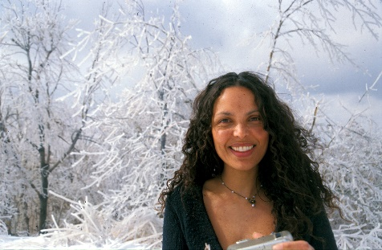  Rikke in the snow-white mountains of New England | 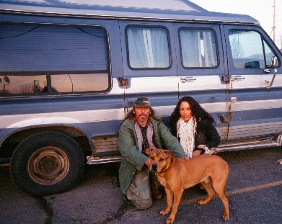  The hitchhiker with his big dog

I had picked up a haggard homeless man with a big farting dog in the mountains of upstate New York. They both "smelled and licked" too much, Rikke thought. She relented, however, as she had already heard me say that it was just such hitchhikers who always fixed my car during its worst breakdowns. The hitchhiker claimed that he had just been kicked out by his wife after several years of marriage when she had taken a lover. Alas, the usual story of how Americans can't integrate their various lovers and in their possessiveness end up losing both family and home. However, his odor revealed everything but the word "straight." Almost as predicted, the car immediately started making strange noises as we drove uphill and soon after lost speed. "What did I tell you, Rikke? Here came our rescuer in the middle of the most desolate mountains. " He had also been a mechanic once and towards evening we pulled into a gas station that was closed on Sundays so he could repair the car. However, he was no better than other mechanics at figuring out the eroded electrical systems and soon the car wouldn't start at all. There was nothing to do but wait and get the car fixed the next morning. But it was about 20 degrees below freezing and Rikke certainly didn't want to share the bed with the smelly hitchhiker and his giant dog. "Well, you can't let him sleep out in the cold when he's just spent so much time helping us?"
"Yes, you bet I can! " Arguing in Danish in front of others had its advantages.
We were only two days into a two-month trip and I didn't want to have a conflict with Rikke over the hitchhiker so quickly and tried to find a solution. And here comes the point about how you can't get by without taking out car insurance with past girlfriends. Because within a couple of hours of each other, even here in these deserted mountains, I actually had two old girlfriends whom I suggested Rikke sleep with so that this hitchhiker could have our bed in the car. "One, Alba Leto, lives an hour's drive from here in an old house right next to Yoko Ono's deserted farm, but she has two big black Great Dane dogs even bigger than the hitchhiker's, who constantly jump into bed with us. The other, Nancy Norton, lives over two hours away, but she has also thrown her love to two Great Danes, her first girlfriend, Kim the Dane, and her next, me. So who do you choose, Rikke?"
Rikke opted out of the dogs, and luckily I didn't have to call Nancy on the phone to ask her to come and pick us up. She even excitedly suggested that she and her husband would immediately come in their SUV to rescue us, as a snowstorm was coming and "You certainly can't sleep out in the blizzard. " Rikke was relieved, but now she realized that this was just my plan to help the hitchhiker into our car and she was once again furious even though I promised that I would wash our sheets afterwards. What I always loved about moving in with new women was now repeating itself. After just a few days with Rikke, our relationship felt like a tired old marriage in which the woman always gets her way and it was just a matter of "saying yes". So, the hitchhiker had to hike dejectedly out on the highway in the now icy darkness of the night.
Nancy and her lovely husband Buzz drove almost as far to pick us up as they had driven for me to find some suitable coal mines, as Lars von Trier asked me to find a special mine shaft for the movie "Dear Wendy," namely 8 hours of driving in a snowstorm as we also had to be brought back to the car. While I wasn't crazy about Nancy's previous three husbands, all of whom were jealous, I loved Buzz, who immediately started with: "Jacob, this time you don't have to sleep in the basement. I've built you a brand new guest house. "
Well, damn if Rikke and I didn't get a luxurious brand new house all to ourselves from the wealthy Buzz - at least he inherited a quarry when his father died. But the beautiful Nancy, who Tony had declared during one of our visits was a carbon copy of Vibeke, turned out to be jealous of Rikke and kept trying to discreetly find out if we were lovers. Old love never rusts. And even worse - she couldn't help but show it all the time, Rikke said. Due to the snowstorm, they insisted that we stay for a couple of days. But no, we were in a hurry to get to the Ku Klux Klan in Indiana, where my "Klan girlfriend" Pamela was waiting for us (see last chapter). It wasn't until 5 o'clock the next evening that the car was finished after an expensive repair - once again due to the erosion from the salt water around Kennedy Airport.

Nancy and Buzz in 1996, when I had so many fellow travelers - including Pia Tafdrup - that Buzz started building a guesthouse for me. | 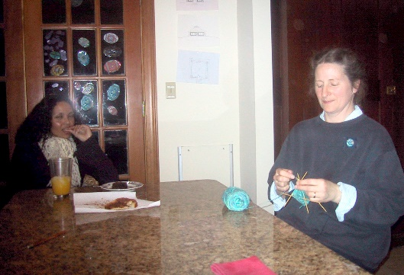  Nancy and Rikke in 2003

But the snowstorm got wilder and wilder and already after a couple of hours of driving the car stalled again - this time at the same distance from Nancy and Buzz, only on the western side of Ithaca. But we managed to maneuver the car at a speed of 10 km to the nearest town, where we again had to wait until the next day. And again, it took the mechanics a whole day to find the eroded wires. The sales manager at Ford tried to convince us of the "sense" of buying a new car from him and didn't understand my argument that it was much cheaper to "have many wives" than expensive cars. An American couldn't understand that, but then Rikke tried to make him understand what I meant and began to entertain this very local tradition-bound man without much knowledge about the twenty wives her own grandfather had had in the Masai tribe in Kenya, about his 400 children and about her 2000 spear-carrying and blood-drinking cousins, who always waited for Rikke when she just snapped her fingers during her visits down there. As the husband ended up saying excitedly: "I can't wait to tell all these stories to my wife tonight. I've been working in this workshop for 45 years, but you are the greatest thing that ever happened around here!"

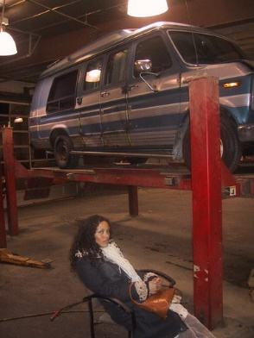  Rikke our first night together at an illegal African workshop in New York, where she sat all night and used her charm to get the Africans to fix the car so we could make it to the next lecture | Rikke charms the Ford sales manager for a whole day to get us to the Ku Klux Klan
So every time since when the car broke down on our 10,000 km trip, I let the charming and sexy Rikke use her black womanly charm to get the car fixed quickly. But if anything, she came to appreciate always finding accommodation with old girlfriends in this way.
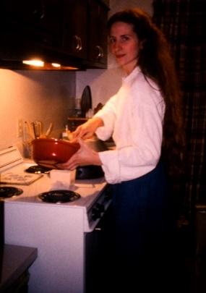  Nancy in her younger years when I met her | Nancy in 1989 when I had my 9-year-old son and Tony with me
Nancy, Rikke was particularly impressed that I had been able to hold on to her for so many years, because I had "dated" her three or four times. And she was even a Christian fundamentalist when she first accosted me because I reminded her of her "high school sweat heart", the Dane Kim. After that, I was a bit out in the cold the first time when she married Milton, a mailman, with whom she had a son, Joel. When they divorced and I started touring, she contacted me again to resume the relationship. It was very convenient for me because she lived in Ithaca, where I had freshman orientation for the new students at Cornell every year for 17 years. As a single mom, she was poor, but then she met and dated a rich gambler. And even though he gambled in Atlantic City and Las Vegas half the time, I was still relegated to the guest bed for all his time, as Nancy felt she was still a good Christian. But then in 1990 when I was lecturing out in Hawaii, the gambler came up to me after the show and said: "Hey, Jacob, you can have Nancy back now. She got tired of me never being there and kicked me out. And it looks like you need her more than I do." And he was right, because now I had so many lectures in town that Nancy almost became my second American headquarters. She also saved one of my biggest lectures at Harvard when I left my tapes at her house that morning. Then she flew to Boston and only had half an hour to give me the audio for the show.

She was a true angel of salvation for me, so I wasn't thrilled when she married the wealthy Buzz a few years later and I was once again relegated to the guest room in the basement. Luckily, he was so nice that since I almost always had foreigners on my trips, Nancy convinced Buzz to build a special guesthouse for us. Now that I have finished my American tours, we miss each other so much that they have both visited Vibeke and me in Denmark several times, where they are similarly referred to our guesthouse in the garden. Unfortunately, this is unlikely to happen again, as at the time of writing they have gone bankrupt during the Corona crisis and lost everything.
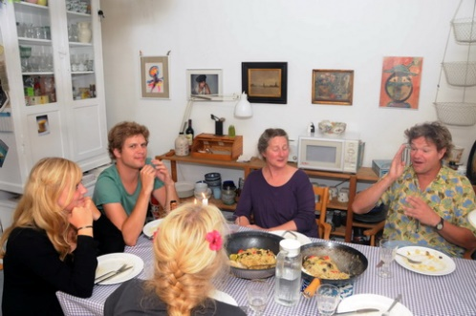  Nancy and Buzz with Vibeke and our children in Copenhagen in 2009 | 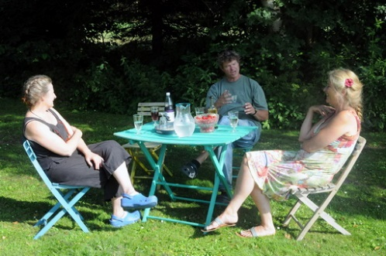  Nancy and Buzz with Vibeke in the summer house in 2010
The reason I cherish and value my "lifetime girlfriends" so much is, as I will try to show in this chapter, that I realized and acknowledged early on that they became a kind of mothers to replace the one I never really had. With their need to motherly protect me, these special women sought me out - despite my obviously edgy sides, my ADHD confusion, my rude and downright oppressive sides - and took care of me throughout my life. A life with a life's work that would have been nothing without them. I owe them everything - not least my continued friendship.
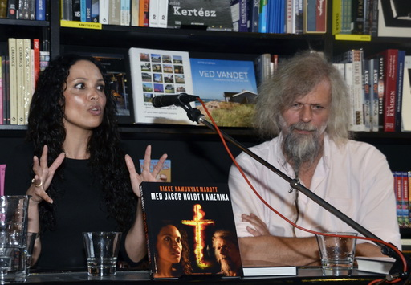
Rikke Marott later wrote this book about our trip to visit my old friends and the KKK, which we lectured about together. For some reason, her publisher chose to put this sentence in full-page format: “There isn't a state or city in the US that doesn't have one of Jacob's ex-girlfriends, and they always welcome us with open arms....”

